**Prokaryotic Gene Regulation**

* trp operon
* lac operon
* Bacteria: *E. coli*

Gene expression

* for genes to work properly, they have to be turned on a the right time
* Operons…
  + Proteins that are needed for a specific function and are encoded in blocks together
    - Closely located on same chromosome
  + Unique to bacteria (rare in eukaryotes)
  + Jacques Monod

TRP operon

* Makes amino acid Tryptophan from precursor molecule
  + E. coli can:
    - Ingest Tryptophan from the environment
    - Synthesize Tryptophan using enzymes that are encoded by 5 genes
  + **5 genes working together: trp operon**
  + (pairs of trp operons – paralogs)
* Example of feedback inhibition
  + Regulation of enzyme production -> regulation of gene expression
    - If there is tryptophan, there is no need for the cell to make any more
    - Presence of Tryptophan: Production shuts down
    - Absence of Tryptophan: Production starts up

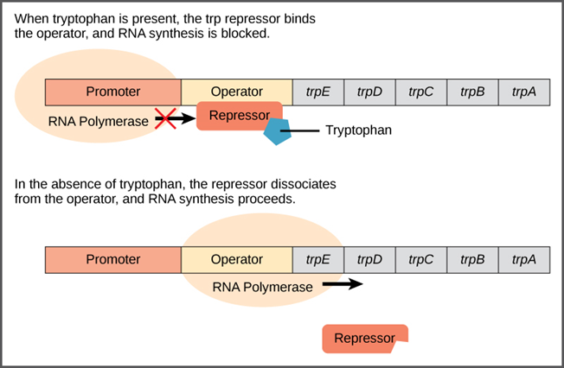

LAC operon

Lactose

* Disaccharide: Glucose + Galactose
* E.coli consume by breaking bond between rings
* Broken down by lactase

Lac operon

* Inducer operon
* 3 closely linked genes that are involved in the breakdown of lactose
* (oposite of trp operon)
  + If no lactose present, no need to produce lactase
  + If lactose is present, it binds to the represor to deactivate it from blocking RNA polumerase ---- ‘derepression’

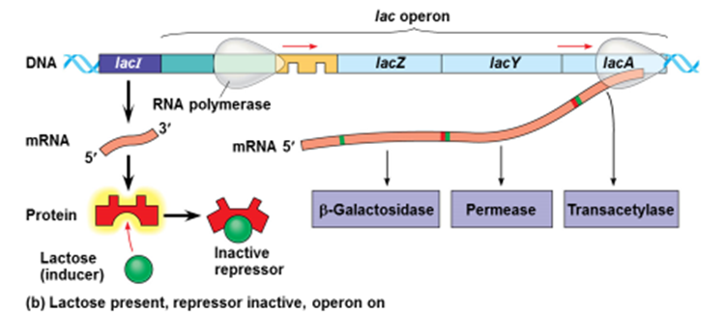

* Genes involved
  + **lacI**: codes for prepressor
  + Promoter: RNA polymerase binding site
  + Operator: Repressor binding site
  + Big Three:
    - **lacZ** codes for B-galactosidase (breaks lactose into 2 ringed subunits)
    - **lacY** codes for Permease (allows lactose into the cell)
    - **lacA** codes for Transacetylase
* Repressor
  + active when lactose is absent
  + When abundance of lactose, *allolactose* binds to repressor and deactivates it
    - (allows production of lactase)

LAC operion – with the glucose variable…

* Glucose is preferred energy source
  + If glucose is present, its more economical to break use it rather that break down lactose to obtain glucose product
* If glucose is present, entire lac operon will be repressed
  + RNA poly need help from CRP (cAMP receptor protein) to bind to promoter
  + CRP is only activated if cAMP is plentiful
  + **Glucose inhibts formation of cAMP**

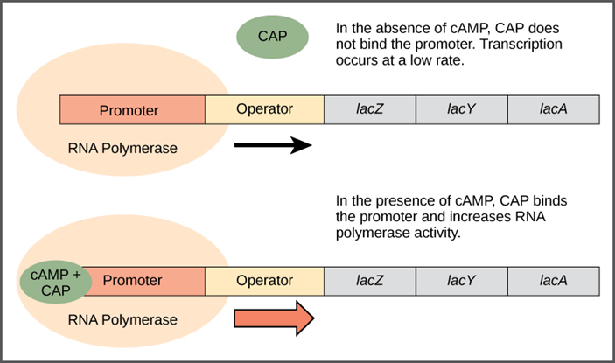

Possibilities:

* High glucose and lactose
  + > low cAMP --> no CPR --> no RNA poly binding --> minimal transcription
* Low glucose and high lactose
  + > high cAMP 🡪 yes CPR (binds to DNA) 🡪 allows binding of RNA poly 🡪transcription activated

Summary of possibilities:

| Glucose | CAP binds | Lactose | Repressor binds | Transcription |
| --- | --- | --- | --- | --- |
| + | - | - | + | No |
| + | - | + | - | Some |
| - | + | - | + | No |
| - | + | + | - | Yes |

LAC operon: Experimental Evidence

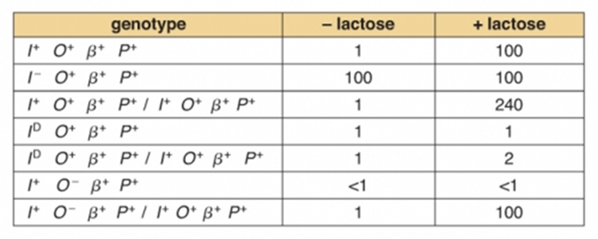

* I+ is normal repressor
  + Induction proceed as expected
* I- is inactive repressor
  + It can’t bind to operator
  + Lactase will be produces regardless if lactose is present
* Bi-normal diploid
  + Normal, but double lactase is produced if lactose is present
* I D dominant mutant
  + Can bind to operator, but not to lactose
  + No production of lactase even if lactose is present
  + In diploid cases when a normal I is co-present, D mutant acts dominantly over normal
    - Acts trans
    - D overtakes + and no produces no lactase
* O- cannot bind repressor
  + No lactase production
* Diploid of O- and O+
  + O+ is dominant
  + Behaves normally
  + Acts cis

How does repression work?

* Lac I codes for repressor protein that binds to lac O gene (operator)
* Repressor binding causes a loop in the operon that prevents transcription downstream

Summary of TRP operon vs LAC operon (directly taken from Dr. Sorensen’s PPT)

***E. coli* operons: A set of linked genes under transcriptional control**

* TRP operon
  + Makes enzymes that make TRP when TRP is low
  + TRP binds and activates the repressor to physically block the RNA polymerase.
  + TRP is a corepressor
* LAC operon
  + Makes enzymes that utilize (break down) lactose
  + Lactose *in*activates the repressor (opposite from the TRP repressor) and the repressor lets go.
  + Called “induction by derepression”.

MC questions

1. In a cell with an abundance of Tryptophan, trpR synthesizes an mRNA which codes for a protein that acts as a repressor. This repressor, in turn, binds with excess Tryptophan, allowing it to bind to which segment of the trp operon?
2. trpR gene
3. RNA polymerase
4. Operator
5. trpB gene
6. The trp operon can be considered to promote feedback inhibition because
7. An abundance of Tryptophan produced promotes an increase in the rate of Tryptophan production
8. The enzyme Tryptophase is coded for which breaks down Tryptophan
9. Produced Tryptophan activates the repressor, allowing it to bind with the operator, halting the production of Tryptophan
10. An abundance of Tryptophan activates the lac repressor and prevents lactase from being produced.
11. An operon can best be described as
12. A single gene controlled by many factors
13. Many genes grouped together on the same chromosome that are under one control
14. Many genes with a similar function, each located on a different chromosome
15. A group of genes that are most commonly known for coding eukaryotic cells
16. In a situation when there is little or no glucose present in a cell, a certain gene on the lac operon codes for an enzyme that is primarily responsible for splitting a lactose molecule into two monosaccharide subunits. This enzyme is called
17. β-galactosidase
18. Permease
19. Helicase
20. Transacetylase
21. In lab you were to conduct an experiment testing the lac operon to test for the amount of lactase produced for a given situation. Your first experiment was performed in an environment that lacked any measurable lactose, and you noted that a large quantity of lactase enzyme was produced. Explain the results.
22. The entire lac operon was wild type.
23. The operon in question was actually diploid wild type.
24. The repressor was inactive and couldn’t bind to the operator.
25. The operator was mutated, preventing RNA polymerase from transcribing.

Essays

1. Using the data produced during Monod’s experiments on the lac operon, explain the significance of the genotypes on how they affect lactase production both with the initial presence of lactose and the initial absence of lactose. Do this for the two indicated tests.



->

->

1. Briefly explain what occurs on the lac operon in an environment that lacks glucose. Contrast the difference in process between what occurs in a high concentration of lactose versus when there is a negligible amount of lactose present, and give the overall purpose of the lac operon.

Answer Key:

MC:

1. C
2. C
3. B
4. A
5. C

Essay:

1. Outline:

* + I+ is normal repressor
    - Induction proceed as expected
  + In diploid cases when a normal I is co-present, D mutant acts dominantly over normal
    - Acts trans
    - D overtakes + and no produces no lactase

Example Essay:

The first test represents a test of the wild type lac operon, in which the repressor is normal. When lactose is present, it binds with the receptor, forcing the receptor release from the operator or derepress, allowing RNA polymerase to transcribe down the operon. As a result, lactase is produced. When lactose is absent, the receptor remains bonded to the operator, preventing RNA polymerase form passing down the operator and transcribing lactase.

The second test represents a mutant repressor, but in this case, the operon is a diploid, one being mutant and the other being normal. In this case, the mutant I-D is dominant over the normal wild type. Even though there is one copy of a normal operon, it is overwritten by the dominant D mutant. It acts in a trans manner because the mutant affects the wild type, which is located in another part of the cell. As a result, no lactase is produced whether lactose is present or not.

2. Outline:

* 1. Because glucose is not present, bacteria must breakdown lactose to get the necessary energy requirements
  2. In the case of low lactose concentration, the lac operon doesn’t need to break anything down
     1. The lacI gene produces an mRNA that codes for the repressor.
     2. In the absence of lactose, the repressor can bind to the operator and prevent RNA polymerase from transcribing past the operator
     3. No lactase will be produced because it is not needed
  3. In the case of high lactose concentration, lactose needs to be broken down
     1. The same repressor is coded, but a variant of lactose, allolactose, binds to it, causing derepression
     2. Therefore, the RNA polymerase can pass down the operon and code for enzymes that breakdown the lactose
  4. The purpose of the lac operon is to produce lactase, an enzyme that breaks down lactose, but has the ability to shut off production to save energy.

Example Essay:

Glucose is bacteria’s choice to consume because it is easier to break down than is lactose. If there is not glucose, lactose must be broken down to provide for the energy requirements. If there is a low lactose concentration in the cell, the operon does not need to break down anything. In this situation, the lacI gene codes for an mRNA that makes the receptor protein. Because there is no lactose present, the repressor is bound to the operator. Nothing is making it leave. This binding prevents RNA polymerase from passing down the gene coding for lactase. If lactose is present, a lactose variant, allolactose acts as an inducer and binds to the receptor. This binding removes the receptor for the operator, allowing the RNA polymerase to move down the operon and code for lactase. The whole purpose of the lac operon is to conserve energy. There’s no need to waste energy to produce enzymes that break down lactose is there is no lactose present.