**Phylogenetics**

* Phylogenetics refers to the evolution of organisms
* Paralogs
  + Paralogs are genes that are related by duplication within a genome.
* Homologs
  + A homolog is a gene related to a second gene by descent from a common ancestral DNA sequence
  + Some homologous features lose their usefulness
    - Vestigial features are those that have become functionless in the course of evolution
  + The humerus, radius, and ulna are conserved through (homologous for) all tetrapods
  + Homologies extend to the cellular and molecular scale as well
* Analogs
  + An analog is a feature that appears similar in two taxa which have originated from two different ancestors
    - Traits that are analogous are alike, not because of a common ancestor, but because of natural selection evolution.
  + Bat and bird wings are analogous
    - They evolved independently by convergent evolution
    - Classified as forelimbs, though, they are homologous
* Convergence
  + Convergent evolution is the independent evolution of similar features in species of different lineages
    - Convergence contrasts with homology
    - It also creates analogous structures that have similar form or function, but that were not present in the last common ancestor of those groups
  + The wings of bats, birds, and pterosaurs are convergent
    - Each group evolved independently from different wingless ancestors
* Phylogenetic Trees
  + A phylogenetic tree is a branching diagram showing the inferred evolutionary relationships among various biological species based upon similarities and differences in their physical and/or genetic characteristics
  + As you move from the root to the tips, you are moving forward in time.

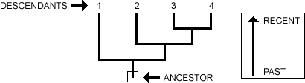

* + When a lineage splits (speciation), it is represented as branching on a phylogeny. When a speciation event occurs, a single ancestral lineage gives rise to two or more daughter lineages.

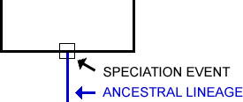

* + Phylogenies trace patterns of shared ancestry between lineages. Each lineage has a part of its history that is unique to it alone and parts that are shared with other lineages.

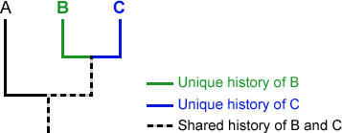

* + Similarly, each lineage has ancestors that are unique to that lineage and ancestors that are shared with other lineages — common ancestors.

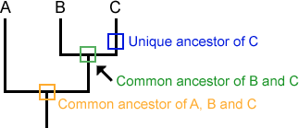

* + Clades
    - A clade is a grouping that includes a common ancestor and all the descendants (living and extinct) of that ancestor.
    - Clades are nested within one another

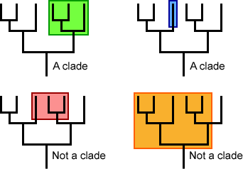

* Phylogenies
  + Evolution produces a pattern of relationships among lineages that is tree-like, not ladder-like.
  + Just because phylogenies are read from left to right does not mean there is a correlation with level of advancement.
  + For any speciation event on a phylogeny, the choice of which lineage goes to the right and which goes to the left is arbitrary.
* Cladograms
  + A cladogram shows the cladistics relationship between a number of species
  + Making a cladogram
    - The more recent the common ancestor, the fewer the differences found
    - A cladogram must be supported by anatomy and DNA
    - Large trees require computational shortcuts called heuristics

**Phylogenetic Test Questions**

1. Which of the following describes a phylogeny?
   1. Natural relationships between organisms
   2. Evolutionary pathways
   3. A genealogy
   4. A tree
   5. All of the above
2. Paralogs are:
   1. Genes related by duplication within a genome but retain the same function
   2. Genes related by duplication within a genome but evolve new functions
   3. A gene related to a second gene by descent from a common ancestral DNA sequence
   4. Genes duplicated but are not the same
   5. Genes in a different species that evolved from a common ancestral gene by speciation

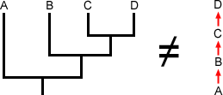

1. The image to the right represents what?
   1. Aristotle’s “the great chain of being”
   2. Woese’s “lineage of life”
   3. A typical process of evolution in a species
   4. Chain of how all species evolve
   5. 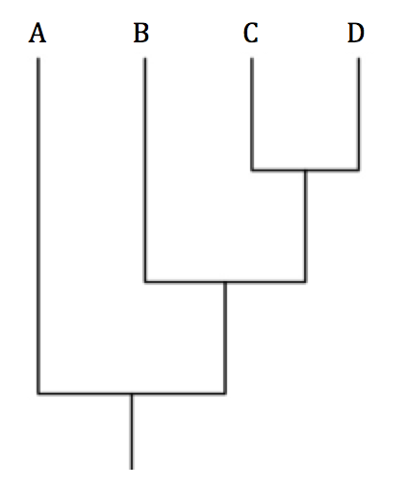How humans typically evolve
2. Which taxon in this tree most closely related to taxon B?
   1. A
   2. B
   3. C
   4. D
   5. All are equally related to B
3. Taxonomy is what?
   1. A branch of science concerned with the classification of organism; systematically
   2. A feature similar because of a common ancestor
   3. The study of homologous species
   4. The process of how protein is found in a BLAST sequence
   5. A way to gather similar mitochondria
4. What is phylogeny and what is a phylogenetic tree? What's the difference between a phylogeny, an evolutionary tree, a phylogenetic tree, and a cladogram?
5. What is the difference between analogous and homologous structures? Provide one example of both.

**Phylogenetic Test Questions Key**

1. E
2. B
3. A
4. E
5. A
6. For general purposes, not much is different. Many biologists use these terms interchangeably — all of them essentially mean a tree structure that represents the evolutionary relationships within a group of organisms. It varies based on the context in which the term is used, as this will tell you more details about the representation. However, some biologists do use these words in more specific ways. To some biologists, use of the term cladogram means that the diagram represents a hypothesis about the actual evolutionary history of a group, while phylogenies represent true evolutionary history. To other biologists, a claogram suggests that the lengths of the branches in the diagram are random, while in a phylogeny, the branch lengths indicate the amount of character change. These vocabulary differences are subtle and are not consistently used within the biological community. The things to remember are that organisms are related and that we can represent those relationships (and our hypotheses about them) with tree structures. A phylogeny, or evolutionary tree, represents the evolutionary relationships among a group of organisms, called taxa (taxon (individual)). A phylogenetic tree is a diagram showing the evolutionary interrelations of a group of organisms, which came from a common ancestral group.
7. Analogous characters may appear similar, but have separate evolutionary origins. Homologous characters are corresponding parts of different organisms that are similar because they were inherited from a common ancestor that also had that character. For example, bat and bird wings are analogous, as they evolved independently by convergent evolution. As forelimbs, though, they are homologous. The wings are front legs adapted for flying, making the four limbs a homologous trait.