Claire Loughran and Lexi Palladino

Biology 110 Study Guide- PCR

Outline

Polymerase Chain Reaction (PCR) - a laboratory technique used to make multiple copies of a specific segment of DNA. This is an “in vitro” process (in test tube).

* PCR allows DNA to be amplified by a power of 2. Ex. 5 cycles 2^5=64 copies
* A single cycle can occur within the matter of minutes, 30 cycles will produce over a billion DNA segments

Components Needed

1. DNA segment
2. Heat stable DNA polymerase
   1. Given that PCR involves extremely high temperatures, the DNA polymerase must be heat stable
   2. Typical Polymerase utilized is Thermus Aquaticus or Taq Polymerase
3. Deoxyribose triphosphates
   1. Nucleotides that create the DNA sequence when combined
4. Buffer
   1. The solution provides a suitable chemical environment for optimum activity and stability of the DNA polymerase.
5. DNA primers
   1. Very specific nucleotide sequence that ensures the sequencing will begin in the right location on the DNA. Also, consist of 15-40 base pairs to ensure bonding in the right location.
   2. DNA primers are used, unlike RNA primers in DNA replication, because the sequencing begins on the ends on the DNA segment provided and not in the middle of a fork.
6. Thermo cycler
   1. Controls the temperatures of the reaction mixture

Process

1. Denature DNA- Heat DNA to a temperature of 95 degrees Celsius.
   1. High Temp breaks hydrogen bonds therefore separating the double helix into two strands
   2. This portion of the procedure mimics the job of helicase in DNA replication
2. Primers Anneal- Cool to 40-65 degrees Celsius
   1. Primers bind to the newly separated DNA strands
   2. Primers contain specific sequence allowing for the replication of a particular DNA segment
   3. There are forward and reverse primers for each strand
3. DNA extension- Heat to 72 degrees Celsius
   1. DNA polymerase extends the DNA chain by adding nucleotides to the 3’end of primers

* PCR must undergo 3 cycles in order for the production of a segment to occur

[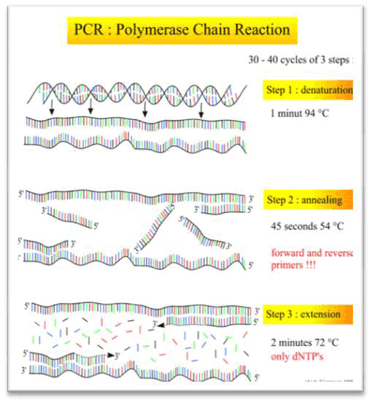](http://www2.le.ac.uk/departments/genetics/vgec/highereducation/topics/recombinanttechniques)

Multiple Choice Questions

1. PCR requires all of the following EXCEPT

a) Primers

b) DNA ligase

c) DNA polymerase

d) DNA of interest

2. What are the three basic steps of conventional PCR?

a) Denature, anneal, strand displacement

b) Denature, anneal, extension

c) Strand displacement, synthesis, release

d) Reverse transcription, anneal, extend

3. Taq polymerase starts copying at

a) the end of free single-stranded RNA

b) at any point

c) RNA primers attached to the end of the desired gene

d) DNA primers attached to the end of the desired gene

4. Taq polymerase is a commonly used enzyme because this enzyme is?

a) not prone to errors

b) a faster polymerase

c) thermo stable

d) a primer replicase

5. At the beginning of each cycle the temperature of the PCR is raised in order to

a) denature the double DNA strands

b) polymerize the DNA

c) attach the primer

d) re-nature the DNA strands

e) elongate the primer

Key

1. B
2. B
3. D
4. C
5. A

Essay Questions

1. A. What is PCR? B. Describe the Process of PCR.
2. Mrs. Peacock was found murdered in the study with a candelabra, the crime scene is covered in DNA. With little to no lead on the suspect, what technology would Forensic Scientists choose to discover her murderer and why is the beneficial? Give one more reason what this technology can be used for other than Forensic Science.

Key

1.

1. **Polymerase Chain Reaction** (**PCR**) is a used to amplify a single copy or a piece of DNA, generating thousands to millions of copies of a particular DNA sequence.
2. **Denaturation:** At 94 C, the double-stranded DNA separates into two pieces of single-stranded DNA.
3. **Annealing:** At around 54 C, the primers pair up (anneal) with the single-stranded "template" (The template is the sequence of DNA to be copied.) On the small length of double-stranded DNA (the joined primer and template), the polymerase attaches and starts copying the template.
4. **Extension:** At 72 C, DNA building blocks complementary to the template are coupled to the primer, making a double stranded DNA molecule.
5. The technology they would use would be PCR. Because they don’t know whether the DNA belongs to Mrs. Peacock or her killer, they could use this not only to distinguish between the two individuals at the scene but it can identify any one person from millions of others. Tiny samples of DNA isolated from a crime scene can be compared with DNA from suspects, or compared with a DNA database. Such procedures can identify or rule out suspects during a police investigation.
   1. Can be used for… possible answers:
      1. to diagnose genetic
      2. diseases do DNA fingerprinting
      3. find bacteria and viruses
      4. study human evolution
      5. establish paternity or biological relationships