Polygenetics: How are organisms related to each other?

* **Information used to build a tree**
  + Biologists collect data about heritable traits that can be compared across organisms
    - Physical characteristics (morphology), genetic sequences, and behavioral traits
* **Homologies and Analogies** 
  + Homologous Features
    - Features in different organisms that are similar because they were inherited from a common ancestor that also had that feature
    - Example of homologous features in tetrapods:
      * 4 limbs
        + Ancestors of tetrapods evolved four limbs and decedents have inherited that feature as well- 4 limbs is a homologous feature for tetrapods
      * Humurous
      * DNA
        + Cellular structure homologous for plants and animals
      * CO1 gene
        + Gene that is homologous for every organism with mitochandira
  + Analogous Features
    - Features that come to be through convergent evolution- they have separate evolutionary origins
      * Example of analogous feature:
        + Bird wings vs. bat wings

They have separate evolutionary origins but are similar because they both experienced natural selections. (Convergent evolution)

* **What happened when?**
  + Radiometric Dating
    - Relies on half-life decay of radioactive elements to allow scientists to date rocks and materials
  + Stratigraphy
    - You know how old a species is based on what layer of rock it is found in
  + Molecular Clocks
    - Allow scientists to use the amount of genetic divergence between organisms to extrapolate backwards to estimate dates
* **Clade**
  + A group of organisms believed to have evolved from a common ancestor

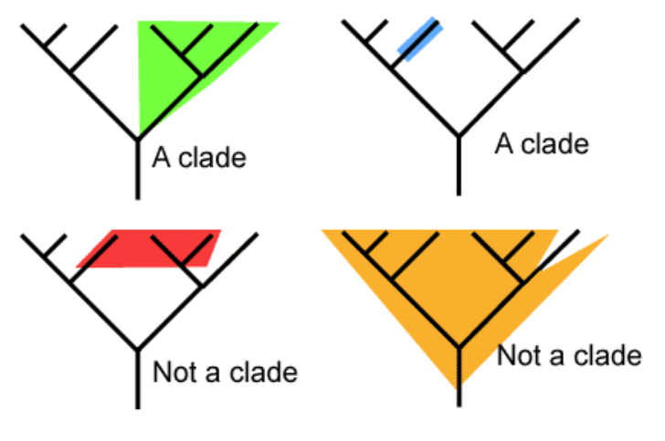

* **If humans evolved from apes, why do they still look like apes and not like humans?**
  + We didn’t evolve from them, we just have a common ancestor
  + Allopatric Speciation
    - Small group breaks away from a population and begins to evolve independently
    - The source group does not need to go extinct, and is normally not affected by the development of the new group