# Phylogenetics

## Phylogenic Trees

### Shows the origins of current species and how they are related

### Also known as cladograms

### There is a phylogenetic tree of life

* 1. Broken up into 3 domains: bacteria, archaea, & eukaryote
  2. Made up of DNA sequences for ribosomal subunits
  3. Make up tree because of genetic code
     1. Genetic code is the process that is common to all cellular life

### Traits are presented along the tree and the higher you go up the tree more recent the trait has evolved

### based on sequence alignments in DNAs and differences in anatomical structure

### supports evolution because traits are nested into groups and evolve through generations

### Macintosh HD:private:var:folders:qk:fqlybsgn5zn7n119hptbmx640000gn:T:TemporaryItems:images.png

* Circles represent a speciation event where a new

species evolved

* Where the lines are intersected shows common ancestors
* Clades
  + All species within a group with a common ancestor
* How to build a Phylogenetic tree
  + Construct a chart of differing DNA sequences or of anatomical features
  + Count how many differences are between each species being evaluated
  + The fewer differences within a species the closer related they are
  + First, see how many species differ by one trait and build off from there
  + Then see how many differ by 2 and so on until you complete the tree

**Multiple Choice Questions**

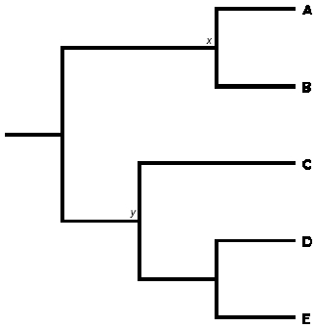

1. Based on the cladogram above, how many differences can you assume there are between species A and B?
2. 2
3. 0
4. 1
5. 4
6. Based on the cladogram above, what species is the closest related to species D?
7. A
8. B
9. C
10. E
11. What is a clade?
12. the cells that make you who you are
13. different species with similar genes
14. different genes in the same species with a common ancestor
15. all species in a group with a common ancestor
16. What are the three domains of the phylogenetic tree of life?
17. Arachea, bacteria, eukaryota
18. Bacteria, archea, prokaryota
19. Eukaryota, prokaryota, bacteria
20. Eukaryota, prokaryota, arachea
21. What process allows biologists to assemble the “tree of life?”
22. PCR
23. BLAST
24. Genetic Code
25. Cladograms

**Answer Key**

1. C 2.) D 3.) D 4.) A 5.) C

**Essay (10 POINTS)**

Create a chart and phylogenetic tree out of the following information about species DNA.

Position: 1 2 3 4 5 6 7 8 9 10

A G A G A C T C C T A

B G A G A C T C C T T

C C A G - C T C C A -

D C A G - C T C C T -

E C T G A C T C C T A

**Answer Key:**

|  |  |  |  |  |
| --- | --- | --- | --- | --- |
|  | **B** | **C** | **D** | **E** |
| **A** | **1** | **4** | **3** | **2** |
| **B** |  | **5** | **4** | **3** |
| **C** |  |  | **1** | **4** |
| **D** |  |  |  | **4** |

**5 Points for fully correct chart**

A B

E

D C

5 points for correct phylogenic tree.