Videos to Accompany
Developmental Biology, Ninth Edition

Please Note: The videos require video player software. Please refer to the “System Requirements” section of the Instructor’s Resource Library ReadMe file (located at the top level of the disc) for details. Also, refer to the “PowerPoint Basics” section of the ReadMe for tips on using the videos within PowerPoint.

Chapter 1. Developmental Anatomy

(Related DevBio Laboratory: Vade Mecum³ Videos: 1, 2, 3, 4, 5, 6, 38, 39, 40, 50)
(Related Differential Expressions² Videos: Hay Excerpt 1, Lash Excerpt 1, Le Douarin Excerpts 1–2, Saxén Excerpts 1–2)

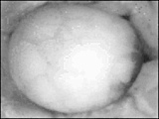
[01-01 Xenopus 1.mpg]

1.1 Early Xenopus Development: Rapid cleavage through larva formation. Animal pole of egg is at the right-hand side. (Courtesy of Ali Brivanlou.)
Textbook Figure Reference: 1.1

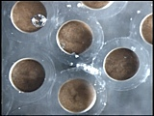
[01-02 Xenopus Early Cleavage.mpg]

1.2 Xenopus Cleavage: Rapid cleavage in Xenopus, without changing volume of the embryo. (Courtesy of Ali Brivanlou.)
Textbook Figure Reference: 1.2

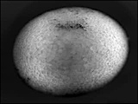
[01-03 Xenopus Gastrulation 1.mpg]

1.3 Gastrulation and Neurulation in Xenopus: Xenopus laevis Vegetal View of Gastrulation and Neurulation: (15.0 hours elapsed, 48 minutes/second). The movie shows gastrulation and neurulation viewed from the vegetal pole, the future dorsal side at the top. Note the dramatic involution of the IMZ, which forms an annulus or ring of cells surrounding the large central disc of vegetal endodermis cells at the center of the vegetal pole. The bottle cells, marking the initiation of involution, have already formed mid-dorsally as indicated by the black pigment accumulation. Note that the dorsal IMZ, region above these bottle cells rolls over the blastopore lip and disappears inside; subsequently this involution proceeds laterally, on both sides, and finally at the midventral line. As the IMZ involutes, it also extends posteriorly and converges around the circumference of the blastopore, but does so inside, out of sight. As it does so, note that the posterior neural tissue likewise converges and extends in the same fashion, on the outside; together these convergent extension movements squeeze the blastopore shut and simultaneously elongate the anterior-posterior axis of the embryo, pushing the future tail away from the head. Note that the converging and extending neural plate simultaneously rolls up to form a neural tube. (Keller, R. and D. Shook. 2004. Gastrulation in Amphibians. In C. Stern (ed.), Gastrulation Cold Spring Harbor Laboratory Press.) (Used with permission.)
Textbook Figure Reference: 1.3

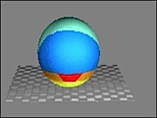
[01-04 Xenopus Fatemap.mpg]

1.4 Xenopus Fate Map (External): Aqua is epidermal ectoderm; blue is neural ectoderm; red is notochord; orange is notochordal mesoderm; yellow is endoderm. (Courtesy of Ali Brivanlou.)
Textbook Figure Reference: 1.11

Chapter 2. Developmental Genetics

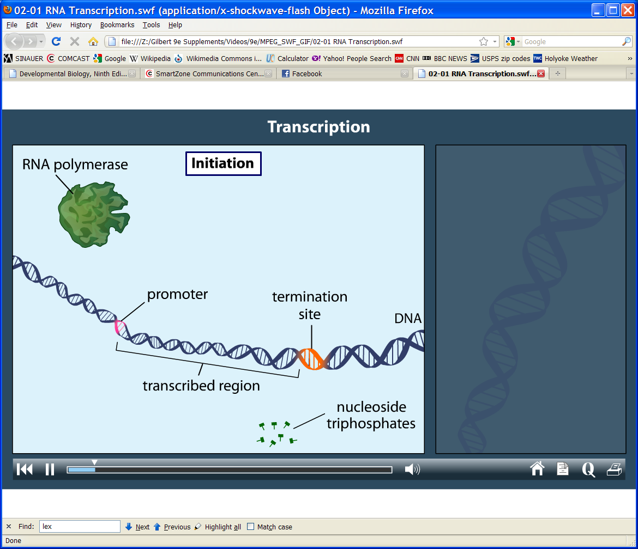
[02-01 RNA Transcription.swf]

2.1 RNA Transcription: The workhorse protein in the transcription process is, of course, RNA polymerase-specifically, RNA polymerase II for protein-coding genes. RNA polymerase II creates a complementary RNA strand from the code in a DNA template strand. However, RNA polymerase II is unable to bind to DNA and begin transcription on its own. It requires other proteins, called transcription factors, to come into play. For a gene to be expressed strongly, it may also need other proteins, such as regulators and activators to bind to DNA regulatory regions. (From the companion website to Sadava et al. 2011. Life: The Science of Biology, Ninth Edition. Sinauer Associates and W. H. Freeman.)
Textbook Figure Reference: 2.7

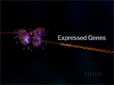
[02-02 MeCP2.mpg]

2.2 MeCP2: Methyl C-p-G binding protein 2 (MeCP2) regulates gene expression. For genes that are switched on, histone "tails" near the promoter region of the gene are acetylated, represented by white glowing balls. When these histones are acetylated the chromatin remains in an open configuration and gene transcription can take place. Alternatively, when DNA further upstream from the promoter region is methylated, (yellow spikes), MeCP2 protein can bind to that DNA region. MeCP2 recruits a protein complex made up of Sin3A and HDAC (histone deacetylase). HDAC removes the acetyl groups from the histone tails, causing the chromatin to change its conformation to a tightly wound form that is not accessible to transcription factors. In the absence of bound transcription factors, the gene is off. (Used with permission from the Howard Hughes Medical Institute, Copyright 2003.)
Textbook Figure Reference: 2.19

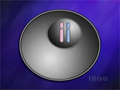
[02-03 X-Inactivation.mpg]

2.3 X-Inactivation: As the cells of an early female embryo divide, they randomly inactivate one of the two X chromosomes. By chance, some cells end up with an active X from their mother, and others the X chromosome they received from their father. As the embryo develops, the descendants of the early dividing cells will inherit the same paternal or maternal active X chromosomes and the specific gene forms on those chromosomes. On average, half of the cells express their maternal X and half express their paternal X. The result of X inactivation is a mosaicism of expressed X-linked traits. (Used with permission from the Howard Hughes Medical Institute, Copyright 2003.)
Textbook Figure Reference: 2.21

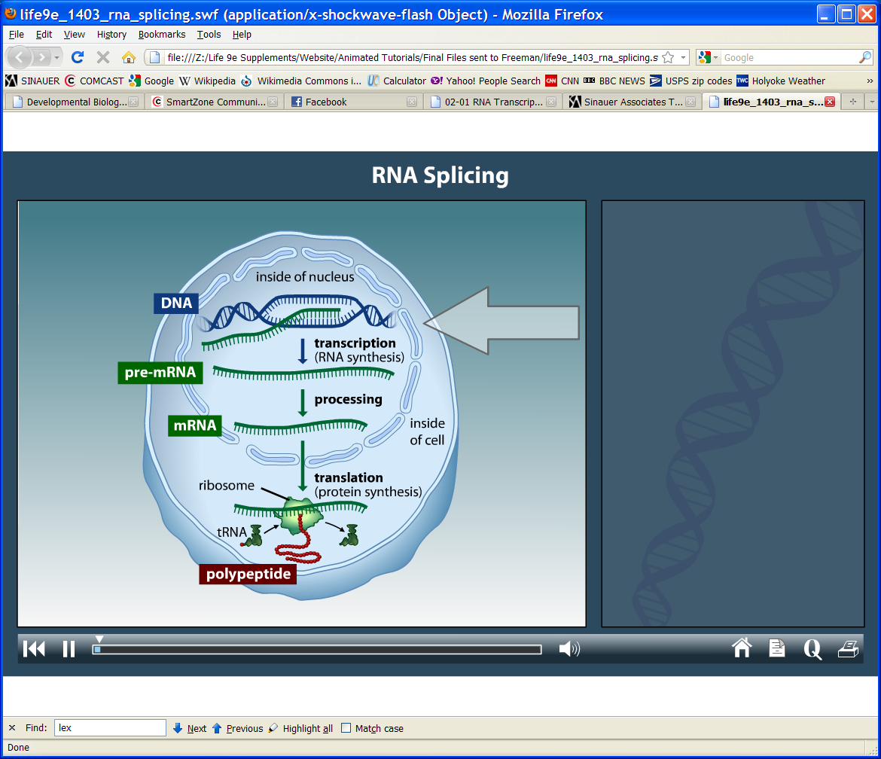
[02-04 RNA Splicing.swf]

2.4 RNA Splicing: The protein-coding genes of a eukaryote typically contain regions of DNA that serve no coding function. Noncoding regions, called introns, interrupt the coding regions, called exons. When the gene is transcribed into RNA, both the coding and noncoding regions are copied. However, a eukaryotic cell has a mechanism for removing the introns from RNA. In a process called RNS splicing, a newly transcribed RNA molecule is cut at the intron-exon boundaries, its introns are discarded, and its exons are joined together. RNA splicing occurs within the nucleus, before the RNA migrates to the cytoplasm. In the cytoplasm, ribosomes translate the RNA-now containing uninterrupted coding information-into protein. (From the companion website to Sadava et al. 2011. Life: The Science of Biology, Ninth Edition. Sinauer Associates and W. H. Freeman.)
Textbook Figure Reference: 2.24

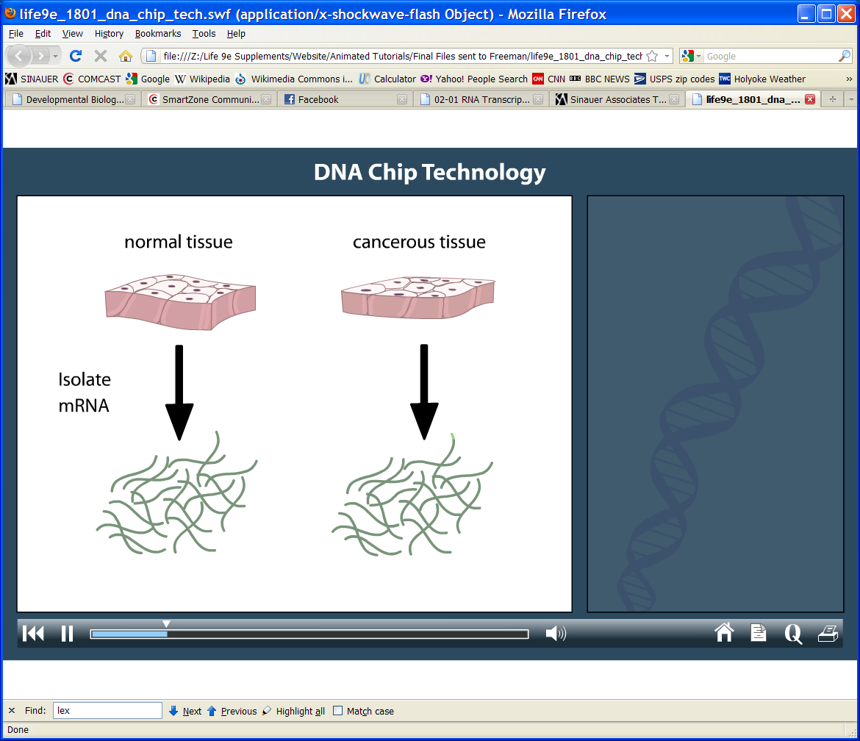
[02-05 DNA Chip.swf]

2.5 DNA Chip: A thumbnail-sized invention called a DNA chip is one of the most powerful new tools to emerge from genome studies. A DNA chip is made with thousands of nucleotide sequences attached to the chip in a grid pattern. The attached sequences act as probes and tell a researcher whether a test sample contains a particular DNA or RNA sequence. (From the companion website to Sadava et al. 2011. Life: The Science of Biology, Ninth Edition. Sinauer Associates and W. H. Freeman.)
See Website 2.4 Techniques of RNA Analysis

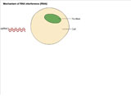
[02-06 RNAi 1.mpg]

2.6 Mechanism of RNA Interference (RNAi): How does RNAi work? Genetic and biochemical data indicate a possible two-step mechanism for RNA interference (RNAi): an initiation step and an effector step. (A) In the first step, input double-stranded (ds) RNA is processed into 21–23-nucleotide “guide sequences.” Whether they are single- or double-stranded remains an open question. An RNA amplification step (shaded box) has been suggested on the basis of the unusual properties of the interference phenomenon in whole animals, but this has not been reproduced definitively in vitro. (B) The guide RNAs are incorporated into a nuclease complex, called the RNA-induced silencing complex (RISC), which acts in the second effector step to destroy mRNAs that are recognized by the guide RNAs through base-pairing interactions. We also suggest the incorporation of an active mechanism to search for homologous mRNAs. (Endo, endonucleolytic nuclease; exo, exonucleolytic nuclease; recA, homology-searching activity related to E. coli recA.) (Hammond, S. M., A. A. Caudy, and G. J. Hannon. 2001. Post-transcriptional gene silencing by double-stranded RNA. Nature Reviews Genetics 2: 110–119.)
See Website 2.4 Techniques of RNA Analysis

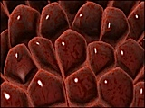
[02-07 RNAi 2.mpg]

2.7 RNA Interference: RNA interference (RNAi) is a form of posttranscriptional gene silencing in which double-stranded RNA induces degradation of the homologous endogenous transcripts, mimicking the effect of the reduction, or loss, of gene activity. (Nature Reviews Genetics, http://www.nature.com/focus/rnai/)
See Website 2.4 Techniques of RNA Analysis

Chapter 3. Cell-Cell Communication in Development

(Related Differential Expressions² Videos: Bonner Excerpt 2, Hay Excerpts 1–5, Steinberg Excerpts 1–5)

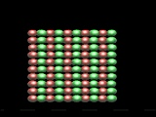
[03-01 Cell Sorting.mpg]

3.1 Cell Sorting: Computer simulation of the sorting of two cells types in an aggregate, due to differences in adhesion. The green “cells” are two times more adhesive than the red “cells.” (Courtesy of Eirikur Paulson.)
Textbook Figure Reference: 3.3

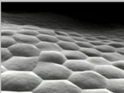
[03-02 Cadherin Synthesis.mpg]

3.2 Cadherin Biosynthesis: Cadherin synthesis and function is critical for cell-cell adhesion. (Courtesy of the RIKEN Center for Developmental Biology.)
Textbook Figure Reference: 3.5

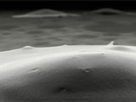
[03-03 Cadherin Function.mpg]

3.3 Cadherin Function at Neurulation: In some instances, different cadherin functions can cause changes in cell affinity and cause the separation of tissues. (Courtesy of the RIKEN Center for Developmental Biology.)
Textbook Figure Reference: 3.5

Chapter 4. Fertilization: Beginning a New Organism

(Related DevBio Laboratory: Vade Mecum³ Videos: 10, 11, 12, 13, 14, 15)

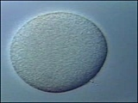
[04-01 Sea Urchin Fertilization.mpg]

4.1 Sea Urchin Fertilization: A single sperm fuses with the egg and triggers the elevation of a fertilization envelope. (Courtesy of Christian Sardet.)
Textbook Figure Reference: 4.8

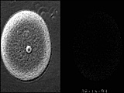
[04-02 Calcium Wave.mpg]

4.2 Calcium Wave in Sea Urchin Fertilization: Side-by-side comparison of the events of fertilization with the calcium release from the endoplasmic reticulum. Sperm entry is at the upper right-hand side. The fertilization envelope can be seen to arise at the site where calcium is being released. The calcium ion release is monitored by green dextran, which fluoresces in the presence of calcium ions. (From M. Terasaki. 1998. Mol. Cell Biol. 9: 1609–1612.)
Textbook Figure Reference: 4.21

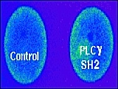
[04-03 Blocking IP3.mpg]

4.3 Blocking IP₃ Pathway: Using an inhibitor that prevents the production of IP₃ will prevent the release of calcium. The egg in the left is successfully fertilized and calcium release is normal; the egg at the right had an inhibitor of IP₃ synthesis added. Calcium release (as monitored by green dextran fluorescence) is significantly delayed. (After Carroll et al. 1999. Dev. Biol. 206: 232–247. Courtesy of Laurinda Jaffe.)
Textbook Figure Reference: 4.24

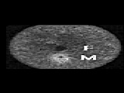
[04-04 Pronuclear Migration.mpg]

4.4 Pronuclear Migration in Sea Urchin Development: The sperm pronucleus can be identified by the high concentrations of microtubules and endoplasmic reticulum that accumulate near its centrosome. The egg and sperm pronuclei migrate towards each other and eventually fuse. (From M. Terasaki. 1998. Mol. Cell Biol. 9: 1609–1612.)
Textbook Figure Reference: 4.28

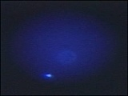
[04-05 Fusion of Nuclei.mpg]

4.5 Sea Urchin Sperm and Egg Nuclei Meet and Fuse: The nuclei of sperm and egg containing the male and female chromosomes meet using microtubules, and then fuse in the center of the egg. (Courtesy of Christian Sardet.)
Textbook Figure Reference: 4.28

Chapter 5. Early Development in Selected Invertebrates

(Related DevBio Laboratory: Vade Mecum³ Videos: 16, 17, 18, 19)

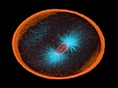
[05-01 SU First Cleavage.mpg]

5.1 Echinoderm First Cleavage: Cell division in 1-cell stage of the echinoderm Dendraster (a sand dollar). The actin is stained red; the tubulin is stained blue. DNA is stained orange-red with propidium iodide. (Courtesy of George von Dassow.)
Textbook Figure Reference: 5.2

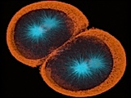
[05-02 SU Second Cleavage.mpg]

5.2 Echinoderm Second Cleavage: Cell division beginning in the 2-cell stage of the echinoderm Dendraster (a sand dollar). The actin is stained red; the tubulin is stained blue. DNA is stained orange-red with propidium iodide. (Courtesy of George von Dassow.)
Textbook Figure Reference: 5.2

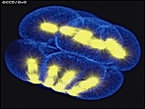
[05-03 Metaphase.mpg]

5.3 Spindles at Fourth (unequal) Cleavage in a Purple Sea Urchin, Strongylocentrotus: Projection of confocal Z-series through an 8-cell purple urchin embryo in metaphase, stained for tubulin (yellow) and actin (blue), animal pole up and vegetal pole down. Rendered using voxx 2 in maximum-intensity mode. (Courtesy of George von Dassow.)
Textbook Figure Reference: 5.6

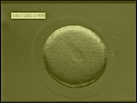
[05-04 Normal Sea Urchin.mpg]

5.4 Normal Sea Urchin Development: Normal sea urchin development from fertilization through blastula formation. (Filmed by Seth Ruffins and Charles Ettensohn. From Fink, R. 1991. A Dozen Eggs. Sinauer Associates.)
Textbook Figure Reference: 5.7

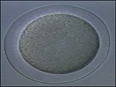
[05-05 Sea Urchin Blastula.mpg]

5.5 Sea Urchin Blastula: Fertilization causes the egg to become a zygote dividing rapidly (every 30–60 minutes) forming a hollow ball of 1,000 cells: the blastula, 5–7 hours after fertilization. (Courtesy of Christian Sardet.)
Textbook Figure Reference: 5.7

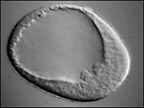
[05-06 Sea Urchin Gastrulation 1.mpg]

5.6 Sea Urchin: Ingression of Primary Mesenchyme Cells: This movie shows the sequence of ingression of primary mesenchyme cells in the sea urchin. Micromeres at the vegetal pole undergo the epithelial-mesenchymal transition by becoming motile, changing a number of adhesion components, then movement of the cells into the blastocoel. (McClay, D. R., J. M. Gross, R. Range, R. E. Peterson, and C. Bradham. 2004. Sea Urchin Gastrulation. In C. Stern (ed.), Gastrulation Cold Spring Harbor Laboratory Press.) (Used with permission.)
Textbook Figure Reference: 5.15

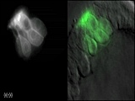
[05-07 Sea Urchin Gastrulation 2.mpg]

5.7 Sea Urchin: Ingression of GFP-Labeled Primary Mesenchyme Cells: This movie shows ingression of GFP-labeled PMCs. As can be seen, the cells elongate during the process of ingression and much of the cell body is inside the blastocoel before the trailing edge of the cell pulls away from the hyaline layer on the outside of the embryo. (McClay, D. R., J. M. Gross, R. Range, R. E. Peterson, and C. Bradham. 2004. Sea Urchin Gastrulation. In C. Stern (ed.), Gastrulation Cold Spring Harbor Laboratory Press.) (Used with permission.)
Textbook Figure Reference: 5.16

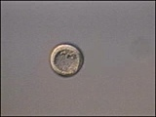
[05-08 Spicules.mpg]

5.8 Sea Urchin Larva Skeleton: A skeleton made of calcium crystals is secreted by small cells produced at the 16-cell stage producing mesenchyme cells inside the embryo. These cells form triradiate spicules which are birefringent in polarized light. (Courtesy of Christian Sardet.)
Textbook Figure Reference: 5.17

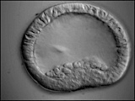
[05-09 Sea Urchin Gastrulation 3.mpg]

5.9 Sea Urchin: Invagination of Archenteron: This movie shows the first third of gastrulation. Beginning with a flattened vegetal plate, the first sign of invagination is a central inbending of the cells at the center of the vegetal plate. That primary invagination gradually extends to become deeper, and involve more cells of the vegetal plate. Much of this initial inbending is due to cell shape changes, and later in gastrulation convergent-extension occurs to further extend the length of the archenteron. (McClay, D. R., J. M. Gross, R. Range, R. E. Peterson, and C. Bradham. 2004. Sea Urchin Gastrulation. In C. Stern (ed.), Gastrulation Cold Spring Harbor Laboratory Press.) (Used with permission.)
Textbook Figure Reference: 5.19

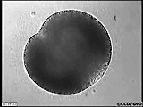
[05-10 Scaphopod First Cleavage.mpg]

5.10 Polar Lobe Formation in the Scaphopod Mollusc Pulsellum: First cleavage in the scaphopod Pulsellum. The embryo segregates a large fraction of the cytoplasm into the polar lobe, passing through a “trefoil” stage before the polar lobe contents are withdrawn into one of the two daughter cells. 360× time/water-immersion 25×/DIC (Courtesy of George von Dassow.)
Textbook Figure Reference: 5.28

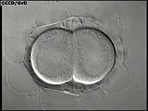
[05-11 Corella Development.mpg]

5.11 Development of the Ascidian Corella: Development through hatching in the ascidian (sea-squirt) Corella inflata. The embryo is surrounded by a chorion and follicle cell layer which it co-habits with many test cells; the movie begins at the 2-cell stage and ends just after hatching. Note the behavior of the test cells toward the end of the movie. 360× time/water-immersion 25×/DIC (Courtesy of Kristin Sherrard and George von Dassow.)
Textbook Figure Reference: 5.34


[05-12 Ascidian.mpg]

5.12 Ascidian Embryogenesis: After fertilization, the Styela clava embryo undergoes cytoplasmic rearrangements resulting in the formation of the pigmented yellow crescent. This special cytoplasm, called myoplasm, gives rise to tail muscle. Ascidian cleavage is bilateral, with the right and left halves of the embryo forming mirror images. First cleavage bisects the yellow crescent, and at the 4-cell stage the yellow cytoplasm is in the two posterior blastomeres. By the 32-cell stage, yellow cytoplasm is restricted to six dorso-posterior cells. Gastrulation is marked by a depression in the vegetal surface of the blastula, formed by the sinking in of the endoderm-the embryo becomes cup-shaped. Neurulation involves neural plate formation and notochord development. As the embryo elongates during the early tailbud stage, the yellow cytoplasm can be seen to form two lines running the length of the developing tail. The tadpole is formed 12 hours after fertilization and can be recognized by the large head and curved tail. The sequence compresses approximately 12 hr of development into 2 min., 13 sec. of video time, so events are speeded up 320 times. Egg diameter is 120 micrometers. After fertilization, the yellow crescent marks the future posterior side of the embryo. (Filmed by Ann Poznanski and Judith Venuti. From Fink, R. 1991. A Dozen Eggs. Sinauer Associates.)
Textbook Figure Reference: 5.36

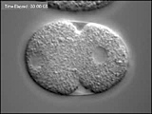
[05-13 Normal Development.mpg]

5.13 C. elegans: Normal Development: Rapid development of C. elegans from early cleavage to hatching (Courtesy of Bob Goldstein.)
Textbook Figure Reference: 5.42

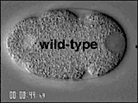
[05-14 CE First Division.mpg]

5.14 First Cell Cycle in C. elegans: Fertilization and first embryonic cell division, viewed by time-lapse DIC microscopy. (By Pierre Gönczy. Courtesy of Tony Hyman.)
Textbook Figure Reference: 5.42

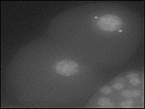
[05-15 Chromosomes.mpg]

5.15 Chromosomes during Fertilization: Chromosomes during fertilization and first cell division in C. elegans. (Desai et al. 2003. KNL-1 directs assembly of the microtubule-binding interface of the kinetochore in C. elegans. Genes Dev. 17 (19): 2421.) (Used with permission.)
Textbook Figure Reference: 5.42

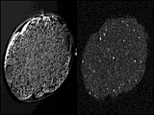
[05-16 P-Granule First Division.mpg]

5.16 P-Granule Migration in C. elegans: First Division: P-granules are initially distributed throughout the embryo, but then move posteriorly to be in the cell that can give rise to the germline. (Hird et al. 1996. Segregation of germ granules in living Caenorhabditis elegans embryos: cell-type-specific mechanisms for cytoplasmic localization. Development 122: 1302–1312.) (Courtesy of Susan Strome.)
Textbook Figure Reference: 5.44

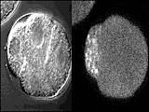
[05-17 P-Granule Third Division.mpg]

5.17 P-Granule Migration in C. elegans: Third Division: P-granules in the P2 cell are initially found around the nucleus. They are deposited on one pole of the mitotic spindle and end up in the P3 blastomere. (Hird et al. 1996. Segregation of germ granules in living Caenorhabditis elegans embryos: cell-type-specific mechanisms for cytoplasmic localization. Development 122: 1302–1312.) (Courtesy of Susan Strome.)
Textbook Figure Reference: 5.44

Chapter 6. The Genetics of Axis Specification in Drosophila

(Related DevBio Laboratory: Vade Mecum³ Videos: 20, 21, 22, 23, 24, 25, 26, 27, 28, 29, 30, 31, 32)
(Related Differential Expressions² Videos: Gehring Excerpts 1–3)

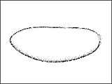
[06-01 Dros Wild Gastrulation.mpg]

6.1 Drosophila Wild Type Gastrulation: Drosophila gastrulation, lateral view, wild type, showing: pole cell migration, germ band extension, segmentation, germ band shortening. (Courtesy of Thom Kaufman.)
Textbook Figure Reference: 6.4

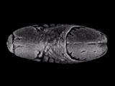
[06-02 Dros Gastrulation Dorsal.mpg]

6.2 Drosophila Gastrulation (Dorsal): Drosophila gastrulation shown from the dorsal view, showing: pole cell migration, germ band extension, segmentation, germ band shortening, dorsal closure. (Courtesy of Thom Kaufman.)
Textbook Figure Reference: 6.4

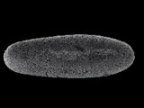
[06-03 Dros Gastrulation Ventral.mpg]

6.3 Drosophila Gastrulation (Ventral): Drosophila gastrulation, shown from the ventral view, focusing on mesoderm invagination. (Courtesy of Thom Kaufman.)
Textbook Figure Reference: 6.4

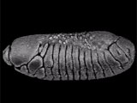
[06-04 Dros Gastrulation Lateral.mpg]

6.4 Drosophila Gastrulation (Lateral): Drosophila gastrulation, lateral view of wild-type embryos. Showing: pole cell migration, germ band extension, segmentation, germ band shortening. (Courtesy of Thom Kaufman.)
Textbook Figure Reference: 6.4, 16.11

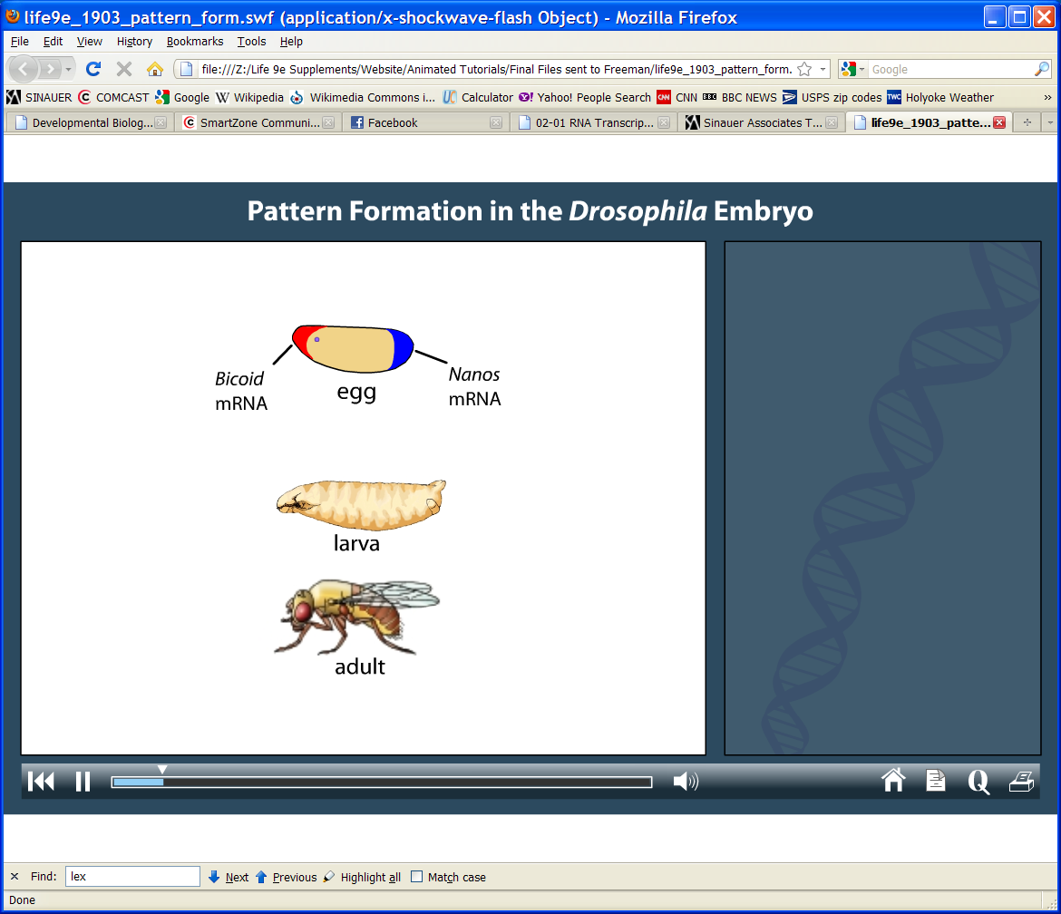
[06-05 Dros Segments.swf]

6.5 Drosophila Segment Identity: The fruit fly Drosophila melanogaster, like other arthropods, is composed of numerous body segments. The fly has several fused head segments, three thoracic segments, eight abdominal segments, and a terminal segment at the end of the abdomen. In the adult fly these segments are clearly unique, in that a head segment has antennae, but a thoracic segment has legs instead, and an abdominal segment has neither. Before the fly emerges as an adult with wings, its segments may appear nearly identical. However, during early embryonic development, the segments of the embryo adopt their own identities. Genes, from the mother and from the developing embryo, control this process of pattern formation. (From the companion website to Sadava et al. 2011. Life: The Science of Biology, Ninth Edition. Sinauer Associates and W. H. Freeman.)
Textbook Figure Reference: 6.17

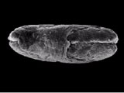
[06-06 Dros BCD Gastrulation.mpg]

6.6 Drosophila bicoid Mutant Gastrulation: Drosophila gastrulation, dorsal view, bicoid (bcd) mutant, showing: pole cell migration, germ band extension, segmentation, germ band shortening, dorsal closure. (Courtesy of Thom Kaufman.)
Textbook Figure Reference: 6.21, 6.7, 6.4

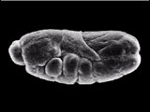
[06-07 Dros FTZ Gastrulation.mpg]

6.7 Drosophila ftz Mutant Gastrulation: Drosophila gastrulation, lateral view, fushi tarazu (ftz) mutant, showing: pole cell migration, germ band extension, abnormal segmentation, germ band shortening. (Courtesy of Thom Kaufman.)
Textbook Figure Reference: 6.32, 6.4

Chapter 7. Amphibians and Fish: Early Development and Axis Formation

(Related DevBio Laboratory: Vade Mecum³ Videos: 16, 17, 18, 19, 38, 39, 40, 41, 42, 43, 44, 45, 46, 47, 48, 49)
(Related Differential Expressions² Videos: Saxén Excerpts 1–2)

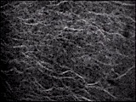
[07-01 Cortical Rotation 1.mpg]

7.1 Cortical Rotation in Xenopus: The cortical rotation is apparent as coordinated translocation of vegetal yolk platelets relative to the immobilized cortex. Microtubules are well aligned and although microtubule waves move in the same direction as the yolk, many microtubule segments show little or no net translocation. (Courtesy of Evelyn Holliston.)
Textbook Figure Reference: 7.1

[07-02 Xenopus Fatemap.mpg]

7.2 Xenopus Fate Map (External): Aqua is epidermal ectoderm; blue is neural ectoderm; red is notochord; orange is notochordal mesoderm; yellow is endoderm. (Courtesy of Ali Brivanlou.)
Textbook Figure Reference: 7.5

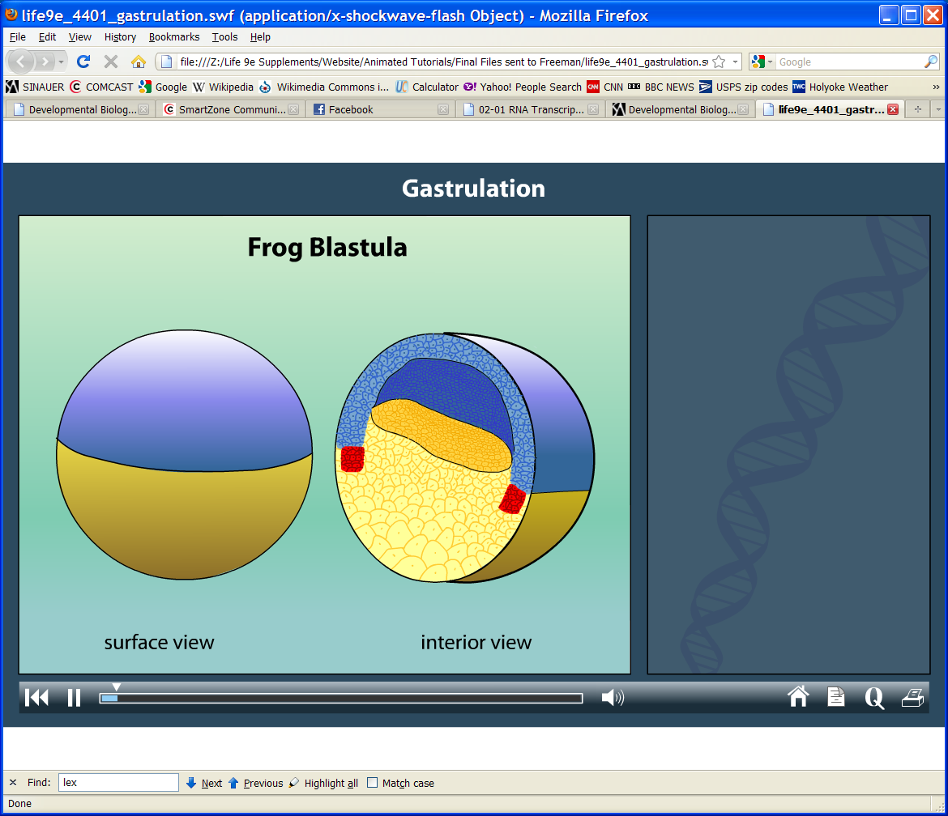
[07-03 Xenopus Gastrulation.swf]

7.3 Xenopus Gastrulation: In gastrulation, the blastula rearranges, with sheets of blastomeres from the outside of the embryo entering the embryo’s interior. Cells move into contact with new cells, allowing unique intercellular communications that lead to cell determination and differentiation. By the end of gastrulation, three embryonic germ layers—endoderm, mesoderm, and ectoderm—take their positions in the embryo. These layers ultimately give rise to specific tissues and organs that make up the adult body plan. (From the companion website to Sadava et al. 2011. Life: The Science of Biology, Ninth Edition. Sinauer Associates and W. H. Freeman.)
Textbook Figure Reference: 7.6

[07-04 Xenopus Gastrulation 1.mpg]

7.4 Gastrulation and Neurulation in Xenopus: Xenopus laevis vegetal view of gastrulation and neurulation: (15.0 hours elapsed, 48 minutes/second). The movie shows gastrulation and neurulation viewed from the vegetal pole, the future dorsal side at the top. Note the dramatic involution of the IMZ, which forms an annulus or ring of cells surrounding the large central disc of vegetal endodermis cells at the center of the vegetal pole. The bottle cells, marking the initiation of involution, have already formed mid-dorsally as indicated by the black pigment accumulation. Note that the dorsal IMZ, region above these bottle cells rolls over the blastopore lip and disappears inside; subsequently this involution proceeds laterally, on both sides, and finally at the midventral line. As the IMZ involutes, it also extends posteriorly and converges around the circumference of the blastopore, but does so inside, out of sight. As it does so, note that the posterior neural tissue likewise converges and extends in the same fashion, on the outside; together these convergent extension movements squeeze the blastopore shut and simultaneously elongate the anterior-posterior axis of the embryo, pushing the future tail away from the head. Note that the converging and extending neural plate simultaneously rolls up to form a neural tube. (Keller, R. and D. Shook. 2004. Gastrulation in Amphibians. In C. Stern (ed.), Gastrulation Cold Spring Harbor Laboratory Press.) (Used with permission.)
Textbook Figure Reference: 7.10

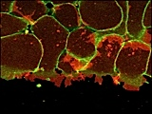
[07-05 Xenopus Gastrulation 2.mpg]

7.5 Mesendodermal Cells Leading Migration along a Fibronectin-Coated Substrate: Xenopus laevis marginal zone explant: (60 minutes elapsed). A two-plane, time-lapse confocal movie shows migration of mesendodermal cells on a fibronectin substrate in culture. The red plane is at the level of the substrate and the green plane is 5 microns deep into the tissue. Note that the posterior cells (top of image) underlap the more anterior ones from behind. The cells are labeled with a plasma membrane targeted GFP. (Keller, R. and D. Shook. 2004. Gastrulation in Amphibians. In C. Stern (ed.), Gastrulation Cold Spring Harbor Laboratory Press.) (Used with permission.)
Textbook Figure Reference: 7.12

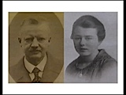
[07-06 Spemann.mpg]

7.6 Spemann-Mangold Experiment: The Spemann-Mangold experiment through which the “organizer” was found is replicated here by Eddy De Robertis. (Courtesy of E. De Robertis.)
Textbook Figure Reference: 7.17

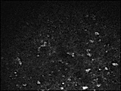
[07-07 Cortical Rotation 2.mpg]

7.7 Cortical Rotation 2: GBP-GFP particles are shown translocating during peak cortical rotation. Translocating GBP-GFP particles move quickly from top to bottom in the field of view, while core rotation moves in the opposite direction from bottom to top. A population of GBP-GFP particles can be observed to move passively from bottom to top, accompanying the rotation of the core. Movie frames were captured at 2.3 second intervals. (Courtesy of David Kimelman.)
Textbook Figure Reference: 7.21

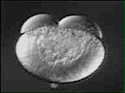
[07-08 Zebrafish Development.mpg]

7.8 Zebrafish Development: Zebrafish development for 24 h from early cleavage to larva. (Karlstrom, R. and D. Kane. 1996. A flipbook of zebrafish embryogenesis. Development 123: 461.) (Used with permission.)
Textbook Figure Reference: 7.37, 7.40

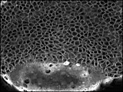
[07-09 Zebrafish Gastrulation 1.mpg]

7.9 Convergent Extension: Dorsal Mesodermal Cells Form the Notochord: Four-hour time-lapse recording of an intact Bodipy-ceramide labeled zebrafish embryo, beginning at midgastrula stage (7.3 hours postfertilization). The notochord-somite boundaries become prominent about halfway through the movie, and following them clearly reveals the narrowing (convergence) and elongation (extension) of the domain. (Glickman, N. S., C. B. Kimmel, M. A. Jones, and R. J. Adams. 2003. Shaping the zebrafish notochord. Development 130: 873–887.) (Used with permission.)
Textbook Figure Reference: 7.44

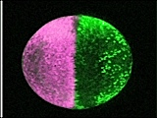
[07-10 Zebrafish Neurulation.mpg]

7.10 Cell Movements during Zebrafish Neurulation: Zebrafish embryo is labeled such that the left side is magenta and the right side is green at 10 hours post-fertilization. As neurulation occurs, cells can be seen migrating to the dorsal midline. As the neural tube forms, some cells can be seen crossing over from one side to the other. Dorsal view. Anterior is to the top. Actual duration: about 10 hours. (Courtesy of K. Hatta.)
Textbook Figure Reference: 7.44

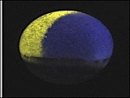
[07-11 Zebrafish Cell Movements.mpg]

7.11 Convergent and Extension Cell Movements during Zebrafish Development, Seen from the Dorsal Side: The ventral half of the gastrula (6 hours post-fertilization, including cells destined to become non-neural ectoderm) is pseudocolored yellow. The dorsal half (including cells destined to become central nervous system) is pseudocolored blue. Some of yellow cells first accumulate around the blue neural plate, separate, aggregate and form various placodal organs including nose, lens, otic vesicles, trigeminal and other sensory ganglia. Anterior is to the top. Actual duration: about 15 hours. (Courtesy of K. Hatta.)
Textbook Figure Reference: 7.44

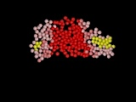
[07-12 Zebrafish Gastrulation 2.mpg]

7.12 Cells Reorganize during Notochord Convergence and Extension: The cells were tracked from time-lapse data shown in earlier figure. The prospective notochord (red) is present as a single domain long before the notochord-somite boundaries can be recognized, and remains coherent despite massive cellular rearrangement across the entire field. (Glickman, N. S., C. B. Kimmel, M. A. Jones, and R. J. Adams. 2003. Shaping the zebrafish notochord. Development 130: 873–887.) (Used with permission.)
Textbook Figure Reference: 7.44

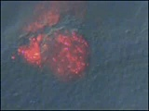
[07-13 Cilia in KV.mpg]

7.13 Motile Cilia in Kupffer’s Vesicle: Fluorescent beads (red) were injected into KV at the 6-somite stage and analyzed until the 12-somite stage. These beads showed a net counterclockwise flow inside KV. This directional flow is particularly apparent when the movie is sped up. This movie is an overlay of DIC and fluorescent images. Dorsal view with the notochord towards the right. (Essner, J. J., J. D. Amack, M. K. Nyholm, E. B. Harris, and H. J. Yost. 2005. Kupffer’s vesicle is a ciliated organ of asymmetry in the zebrafish embryo that initiates left-right development of the brain, heart and gut. Development 132: 1247–1260.) (Used with permission.)
Textbook Figure Reference: 7.49

Chapter 8. Birds and Mammals: Early Development and Axis Formation

(Related DevBio Laboratory: Vade Mecum³ Videos: 33, 34, 35, 51)

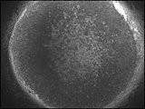
[08-01 Chick Gastrulation.mpg]

8.1 Chick Primitive Streak Formation: Time-lapse movie of a chick embryo developing from stage XII/XIII to stage 3+ (when the middle layer starts to emerge from the primitive streak). The posterior edge of the blastodisc lies towards the left. (Stern, C. D. 2004. Gastrulation in the Chick. In C. D. Stern (ed.), Gastrulation Cold Spring Harbor Laboratory Press.) (Used with permission.) (Sequence acquired by Dr. Cheng Cui in Professor C.J. Weijerâ’s laboratory, included here with kind permission of these colleagues.)
Textbook Figure Reference: 8.2

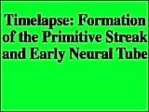
[08-02 Primitive Streak Migration 1.mpg]

8.2 Primitive Streak Migration: Primitive streak formation and regression. Starting at the right-hand side of the picture, the primitive streak begins to form. It converges and extends in the midline of the area pellucida and then begins to regress. The head process and somites begin forming.
Textbook Figure Reference: 8.3

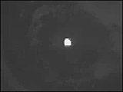
[08-03 Primitive Streak Migration 2.mpg]

8.3 Migration of Cells through the Anterior Primitive Streak: Anterior primitive streak cells were transplanted from an EGFP-labeled embryo into an unlabeled embryo. These cells form paraxial (somitic) mesoderm. (Yang, X., D. Dormann, A. E. Münsterberg, and C. J. Weijer. 2002. Cell movement patterns during gastrulation in the chick are controlled by positive and negative chemotaxis mediated by FGF4 and FGF8. Developmental Cell 3: 425–437.) (Used with permission.)
Textbook Figure Reference: 8.3, 8.4

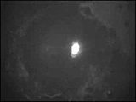
[08-04 Primitive Streak Migration 3.mpg]

8.4 Migration of Cells through the Middle Primitive Streak: Middle primitive streak cells were transplanted from an EGFP-labeled embryo into an unlabeled embryo. These cells contribute to the intermediate and lateral plate mesoderm. (Yang, X., D. Dormann, A. E. Münsterberg, and C. J. Weijer. 2002. Cell movement patterns during gastrulation in the chick are controlled by positive and negative chemotaxis mediated by FGF4 and FGF8. Developmental Cell 3: 425–437.) (Used with permission.)
Textbook Figure Reference: 8.3, 8.4

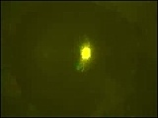
[08-05 Primitive Streak Migration 3 (Tracks).mpg]

8.5 Migration of Cells through the Middle Primitive Streak (Tracks): Middle primitive streak cells were transplanted from an EGFP-labeled embryo into an unlabeled embryo. These cells contribute to the intermediate and lateral plate mesoderm. The movie shows the tracks taken by these cells as they travel. (Yang, X., D. Dormann, A. E. Münsterberg, and C. J. Weijer. 2002. Cell movement patterns during gastrulation in the chick are controlled by positive and negative chemotaxis mediated by FGF4 and FGF8. Developmental Cell 3: 425-437.) (Used with permission.)
Textbook Figure Reference: 8.3, 8.4

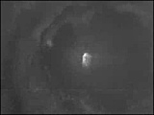
[08-06 Primitive Streak Migration 4.mpg]

8.6 Migration of Cells through the Hensen’s Node: Hensen’s nodes were transplanted from an EGFP-labeled embryo into an unlabeled embryo. Many cells stay in the node, while other cells are seen to contribute to the notochord. (Yang, X., D. Dormann, A. E. Münsterberg, and C. J. Weijer. 2002. Cell movement patterns during gastrulation in the chick are controlled by positive and negative chemotaxis mediated by FGF4 and FGF8. Developmental Cell 3: 425–437.) (Used with permission.)
Textbook Figure Reference: 8.7

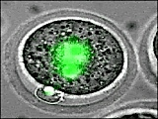
[08-07 GFP-Histone H2B.mpg]

8.7 Mouse Eggs Expressing GFP-Histone H2B: Sperm and egg pronuclear apposition and the first cell division in a mouse embryo. The nuclei are stained green with a GFP-labeled histone H2B. The sperm entry site was marked with a red fluorescent bead. Time Lapse DIC/Fluorescence Images. (Courtesy of K. Piotrowska and Magdalina Zernicka-Goetz.)
Textbook Figure Reference: 8.15


[08-08 Mouse Development 1.mpg]

8.8 Early Mouse Development 1: The early events in mouse development, from cleavage to blastocoel formation. (Filmed by Ann Sutherland. From Fink, R. 1991. A Dozen Eggs. Sinauer Associates.)
Textbook Figure Reference: 8.17


[08-09 Mouse Development 2.mpg]

8.9 Early Mouse Development 2: Mouse development through hatching blastocyst. (Filmed by Roger Pedersen. From Fink, R. 1991. A Dozen Eggs. Sinauer Associates.)
Textbook Figure Reference: 8.17, 8.20

Chapter 9. The Emergence of the Ectoderm: Central Nervous System and Epidermis

(Related DevBio Laboratory: Vade Mecum³ Videos: 33, 34, 35)
(Related Differential Expressions² Videos: Hay Excerpt 3, Le Douarin Excerpts 1–2)


[09-01 Frog Serial Sections 1.mpg]

9.1 Frog Serial Sections 1: “Flying through” the sections of a 0.4 mm frog embryo allows one to see the basic structure of the tadpole.
Textbook Figure Reference: 9.3

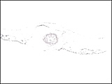
[09-02 Chick 56hr.mpg]

9.2 Chick Serial Sections 6: “Flying through” the serial sections of a 56h chick embryo allows one to appreciate the basic structure of the three germ layers and incipient heart and brain. It also allows one to see the secondary neurulation occurring at the caudal region. (Courtesy of Laurie Iten.)
Textbook Figure Reference: 9.4, 9.8

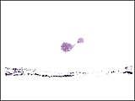
[09-03 Chick 24hr.mpg]

9.3 Chick Serial Sections 24h: “Flying through” the serial sections of a 24h chick embryo. (Courtesy of Laurie Iten.)
Textbook Figure Reference: 9.4


[09-04 Chick 33h.mpg]

9.4 Chick Serial Sections 33h: “Flying through” the serial sections of a 33h embryo allows one to appreciate what a difference 9 hours makes in the early development of the chick. (Courtesy of Laurie Iten.)
Textbook Figure Reference: 9.4

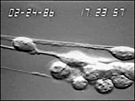
[09-05 Granule Cell Migration 1.mpg]

9.5 Granule Cells Migrating on Glial Processes 1: Migration of cerebellar granule cells along astroglial fibers in vitro. Immature granule neurons, purified from early postnatal cerebellum, extend a specialized, migratory process along the underlying glial fiber. In this sequence, a neuron moves along a glial fiber at approximately 50 microns/h. As the neuron moves, lamellipodia and filopodia extend and retract along the length of the migratory process, enwrapping the glial guide. The neuron forms an interstitial junction along the length of the cell soma, which is released as the cell begins to move. (From Hatten and Edmonson 1987.)
Textbook Figure Reference: 9.22

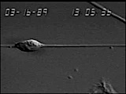
[09-06 Granule Cell Migration 2.mpg]

9.6 Granule Cells Migrating on Glial Processes 2: Migration of neurons from one brain region along astroglial fibers from another. Immature granule neurons, purified from the early postnatal cerebellar cortex, migrate along the processes of glial cells isolated from hippocampus. The dynamics of movement of neurons from one region closely parallel those of neurons from other regions, suggesting that the mode of migration along glial fibers is stereotyped. The movement of the neuron is saltatory. The leading process extends along the glial fiber, after which the cell soma appears to contract and then extend just prior to release of the adhesion junction underneath the cell soma. This sequence is repeated, as the neuron progresses along the glial fiber. (Courtesy of Mary Hatten.)
Textbook Figure Reference: 9.22

Chapter 10. Neural Crest Cells and Axonal Specificity

(Related Differential Expressions² Videos: Le Douarin Excerpts 1–2)

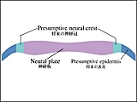
[10-01 Avian Neurulation.mpg]

10.1 Avian Neurulation: This animation of primary neurulation in the chick embryo allows one to follow the movements that give rise to the neural tube and neural crest. (Courtesy of Yoshiko Takahashi.)
Textbook Figure Reference: 10.1, 10.3


[10-02 LeDouarin.mpg]

10.2 Nicole Le Douarin’s Chick-Quail Experiments: The migration of neural crest cells to form avian pigment cells is shown by the transplantation of crest cells between chick and quail embryos. (From Tyler, Kozlowski, and Gilbert. 2006. Differential Expressions². Sinauer Associates.) (Courtesy of Mary Tyler and Nicole Le Douarin.)
Textbook Figure Reference: 10.9

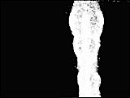
[10-03 Chick Neural Tube.mpg]

10.3 Chick Neural Tube: In this movie, the chick neural tube, which will differentiate into the brain and spinal cord, has been filled with a fluorescent dye to label neural crest cells which migrate into the surrounding unlabeled tissue to form the peripheral nervous system. Notice how streams of migrating cells form a spatial pattern. The embryo was incubated for about 40 hrs prior to filming and the total length of the movie represents 12 hrs with 4 minutes in between each image. The upper cells are formed in the hindbrain and migrate to the pharyngeal arches. (Courtesy of P. M. Kulesa.)
Textbook Figure Reference: 10.10, 10.5

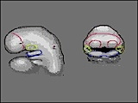
[10-04 Human Face.mpg]

10.4 Human Facial Development: The development of the face. The olfactory (nasal) placodes are outlined in red and are surrounded by the frontonasal process (outlined in pink), that facial mesenchyme produced from the neural crest. The mandibular prominence (swelling) of the first pharyngeal arch is shown in blue, while the maxillary swelling is outlined in yellow. Below the first arch are the second and third arches. During the fourth week of human development, the eye can be seen at the lateral edges of the face, and the otic pit is invaginating to form the otic vesicle. The eye becomes located frontally during the sixth week. The nasal pit will form and be surrounded by the lateral and medial nasal prominences that originate in the frontonasal process. The medial nasal prominences fuse to form the bridge of the nose, while the lateral nasal prominences form the sides. The nostrils are formed by the nasal pits. (From Lash, J. 1998. Interactive Embryology. Sinauer Associates.)
Textbook Figure Reference: 10.10

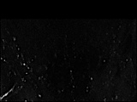
[10-05 Growth Cone Migration 1.mpg]

10.5 Growth Cone Migration: A growth cone migrates across the ventral forebrain. A DiI-labeled retinal ganglion cell (RGC) growth cone in a live zebrafish embryo at approximately 30 hours post-fertilization. A series of optical sections through the growth cone and its trailing axon are imaged every 3 minutes. The z-series at each time point is projected into two dimensions and the resulting images are combined into time-lapse movies such as those seen below. (Courtesy of Lara Hutson.)
Textbook Figure Reference: 10.22

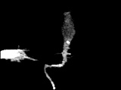
[10-06 Mauthner Growth Cone.mpg]

10.6 Mauthner Growth Cone and Primary Motor Neurons: Simultaneous two-photon imaging of the Mauthner growth cone and primary motor neurons. The video sequence shows maximum-intensity projections from a representative time-lapse sequence during which an M-cell growth cone migrated past a CaP motor neuron. The growth cone was highly active and transiently interacted with the CaP cell, one of its synaptic partners. The growth cone moved past the CaP cell without collapsing, stalling, or significantly altering its morphology. (Jontes, J. D., J. Buchanan, and S. J. Smith. 2000. Growth cone and dendrite dynamics in zebrafish embryos: early events in synaptogenesis imaged in vivo. Nat Neurosci. 3: 231–237.) (Used with permission.)
Textbook Figure Reference: 10.22

Chapter 11. Paraxial and Intermediate Mesoderm

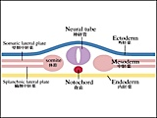
[11-01 Coelom Formation.mpg]

11.1 Coelom Formation: The formation of the coelom and the expansion of the mesoderm readily grasped by animations. (Courtesy of Yoshiko Takahashi.)
Textbook Figure Reference: 11.1


[11-02 Chick 48hr.mpg]

11.2 Chick Serial Sections 48h: “Flying through” serial sections of a 48h chick embryo allows one to see how the mesoderm has formed. (Courtesy of Laurie Iten.)
Textbook Figure Reference: 11.2

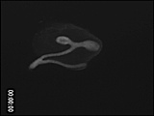
[11-03 Kidney Branching.mpg]

11.3 Kidney Branching: Branching of the mouse ureteric bud. The ureteric bud and the associated mensenchyme can be isolated from the embryonic mouse and cultured in a Petri dish. These cultured organ rudiments can then be observed under the microscope. In these movies, the ureteric bud is made to express GFP, which fluoresces green. (Courtesy of F. Costantini.)
Textbook Figure Reference: 11.26

Chapter 12. Lateral Plate Mesoderm and the Endoderm

(Related DevBio Laboratory: Vade Mecum³ Videos: 33, 34, 35)

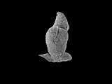
[12-01 Heart Looping.mpg]

12.1 Heart Looping: The looping of the chick heart is a complex orchestration of events, eventually positioning the atria atop the ventricles. (Courtesy of Bianca Hogers and Adriana Gittenberger-de Groot.)
Textbook Figure Reference: 12.8

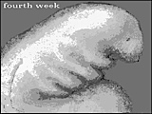
[12-02 Human Gastro.mpg]

12.2 Human Pharyngeal Pouches: The branchial system consisting of internal pharyngeal pouches and corresponding external clefts. The tissue between the two clefts is the “arch.” The movie zooms in on the pharyngeal (branchial) arches from inside the developing pharynx. Arch 1 is pink; arch 2 is green, arch 3 is aqua, arch 4 is blue, and arch 6 is yellow. The pouches form at the junction of the arches. The two swellings in the floor tissue of the first pharyngeal arches are the lingual swellings that form the anterior portion of the tongue. A swelling in the floor between the second pharyngeal arches produces the thyroid diverticulum. This tissue will migrate posteriorly as it develops. The floor of the third and fourth arches contains tissue that becomes the posterior portion of the tongue. Most posteriorly, in the sixth arch floor tissue, is the region that will invaginate to form the laryngotracheal groove, the tube that generates the larynx, trachea, and lung. The first pharyngeal pouch becomes the eustachian tube and the middle ear. The second pharyngeal pouch produces the tonsils. The third pouch forms the some of the parathyroid glands and thymus. The fourth pouch forms some of the parathyroid glands. The epiglottis will form from the endoderm and mesoderm at the posterior end of the fourth arch, as the thymus buds off. The parathyroid glands also bud off from adjacent fourth arch tissue. (From Lash, J. 1998. Interactive Embryology. Sinauer Associates.)
Textbook Figure Reference: 12.27

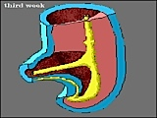
[12-03 Human Branchial.mpg]

12.3 Human Gastrointestinal Development: At the third week, the human gastrointestinal system has an anterior foregut with rudiments for the pancreas and liver/gallbladder. The midgut grows rapidly and will split to form the umbilicus (drawing the mesenteries with it). The vitelline duct (yolk stalk) branches from the midgut and connects to the remnant of the yolk sac. The rotation of the gut is shown here both diagrammatically and by arrows. The hindgut ends at the cloaca with the cloacal (proctodeal) membrane. The allantois, which originates from the roof of the yolk sac, is mostly inactive in humans. It contributes some endodermal lining to the bladder. The gastrointestinal mesoderm is encased in mesenteric mesoderm. The spleen will form from condensing mesoderm as muscles form around the stomach and intestines. (From Lash, J. 1998. Interactive Embryology. Sinauer Associates.)
Textbook Figure Reference: 12.28

Chapter 13. Development of the Tetrapod Limb

(Related Differential Expressions² Videos: Saunders Excerpts 1–5)

Chapter 14. Sex Determination

There are no videos for Chapter 14.

Chapter 15. Postembryonic Development: Metamorphosis, Regeneration, and Aging

(Related DevBio Laboratory: Vade Mecum³ Videos: 29, 30, 31, 32, 36, 37, 40)

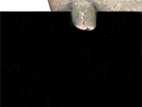
[15-01 Limb Regeneration.gif]

15.1 Amphibian Limb Regeneration: This time-lapse sequence shows the stages of newt limb regeneration. The surgical amputation was at the level of the humerus. The pictures show the wound healing, de-differentiation, blastema, and re-differentiation stages of regeneration. Total time shown is approximately 20–25 days. (Courtesy of Susan Bryant.)
Textbook Figure Reference: 15.19

Chapter 16. The Saga of the Germ Line

(Related DevBio Laboratory: Vade Mecum³ Videos: 10, 24, 25, 26, 27)

Chapter 17. Medical Aspects of Developmental Biology

(Related DevBio Laboratory: Vade Mecum³ Videos: 50, 51)
(Related Differential Expressions² Videos: Lash Excerpt 1)

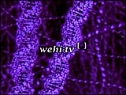
[17-01 Angiogenesis.mpg]

17.1 Tumor-Induced Angiogenesis: A tumor consists of cells that are dividing at an abnormally high rate, crowding surrounding healthy cells and competing for resources. Tumor growth typically proceeds in 3 dimensions, pushing out from the surrounding normal tissue and growing to become visible to the naked eye. A tumor must recruit blood vessels from the surrounding tissue to grow much bigger than 1 mm across. (Copyright 2003 The Walter & Eliza Hall Institute.) (Used with permission.)
Textbook Figure Reference: 17.22

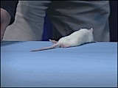
[17-02 Stem Cell Therapy 1.mpg]

17.2 Stem Cell Therapy (Before): Rats were experimentally induced to get the equivalent of ALS (amyotrophic lateral sclerosis; Lou Gehrig’s disease). This caused paralysis of their hindlimbs. (Kerr, D. A., J. Llado, M. J. Shamblott, N. J. Maragakis, D. N. Irani, T. O. Crawford, C. Krishnan, S. Dike, J. D. Gearhart, and J. D. Rothstein. 2003. Human embryonic germ cell derivatives facilitate motor recovery of rats with diffuse motor neuron injury. J Neurosci. 23: 5131–5140.) (Courtesy of John Gearhart.)
Textbook Figure Reference: 17.26

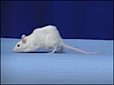
[17-03 Stem Cell Therapy 2.mpg]

17.3 Stem Cell Therapy (After): Rats with experimentally induced ALS paralysis were injected into the spinal cord with human stem cells. After three months, they started walking again. (Kerr, D. A., J. Llado, M. J. Shamblott, N. J. Maragakis, D. N. Irani, T. O. Crawford, C. Krishnan, S. Dike, J. D. Gearhart, and J. D. Rothstein. 2003. Human embryonic germ cell derivatives facilitate motor recovery of rats with diffuse motor neuron injury. J Neurosci. 23: 5131–5140.) (Courtesy of John Gearhart.)
Textbook Figure Reference: 17.26

Chapter 18. Developmental Plasticity and Symbiosis

(Related DevBio Laboratory: Vade Mecum³ Videos: 7, 8, 9, 30)
(Related Differential Expressions² Videos: Bonner Excerpts 1–3)


[18-01 Slime Mold 1 Amoebae.mpg]

18.1 Slime Mold Morphogenesis 1, Amoebae: Sequences showing the life cycle of Dictyostelium discoideum. Events are shown at 120 times normal speed. At room temperature conditions, the entire life cycle from spore-amoeba-aggregate-pseudoplasmodium-fruiting body takes about 3–4 days. Individual amoebae are about 10–15 micrometers in diameter. Migrating slugs (pseudoplasmodia) are on the order of 1 millimeter in length. A mature fruiting body is approximately 2 millimeters tall.

Amoebae: This first sequence shows migration of individual amoebae. (Filmed by John Bonner. From Fink, R. 1991. A Dozen Eggs. Sinauer Associates.)
Textbook Figure Reference: 18.13

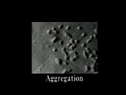
[18-02 Slime Mold 2 Aggregation.mpg]

18.2 Slime Mold Morphogenesis 2, Aggregation: Sequences showing the life cycle of Dictyostelium discoideum. Events are shown at 120 times normal speed. At room temperature conditions, the entire life cycle from spore-amoeba-aggregate-pseudoplasmodium-fruiting body takes about 3–4 days. Individual amoebae are about 10–15 micrometers in diameter. Migrating slugs (pseudoplasmodia) are on the order of 1 millimeter in length. A mature fruiting body is approximately 2 millimeters tall.

Aggregation: These three sequences show aggregation—the cellular response to starvation. As individual amoebae emit what is now known to be cAMP, a chemotactic wave of signaling is transmitted through the population, and cells stream together until all available cells have joined the aggregate. (Filmed by John Bonner. From Fink, R. 1991. A Dozen Eggs. Sinauer Associates.)
Textbook Figure Reference: 18.13, 18.14

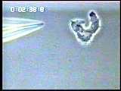
[18-03 Dictyostelium and cAMP.mpg]

18.3 Dictyostelium Migration and cAMP: Single Dictyostelium cell exposed to a cyclic AMP gradient from a micropipette. Concentration of cyclic AMP changes ~20% across the cell. (Courtesy of Peter Devreotes.)
Textbook Figure Reference: 18.14

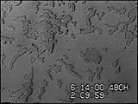
[18-04 Dictyostelium Streaming.mpg]

18.4 Streaming of Dictyostelium Cells: Stepwise chemotactic movements of Dictyostelium cells towards an aggregation center. (Courtesy of Peter Devreotes.)
Textbook Figure Reference: 18.14

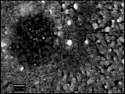
[18-05 Dictyostelium Spiral Wave.mpg]

18.5 Spiral Wave of Myxamoebae Responding to cAMP: Core of a spiral wave in aggregating Dictyostelium cells. (Courtesy of Florian Siegert.)
Textbook Figure Reference: 18.14

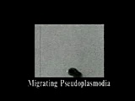
[18-06 Slime Mold 3 Migration.mpg]

18.6 Slime Mold Morphogenesis 3, Migration: Pseudoplasmodium migration: The aggregate forms a crawling slug, or pseudoplasmodium. The translucent sheath around the slug and the slime trail left behind as it migrates can be easily seen. At the end of this sequence, a very large pseudoplasmodium splits into two. (Filmed by John Bonner. From Fink, R. 1991. A Dozen Eggs. Sinauer Associates.)
Textbook Figure Reference: 18.15

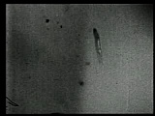
[18-07 Slime Mold 4 Culmination.mpg]

18.7 Slime Mold Morphogenesis 4, Culmination: Culmination: When the pseudoplasmodium ceases migration, it differentiates into a fruiting body in the process of culmination. The anterior cells of the pseudoplasmodium form a stalk, and the more posterior cells differentiate into spore cells. While not seen in the film, the life cycle is completed when spores are released from a mature fruiting body; each spore becomes a new amoeba. (Filmed by John Bonner. From Fink, R. 1991. A Dozen Eggs. Sinauer Associates.)
Textbook Figure Reference: 18.15

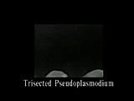
[18-08 Slime Mold 5 Trisection.mpg]

18.8 Slime Mold Morphogenesis 5, Trisecting: Trisected pseudoplasmodium: In this experiment, an individual pseudoplasmodium was cut into three parts. As the sequence shows, each fragment is able to rearrange and differentiate into a complete fruiting body. (Filmed by John Bonner. From Fink, R. 1991. A Dozen Eggs. Sinauer Associates.)
Textbook Figure Reference: 18.15

Chapter 19. Developmental Mechanisms of Evolutionary Change

(Related Differential Expressions² Videos: Le Douarin Excerpts 1–2)

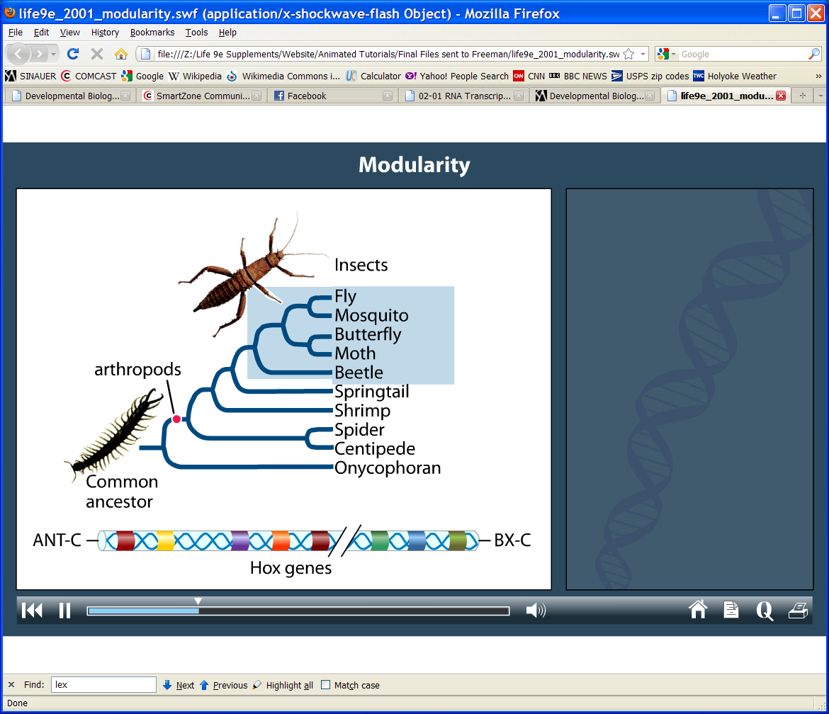
[19-01 Modularity.swf]

19.1 Modularity and Gene Expression: All insect species on Earth have exactly six legs—a pair on each of three thoracic (middle) body segments. Look at the larger group of arthropods, however, and you will see a striking variation in leg number, including finding legs on abdominal segments. These dramatic differences in morphology represent changes in self-contained body units (modules). The modular changes can arise through relatively small changes in key regulatory genes. Also, relatively small changes in the timing or place of expression of key regulatory genes can affect the morphology of different species; for example, the hindlimbs of ducks (webbing) compared with those of chickens (no webbing). (From the companion website to Sadava et al. 2011. Life: The Science of Biology, Ninth Edition. Sinauer Associates and W. H. Freeman.)
Textbook Figure Reference: 23.8

Plant Development Chapter

(From Developmental Biology, Eighth Edition; available at www.devbio.com)

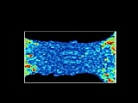
[Plant Dev 1.mpg]

Arabidopsis Emerging Leaf (8 Days): Emerging leaf of a 8-day Arabidopsis seedling using optical coherence microscopy. This microscopy technique measures the scattering of light, a property that distinguishes the different parts of the developing plant. The cotyledon petioles are oriented parallel to the y-axis, while the primordia of leaves 1 and 2 are opposite each other along the x-axis. The colors reflect differences in light-scattering ability. (Hettinger, J. W., M. de la Pena Mattozzi, W. R. Myers, M. E. Williams, A. Reeves, R. L. Parsons, R. C. Haskell, D. C. Petersen, R. Wang, and J. I. Medford. 2000. Optical coherence microscopy. A technology for rapid, in vivo, non-destructive visualization of plants and plant cells. Plant Physiol. 123: 3–16.)
See Website Plant Development Chapter

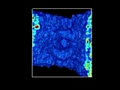

[Plant Dev 2.mpg]

Arabidopsis Leaf Primordium (8 Days): Leaf primordium of an 8-day Arabidopsis seedling using optical coherence microscopy. This microscopy technique measures the scattering of light, a property that distinguishes the different parts of the developing plant. The cotyledons are at the sides, and the first leaf primordia appear centrally. One of these primordia is cropped and the color thresholds are changed to reflect smaller differences within the primordium. (Hettinger, J. W., M. de la Pena Mattozzi, W. R. Myers, M. E. Williams, A. Reeves, R. L. Parsons, R. C. Haskell, D. C. Petersen, R. Wang, and J. I. Medford. 2000. Optical coherence microscopy. A technology for rapid, in vivo, non-destructive visualization of plants and plant cells. Plant Physiol. 123: 3–16.)
See Website Plant Development Chapter

