Name(s):

The Orbits of the Moons of Jupiter

ESC 115 Lab 5, Mercer University

Adapted from Project CLEA Student Manual and written for use in ESC 115, by R. S. Armour, Jr., Physics Dept., Mercer University, Fall 2001

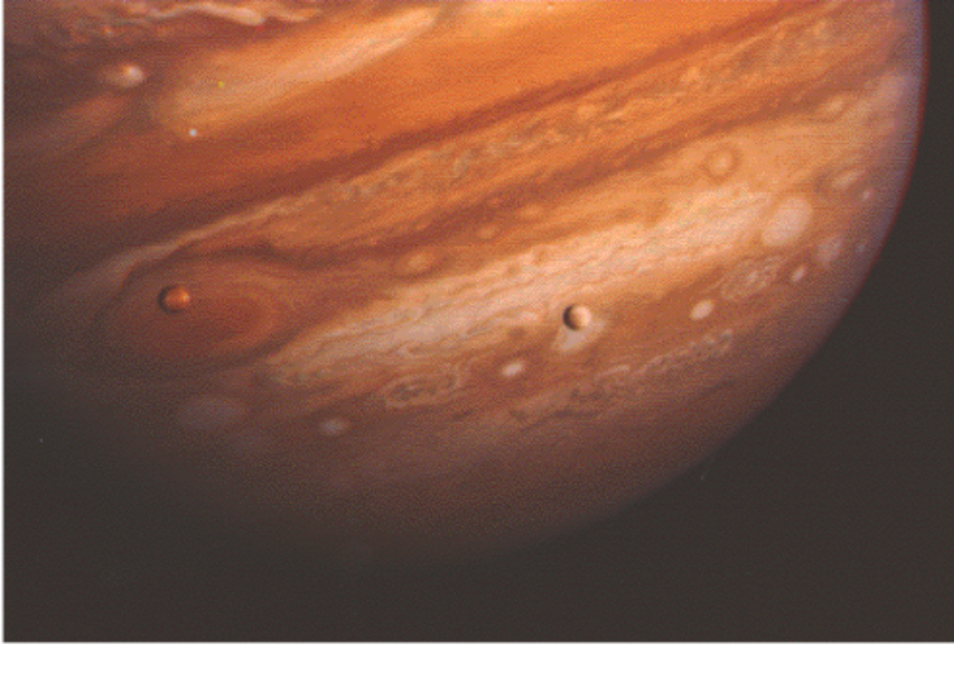


Software Developed by

The CLEA Project

Department of Physics

Gettysburg College

Gettysburg, PA 17325

Telephone: (717) 337-6028

email: clea@gettysburg.edu

Goals

To determine the mass of Jupiter by measuring the orbital properties of Jupiter’s moons and analyzing their motion using Kepler’s Third Law.

Objectives

If you learn to …

Interpret the apparent back and forth motion of an orbiting satellite as the linear projection of circular motion and apply that interpretation to the moons of Jupiter,

Graph the motion of a circularly-orbiting satellite versus time and fit a sine curve to that graph,

Employ the relationship between the radius and period of an orbit for a gravitationally bound satellite,

You should be able to …

Apply Kepler’s Third Law of orbital motion to calculate the mass of Jupiter,

Estimate the orbital period, or radius, of another moon of Jupiter.

Introduction

Despite the fact that we cannot directly measure their mass relative to objects on Earth, we can deduce the mass of large celestial objects by studying the motion of smaller objects they hold in orbit. In 1543, Nicolaus Copernicus hypothesized that the planets revolve in circular orbits around the sun. Tycho Brahe (1546-1601) carefully observed the locations of the visible planets and stars over a period of 20 years using a sextant and compass. These observations were then used by Johannes Kepler to deduce three mathematical laws governing the orbit of one object around another. Kepler’s Third Law for a moon orbiting a much more massive planet (parent body) is

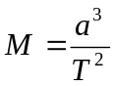
where M is the mass of the planet in solar masses, a is the length of the semi-major axis of the moon’s elliptical orbit (half of the longest axis of an ellipse – this is the radius for a circular orbit) in units of A.U. (the mean Sun-Earth distance), and T is the period of the moon’s orbit in Earth years. The period is the length of time required for the moon to complete one orbit around the planet. Thus knowing the moon’s orbital radius a and its orbital period T allows us to calculate the mass M of its parent planet.

In this lab, we will observe the four moons of Jupiter, first seen by Galileo through a (very) small telescope in 1609. The moons are named Io, Europa, Ganymede, and Callisto, in order of their distance from Jupiter. The mnemonic “I Eat Green Carrots” may help to remember their order. If you looked at Jupiter through a small telescope, you might see something like the following

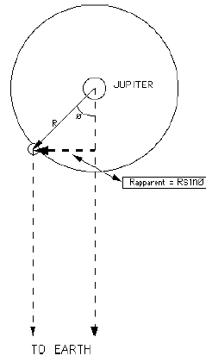
The large dot represents Jupiter, and the smaller dots its four largest moons. The moons appear to be roughly lined up because we are looking edge-on at the orbital plane of the Jupiter system. As time goes by, the moons will move around Jupiter in virtually circular orbits. Thus, from our edge-on perspective, we see the perpendicular distance of the moons from our line of sight to Jupiter. This perpendicular distance is R_{apparent} = R_{sin θ} in Figure 1 below.

Further, the moons move at virtually the same speed at all points on their (virtually) circular orbits. (This would not be true if their orbits were ellipses.) Therefore, when plotted versus time, the perpendicular distance of each moon from Jupiter, as seen from Earth, traces a near-perfect sinusoidal curve. This is illustrated in Figure 2, below. By taking enough observational measurements of the position of a moon, we can fit a sine curve to a graph of its position versus time. From this graph, we can then determine the radius of the moon’s orbit (the amplitude of the sine curve) and the period of its orbit (the period of the sine curve). Once we know the radius and period of the moon’s orbit, we can determine the mass of Jupiter using Kepler’s Third law. We will calculate Jupiter’s mass by observing the orbits of each of its four largest moons. There will be errors of measurement associated with the positions of each moon, and therefore our calculated masses for Jupiter may not be exactly the same in each case, but they should agree reasonably well.
Figure 1

Apparent distance of moon from Jupiter, as seen from Earth

The CLEA Jupiter program simulates the operation of an automatically controlled telescope with a charge-coupled device (CCD) camera that provides a video image to a computer screen. The computer simulation is realistic in all important ways, and using it will give you a good feel for how astronomers collect data and control telescopes. Instead of using a telescope and actually observing the moons for many days, the computer simulation shows Jupiter’s moons as they would appear if you were to look through a telescope at any specified time.

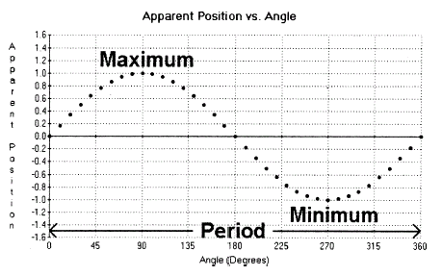

Figure 2

Apparent Position of a Moon

The apparent position of a moon varies sinusoidally with the changing angle from the line of sight, θ, as it orbits Jupiter. Here, the apparent position is measured in units of the radius of the moon’s orbit, R, and the angle measured in degrees.

Overall Strategy

- Use the CLEA Jupiter program to observe and measure the apparent positions of the moons of Jupiter.

- Make an initial rough estimate of the orbital radius and period for each moon.

- Observe and measure the orbit of each moon over a two-week period and plot the apparent distance of each moon from Jupiter as a function of time using the CLEA program. Find the best-fit sine curve to this plot and from this curve determine the orbital radius and period of each moon.

- Calculate the mass of Jupiter using the radius and period of each moon’s orbit and Kepler’s Third Law.

Procedure and Exercises:

Getting Started

- Open the CLEA program “Jupiter Moons” on your computer. If the CLEA window is small (<50% total window size), you may reset your Display Settings under Control Panel to 800x600 pixels. If you need assistance, ask you instructor for help.

- Select “Log In …” from the pull-down menu and enter the names of each person in your lab group. Write each person’s name on the front your lab manual as well. Table number is not required. Click OK to continue.

- Select File > Run to begin the program. The next dialogue box to appear is Start Date and Time. Set the date to 10/1/2001 and the Universal Time (the time in Greenwich, England) to 1 hour, 0 min, 0 sec. This is 8:00PM on 9/30/2001 in Macon, GA. Return to this page (File > Run) whenever necessary to reset the Start Date and Time to an earlier value. This is the only way to return to an earlier time and date. When all information has been entered correctly, click OK.

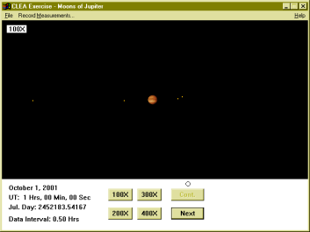
- A screen appears with Jupiter in the middle and four of its moons in orbit surrounding it. These moons are Io, Europa, Ganymede, and Callisto (“I Eat Green Carrots”), in order of smallest to largest orbit.

This view is very similar to what you would see when looking through a large telescope with a wide angle view, though the image here is somewhat clearer. (These are Voyager images.) The image can be viewed at four different magnifications, 100X, 200X, 300X, and 400X. Higher magnifications allow for a better determination of the distance between Jupiter and its closest moons. Clicking on each moon will display its apparent distance from Jupiter in units of Jupiter Diameters (Jup. Diams.).

Part 1: Rough Estimate of the Periods, Radii, and T-Zero Time of Each Moon’s Orbit

We will now make a rough estimate of the orbital radius (the orbital distance from the moon to Jupiter), the orbital period (the time it takes a moon to complete one orbit), and the “T-Zero” time (the time when the moon is exactly in front of Jupiter on a particular orbit) for each of Jupiter’s four largest moons.

- Go to File > Preferences and click on ID Colors. Jupiter’s moons are now color-coded as follows:

Moon | Color
Io | Purple
Europa | White
Ganymede | Light Blue
Callisto | Yellow

- Go to File > Preferences > Timing and set Observation Interval (Hrs) to 0.50 and Animation Step (Hrs) to 0.50 and click OK. Then go to File > Preferences and click on Animation. Now click the Cont. button and observe the moons rotate around Jupiter. You may stop time by clicking Cont. again. To reset the view to an earlier time go to File > Run.

List the moons in order of longest to shortest orbital period.

Longest:

Second longest:

Third longest:

Shortest:

What is the general relationship between the period and ORBITAL SIZE (orbital radius) of the four moons’ orbits? (That is, complete the sentence “The shorter the orbital period, the …” ?)

IO:

1) Orbital Radius (Amplitude):
Io is the purple-colored moon near the center of the picture. Click 400X to zoom in. Under Run, reset the date and time to 10/1/2001, 16 hours, 0 min, 0 sec. Under File > Preferences > Timing, set Observation Interval and Animation Step to 0.05 Hrs. Click the Cont. button to start time and click the button again to stop time as soon as Io appears to have reached its farthest point towards the left of the screen. Be sure Io has traveled less than one orbit around Jupiter. If Io is moving too quickly, you can uncheck Animation under Preferences, reset the time under Run, and click Next to move Io in 0.05 Hr steps.

With time stopped at Io’s maximum apparent separation from Jupiter, click on Io. On the bottom right of the CLEA window you should see a display of the apparent distance of Io from Jupiter in Jupiter Diameters. [X = x.xxE (Jup. Diam.)] This apparent maximum separation in our edge-on view is the true orbital radius of Io. The orbit of Io, and of the other moons, is nearly circular – to see this go to File > Preferences > Top View – and thus Io is always approximately this distance from Jupiter. (In our edge-on view it only appears to get closer.) Record your measurement of the orbital radius of Io in Jupiter diameters and the Modified Julian Date = Julian Day – 2452000 on which it was taken. (The Julian Day, in the lower left of the screen, is the number of days since noon, 1/1/4713 BC.) You should get something like 2.96E Jup. Diam. at Mod. Jul. Date 184.54375.

Orbital Radius of Io (Jup. Diam.) =

Jul. Day – 2452000 (Io at max separation) =

2) T-Zero time (Io):
Starting where you left off, on the Julian Date above, click on Cont. again and stop time as soon as Io gets to the front center of Jupiter’s disk. As before, if Io moves too fast, you can unclick Animation, and click Next to move time in 0.05 Hr steps. What is the Jul. Day – 2452000 when Io is at the center (front) of Jupiter’s disk? (You should get approximately 184.99)

T-Zero time (Io) = Jul. Day – 2452000 (first cross in front of Jup. disk after orbital max) =

3) Orbital Period (Io):
Click Cont. again (Animation must be checked first), and let time flow until Io comes all the way around and returns to its maximum apparent separation from Jupiter on the far left of the screen (again near 3.00E Jup. Diam.). What is the Jul. Day – 2452000 when Io returns this point?

Jul. Day – 2452000 (Io returns to max separation) =

Now subtract the Jul. Day from part 1 from the Jul. Day above to get the orbital period of Io. (You should get approximately 1.8 days.)

Orbital period of Io (Earth days) =

Using similar techniques to those used for Io, find the orbital radii, the first T-zero times after 10/1/2001, and the orbital periods of each of the other three moons. Measurements should begin at the first orbital maximum after 10/1/2001, 1Hr UT. T-zero times are when the moons first cross the front center of Jupiter’s disk after the first orbital maximum.
EUROPA:

1) Orbital Radius (Amplitude, Jup. Diam.), distance at first max separation after 10/1/2001, 1 Hr UT:

Orbital Radius of Europa (Jup. Diam.) =

Jul. Day – 2452000 (at measurement) =

2) T-Zero time (first front crossing of Jupiter’s disk after orbital maximum):

Jul. Day – 2452000 (at front center crossing) =

3) Orbital Period (time to complete one orbit, days):

Jul. Day – 2452000 (time Europa returns to max separation) =

Orbital period of Europa (days) = Jul. Day part 3 – Jul. day part 1 =

GANYMEDE: Under File > Preferences > Timing, set the Observation Interval and Animation Step to 0.15 (to “speed up time”). Also, you may prefer to measure Ganymede’s orbit from its maximum apparent separation to the right of Jupiter, instead of to the left.

1) Orbital Radius (Amplitude, Jup. Diam.), distance at first max separation after 10/1/2001, 1 Hr UT:

Orbital Radius of Ganymede (Jup. Diam.) =

Jul. Day – 2452000 (at measurement) =

2) T-Zero time (first front crossing of Jupiter’s disk after orbital maximum):

Jul. Day – 2452000 (at front center crossing) =

3) Orbital Period (time to complete one orbit, days):

Jul. Day – 2452000 (time Ganymede returns to max separation) =

Orbital period of Ganymede (days) = Jul. Day part 3 – Jul. day part 1 =

CALLISTO: Under File > Preferences > Timing, set the Observation Interval and Animation Step to 0.25.

1) Orbital Radius (Amplitude, Jup. Diam.), distance at first max separation after 10/1/2001, 1 Hr UT:

Orbital Radius of Callisto (Jup. Diam.) =

Jul. Day – 2452000 (at measurement) =

2) T-Zero time (first front crossing of Jupiter’s disk after orbital maximum):

Jul. Day – 2452000 (at front center crossing) =

3) Orbital Period (time to complete one orbit, days):

Jul. Day – 2452000 (time Callisto returns to max separation) =

Orbital period of Callisto (days) = Jul. Day part 3 – Jul. day part 1 =

Part 2: Accurate Measurement of Orbits of Jupiter’s Moons from Multiple Observations

Section 1, Observations:

In this section, we will record the positions of the moons of Jupiter on a two-week observing run and use this data to make a more accurate determination of their orbital periods and radii. Go to File > Preferences > Timing and set Observation Interval to 4.00 Hrs.

Go to File > Data > Load. Click on instruct.csv and click OK. (Click No when asked to “merge” data.) This loads the data from 10/1-10/6 below into the program. Next, go to File > Run and set the date and time to 10/7/2001, 1:00 UT. Now measure the positions of each moon and record your measurements in the table below and under Record Measurements on the pull down menu. To measure the apparent position of each moon accurately, switch to the highest magnification that will leave that moon in the field of view.

Click OK to close Record/Edit Measurements, then click Next until you reach the next indicated date and time on the table. If NEXT is grayed out, unclick Animation under Preferences. Click Next once to get to 5:00 UT, and five more times to get to 1:00 UT on the next day. Record the positions of each moon at the new date and time, both in the table below and under Record Measurements on the pull-down menu. Repeat this procedure for the remaining dates and times in the table. If it is cloudy on the day of observation, or the moon is obscured behind Jupiter, leave Record Measurements … blank and write either Cloudy or Obscured in the table below, as appropriate.
Data Sheet:

Date | UT Time | Jul. Day | Day | Io | Europa | Ganymede | Callisto
10/1/2001 | 1:00 UT | 183.54 | 0.00 | 2.65W | 2.90E | 3.11W | 12.37E
10/1/2001 | 5:00 UT | 183.71 | 0.25 | 2.90W | 3.86E | 4.07W | 12.68E
10/2/2001 | 1:00 UT | 184.54 | 1.00 | 2.96E | 3.05E | 7.23W | 13.33E
10/2/2001 | 5:00 UT | 184.71 | 1.25 | 2.54E | 1.90E | 7.43W | 13.27E
10/3/2001 | 1:00 UT | 185.54 | 2.00 | 2.74W | 4.07W | 6.13W | 12.40E
10/3/2001 | 5:00 UT | 185.71 | 2.25 | 1.66W | 4.57W | 5.43W | 12.07E
10/4/2001 | 1:00 UT | 186.54 | 3.00 | 2.13E | 1.49W | 0.63W | 9.85E
10/4/2001 | 5:00 UT | 186.71 | 3.25 | 0.60E | Obscured | 0.46E | 9.25E
10/5/2001 | 1:00 UT | 187.54 | 4.00 | 1.08W | 4.70E | 5.35E | 5.88E
10/5/2001 | 5:00 UT | 187.71 | 4.25 | 0.63E | 4.65E | 6.05E | 5.13E
10/6/2001 | 1:00 UT | 188.54 | 5.00 | Cloudy | — | — | —
10/6/2001 | 5:00 UT | 188.71 | 5.25 | 1.70W | 1.68W | 7.30E | 0.29E
10/7/2001 | 1:00 UT | 189.54 | 6.00
10/7/2001 | 5:00 UT | 189.71 | 6.25
10/8/2001 | 1:00 UT | 190.54 | 7.00
10/8/2001 | 5:00 UT | 190.71 | 7.25
10/9/2001 | 1:00 UT | 191.54 | 8.00
10/9/2001 | 5:00 UT | 191.71 | 8.25
10/10/2001 | 1:00 UT | 192.54 | 9.00
10/10/2001 | 5:00 UT | 192.71 | 9.25
10/11/2001 | 1:00 UT | 193.54 | 10.00
10/11/2001 | 5:00 UT | 193.71 | 10.25
10/12/2001 | 1:00 UT | 194.54 | 11.00
10/12/2001 | 5:00 UT | 194.71 | 11.25

After you have recorded your measurements for the positions of the moons of Jupiter, save your data under your name, or the name of someone in your group, by clicking on File > Data > Save. When prompted, click No and then create a name for the data file in the JupLab directory, e.g. c:\clea\juplab\JohnDoe.csv. Make sure your file name ends in “.csv”! This will guarantee that it will be recognized by the data analysis software in the next section.

Section 2, Data Analysis:

Our task now is to find the orbital period of each moon from our data above. As explained in the introduction, the orbits of Jupiter’s moons are nearly circular. If you have not already done so, go to File > Preferences > Top View to see this clearly. Click on Animation (under Preferences) and click Cont. to see this over-head view in motion. As discussed earlier, our view from Earth is edge-on, so to us the moons appear to move back and forth along a line, slowing down near the edges and speeding up in the center. If we plot the position of the moons versus time, we get a sine curve, essentially the same curve represented by the mathematical functions sine and cosine. An example of such a plot is given below for a fictitious moon named Clea.
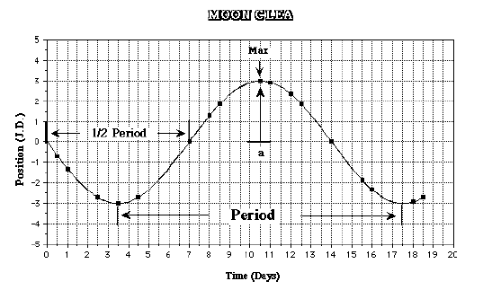

Period, T = 14 days = 0.0383 years

Radius (semi-major axis), a = 3 J.D. = 0.00286 A.U.

Each point on the graph is from one observation. The points are irregularly spaced because some days were cloudy, or the moon was obscured, leaving no data for that day. Note that the amplitude a of the sine wave (height from center to top) is the radius of the moon’s orbit, and the period of the sine curve (distance from peak to peak) is the period T of the orbit.

We will now find the sine curve that best fits our data above in order to determine the orbital properties of each of Jupiter’s largest moons.

IO, graphical analysis:

- Go to File > Data > Analyze. Then select Io from the moon menu. The data for Io will appear with circles representing each data point.

- Click on Plot > Fit Sine Curve > Set Initial Parameters. Here, we must input an expected T-zero time, Period, and Amplitude (radius) for Io. For this, we use our values obtained in Part I, Section I. Beside “T-Zero”, type in your value for Io’s T-zero time from No. 2, p. 6. Beside “Period”, type its period from No. 3, p. 6, and next to “Amplitude”, type its radius from No. 1, p. 6. Your values should be close to T-Zero = 184.99, Period = 1.77 days, Amplitude = 2.99 J.D.

- Now adjust the T-zero point, the period, and the amplitude of the sine wave (blue line) by pressing the left and right scroll arrows (or the middle scroll bar) next to each parameter until the sine wave best fits your data. The “best-fit” is when the sine wave goes through as many data points as possible. If no data points are clearly misplaced (far from the curve), this should also be when the RMS Residual value (at the bottom of left the screen) is at a minimum.

- When you have found the best-fit sine curve for your data, Print your graph from Plot > Print Current Display. Record the period and amplitude of the sine wave below.

Io Best-fit Period (days) =

Io Best-fit Amplitude (Radius, Jup. Diams.) =

Following the same procedure as for Io, find and Print the best-fit sine curve to your data from the other three moons. Record their Periods and Amplitudes below. Attach all four graphs to the lab report of one of your group members.

EUROPA, graphical analysis

Best-fit Period (days) =

Best-fit Amplitude (Radius, Jup. Diams.) =

GANYMEDE, graphical analysis:

Best-fit Period (days) =

Best-fit Amplitude (Radius, Jup. Diams.) =

CALLISTO, graphical analysis:

Best-fit Period (days) =

Best-fit Amplitude (Radius, Jup. Diams.) =

After you have completed the sine-wave analysis, exit the Data Analysis Window, click on File > Data > Print on the Main Menu and print both the Data Table and Sine Parameters Summary to include with your report.

Conversion of Units:

From the previous page, we must now convert our best-fit periods from units of Earth days into units of Earth years and our best-fit amplitudes (radii) from units of Jupiter Diameters into units of A.U. This will allow us to more easily compare Jupiter’s mass with that of the Sun below.

IO (years, A.U.):

Best-fit Period (years) = Best-fit period (days) ÷ 365.25 =

Best-fit Amplitude (Radius, A.U.) = Best-fit Amplitude (Radius, Jup. Diams.) ÷ 1046.27 =

EUROPA (years, A.U.):

Best-fit Period (years) = Best-fit period (days) ÷ 365.25 =

Best-fit Amplitude (Radius, A.U.) = Best-fit Amplitude (Jup. Diams.) ÷ 1046.27 =

GANYMEDE (years, A.U.):

Best-fit Period (years) = Best-fit period (days) ÷ 365.25 =

Best-fit Amplitude (Radius, A.U.) = Best-fit Amplitude (Radius, Jup. Diams.) ÷ 1046.27 =

CALLISTO (years, A.U.):

Best-fit Period (years) = Best-fit period (days) ÷ 365.25 =

Best-fit Amplitude (Radius, A.U.) = Best-fit Amplitude (Radius, Jup. Diams.) ÷ 1046.27 =

Questions:

1) Using your results for the period and radius (amplitude) of each of Jupiter’s moons, we may now calculate the mass of Jupiter from Kepler’s Third Law. Kepler’s Third Law relates the period of a satellite to its distance from the gravitating body holding it in orbit. Combined with Newton’s Law of Gravitation we can obtain the following relationship between the mass of a large gravitating body, in our case Jupiter, and the period and radius of an orbiting object, one of Jupiter’s moons. (The mass of the moon is considered negligibly small.) We have
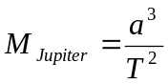where a is the radius of the orbiting moon in A.U., T is the period of its orbit in (Earth) years, and M_{Jupiter} is the mass of Jupiter in units of solar masses.

Calculate the mass of Jupiter using the Best-fit Period in years and Best-fit Amplitude (Radius) in A.U. of each of its four moons found above under the Conversion of Units section, p. 13. Using units of A.U. and years means that Jupiter’s mass will be calculated in solar masses. That is, your answer will be the ratio of Jupiter’s mass to that of the sun. (You should get something like M_{Jupiter} = 9.5x10⁻⁴ solar masses.)

From Io: M_{Jupiter} (solar masses) =

From Europa: M_{Jupiter} (solar masses) =

From Ganymede: M_{Jupiter} (solar masses) =

From Callisto: M_{Jupiter} (solar masses) =

Find the average of these values of M_{Jupiter}.

Average M_{Jupiter} (solar masses) =

2) Using your average value of M_{Jupiter} in solar masses, express the mass of Jupiter in units of Earth masses by dividing M_{Jupiter} (solar masses) by 3.00x10⁻⁶, which is the mass of the Earth in solar-mass units.

Average M_{Jupiter} (Earth masses) = Average M_{Jupiter} (solar masses) ÷ 3.00x10⁻⁶ =

3) There are moons beyond the orbit of Calisto. Will they have larger or smaller periods than Callisto? Why?

4) Which do you think would cause the largest error in M_{Jupiter}, a ten percent error in T or a ten percent error in a? Why?

Extra Credit: The orbit of Earth’s moon has a period of 27.3 days and a radius (semi-major axis) of 2.56x10⁻³ A.U. (= 3.84x x10⁵ km). What is the mass of the Earth? What are the units? (Show your work below.)

End of Lab 5

Adapted from CLEA, Jupiter Moons, by R. S. Armour, Jr. for ESC 115, Fall 2001, Mercer University.

