Unit VII: In the Aftermath of Human Rights Abuse: Truth and Reconciliation
Presenters
1st half of book:
Cynthia
Tyler
Caitlin
2nd half of book:
Siobhan
Daniela
Linnea
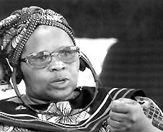
Film: "Long Night's Journey into Day: South Africa's Search for Truth and Reconciliation"
Ross, Fiona C.
2001 "Speech and Silence: Women's Testimony in the First Five Weeks of Public Hearings of the South African Truth and Reconciliation Commission"

Wilson, Richard A.
2000 "Reconciliation and Revenge in Post-Apartheid South Africa"

