Unit VI: Children's Rights: Street Children &

Walley, Christine J.  
2004 ”Searching for 'Voices': Feminism, Anthropology, and the Global Debate over Female Genital Operations"

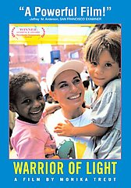

Film: “Warrior of Light

film Africa rising.gif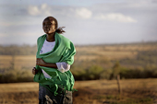

Film: "Africa Rising: The Grassroots Movement to End Female Genital Mutilation"

Female Genital Operations

Presenters

1st half of book:

Siobhan

Felicia

Cat

2nd half of book:

Caitlin

Maggie

Taylor