Unit #V: Stateless Persons and Group Rights

Presenters

1st half of book:

Maggie

Taylor

Linnea

2nd half of book:

Tyler

Cynthia

Daniela

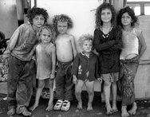

Film: "Suspino: A Cry for Roma"

Perez, Michael Vicente  
2011 "Human Rights and the Rightless: the Case of Gaza Refugees in Jordan"

Moorehead, Caroline  
2006 "The Corridors of Memory: The Naqba and the Palestinians of Lebanon"

from:

