Unit #IV: Global Industry and Worker's Rights

Presenters

1st half of book:

Donna

2nd half of book:

Taylor

Eric

Felicia

Mills, Mary Beth  
2005 "From Nimble Fingers to Raised Fists: Women and Labor Activism in Globalizing Thailand"

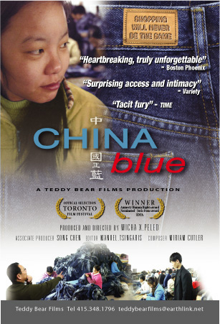

Film: “China Blue”

Wright, Melissa W.   
1999 "The Dialectics of Still Life: Murder, Women, and Maquiladoras"

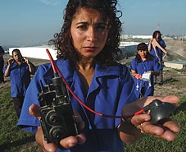

Film: “Maquilapolis"