Unit III: State Terrorism and Control of Media

Presenters

1st half of book:

Tyler

Cat

Daniela

2nd half of book:

Cynthia

Eric

Maggie

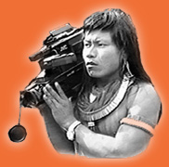

Film: “Seeing is Believing: Handicams, Human Rights, and the News”

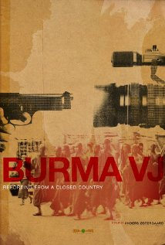

Film: “Burma VJ: Reporting from a Closed Country”

Gregory, Sam  
2006 "Transnational Storytelling: Human Rights, WITNESS, and Video Advocacy"

McLagan, Meg   
2002 "Spectacles of Difference: Cultural Activism and the Mass Mediation of Tibet"