Unit II: Human Trafficking & "The New Slavery"

Presenters

1st half of book:

Siobhan

Eric

Caitlin

2nd half of book:

Cat

Linnea

Felicia

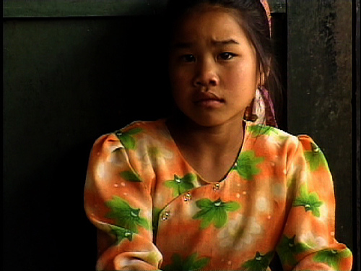

Film: “Trading Women”

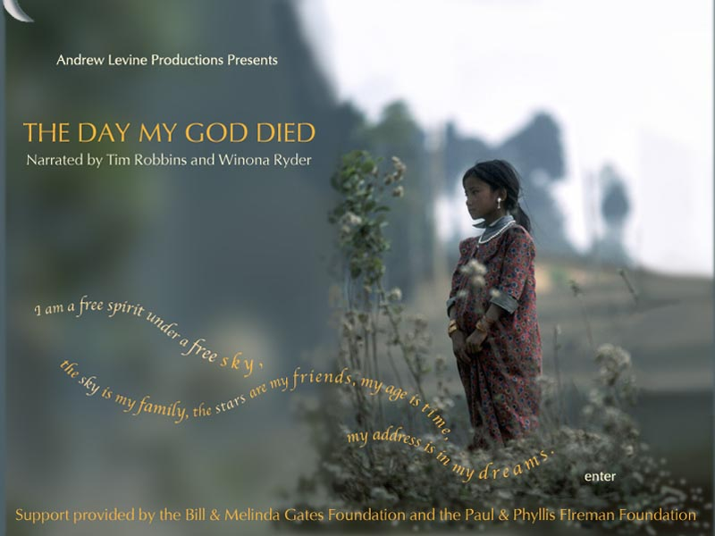

Film: “The Day My God Died”

Day, Sophie  
2009 "Renewing the war on prostitution: The spectres of ‘trafficking’ and ‘slavery’"

Montgomery, Heather  
2007 " Working With Child Prostitutes in Thailand: Problems of Practice and Interpretation"

Taylor, Lisa Rende  
2005 "The Behavioral Ecology of Child Labor and Prostitution in Rural Northern Thailand"

Excerpts from:

[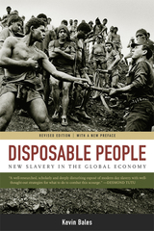](http://www.ucpress.edu/image/covers/isbn13/9780520243842.jpg)