# Poster Notes

Carrie Szarko

Gettysburg College

Educational Technology

[cszarko@gettysburg.edu](mailto:cszarko@gettysburg.edu)

1. Many online resources
   1. Ex. Designing Conference Posters by Colin Purrington
   2. <http://colinpurrington.com/tips/poster-design>
2. Poster Size
   1. How big does it need to be?
   2. 36 in. width by 24 in height
   3. Check conference or class specifications
   4. Set your slide size in PowerPoint before adding content to poster
   5. PowerPoint 2013
      1. **Design tab** **🡪 Slide Size 🡪 Custom Slide Size**

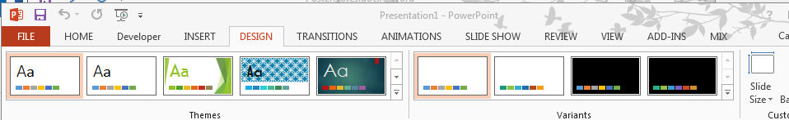

* 1. PowerPoint 2010
     1. **Design tab🡪Page Setup**

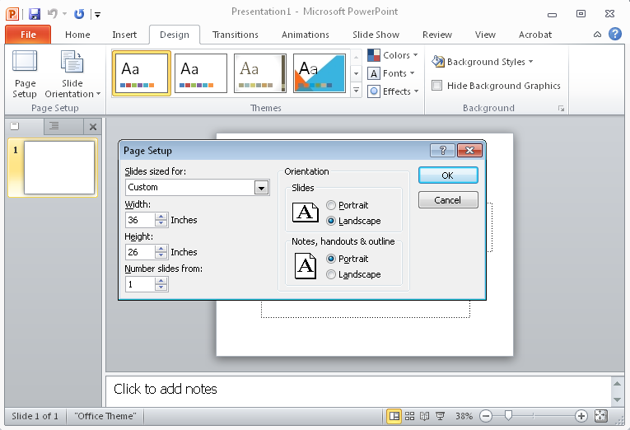

* 1. PowerPoint 2011 (Mac)
     1. **Themes tab🡪Page Setup**

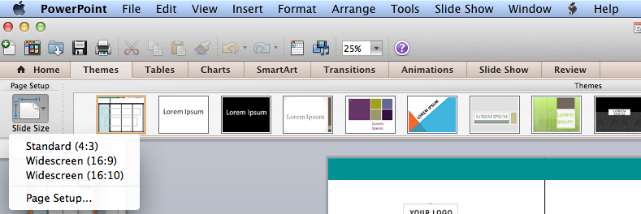

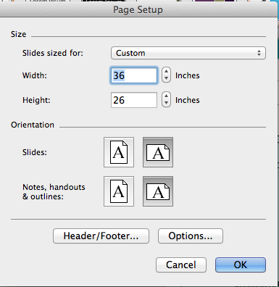

1. Poster Must be Clear and Legible
   1. Font Size
      1. Should be able to read from 5 ft. away
      2. No text smaller than 18 pt.  
         <http://www.kmeverson.org/academic-poster-design.html#IV>
         1. 72-120 pt. for title
         2. 48-80 pt. for authors
         3. 36-72 pt. for sub-heading
         4. 24-48 pt. for body text (Don’t make this text too small!)
         5. 18 pt. for captions
      3. Sans-serif (without small line attached to end of stroke) for title or large print  
         <http://www.fonts.com/content/learning/fontology/level-1/type-anatomy/serif-vs-sans-for-text-in-print>
         1. Used on web because serif’s don’t translate well with the light shining through the screen
         2. For Emphasis
         3. A lot of people prefer sans-serif for large type
         4. Ex. Helvetica
      4. Serif (with small line attached to end of stroke) for body
         1. Increases speed of reading and better for smaller text
         2. Used in books
         3. Ex. Palatino
      5. Academic posters often use sans-serif for title, author, and sub-headings
      6. Use serif for body text
   2. Background
      1. Dark text on light background works best
      2. White text on a black background is particularly hard to read
2. Layout
   1. Use columns
   2. Basically left to right/top down
   3. Still the eye does gravitate toward certain areas of the screen (Picture an upside down triangle with its base stretching across the title area.)
   4. *The University of Wisconsin-Madison Writing Center* site has a good illustration
      1. <http://writing.wisc.edu/Handbook/presentations_poster.html#design>
3. Templates
   1. Can be helpful if you are new to design
   2. Purrington’s site <http://colinpurrington.com/tips/poster-design#templates>
   3. Microsoft’s site [*https://templates.office.com/en-us/Posters*](https://templates.office.com/en-us/Posters)
   4. Dartmouth’s site [*http://www.dartmouth.edu/~ugar/undergrad/posterinstructions.html*](http://www.dartmouth.edu/~ugar/undergrad/posterinstructions.html)
   5. Some templates (such as those provided by Microsoft) place the colors of headings on the “Slide Master.” To access or change these features of the templates, click the **VIEW** tab and change the view from **Normal** to **Slide Master**.

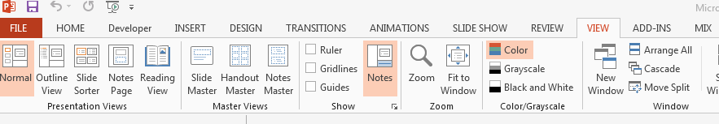

1. Images
   1. They should be at least 150 dpi
   2. Most web images are only 72 dpi and will not print well
      1. Thus, don’t just right-click and save as on a web image
   3. When using logos check the site for a logos page with high resolution logo images
      1. Ex. Gettysburg College has a Visual Standards page under Communications & Marketing
      2. These images are larger and higher resolution when printing
      3. <http://www.gettysburg.edu/about/offices/ees/communications/brand/>
   4. Sites like Flickr or library image databases provide numerous sizes of an image

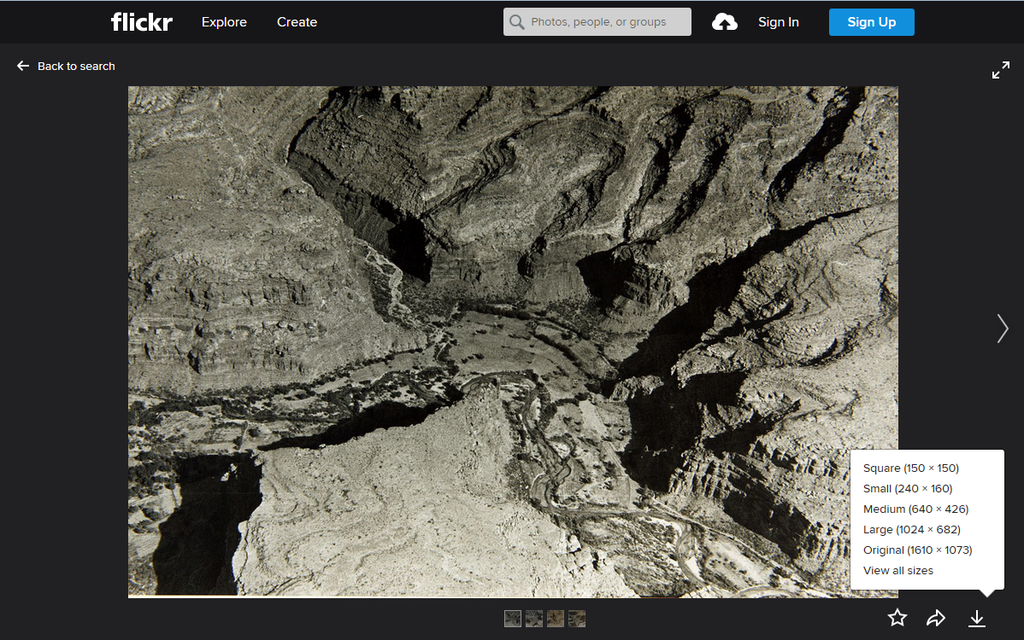

* 1. Most images are copyrighted
     1. You will need permission to use
     2. Sometimes the copyright allows you to use if you cite the copyright holder
     3. Ex. Gettysburg’s Special Collections picture of Penn Hall
        1. <http://gettysburg.cdmhost.com/cdm/ref/collection/p4016coll11/id/812>
        2. <http://www.gettysburg.edu/special_collections/policies/copyright_information.dot>
     4. Check with the library reference desk if you have questions about copyright and your images

1. Printing Your Poster
   1. Ricoh Campus Print Shop
   2. In West Building
      1. Enter from side entrance
      2. Don’t use the door with the blue arch
2. <http://www.gettysburg.edu/about/offices/fa/ikon/index.dot>
3. If you need your poster printing by a specific date, give yourself plenty of time. The print shop may have a backload of orders.