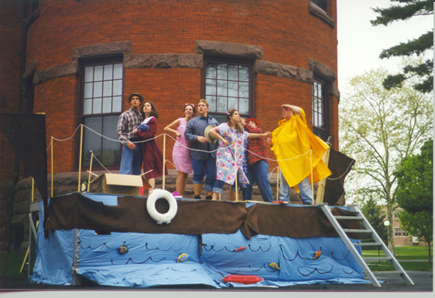
Get on the damn boat!
by Claire Christman
The flood is coming to Glatfelter Hall on Thursday, May 6th, 1999, at 5:00 p.m. Early in the semester, Professor Chris Fee of the English Department took on the challenge of bringing medieval drama to life for those of us brave enough to allow him to do so. Together, we embarked on a journey to discover the summer-stock theater of late medieval Europe which was once considered merely a poor (and distant) relation of Shakespearean theater.
Many colleges and universities throughout the world are putting on medieval plays. "It's a very popular way to make medieval theater accessible to students," says Fee. He also believes that this production ranks among the best put on by undergraduates.
"These students know a lot about medieval drama, and they know this play intimately," according to Fee. We have had exams and listened to lecture, but it's through putting on this production that we have really gotten to know the medieval theater. "The nature of theater," says Fee, "is that it's a living thing."
Medieval drama is also able to translate itself to the idiom of whatever culture it's being performed in. The beauty of medieval theater is that it does not have to be performed in a medieval context; thus, Noah has moved from the Middle East to the backwater country of the U.S.
"This play is as good as anything going on anywhere," says Fee. Over the course of the semester, we have explored the origins and development of medieval drama, examined its social roles, and discussed issues of text and performance through the use of lectures, discussion, and independent research. After reading a variety of examples included within this genre, and after watching several performances on video, we began the process of staging our own medieval play.
In order to complete the task, the class was divided into four groups: direction, construction, costumes, and translation. As a class we agreed on a theme, transforming Noah and his family into the Beverly Hillbillies. The translation group set to work weeks ago translating the Wakefield Master's Noah from Middle English to modern English and then again to fit our country bumpkin theme. The construction group built our very own pageant wagon which will serve as Noah's ark, and which will be used again in future productions. Meanwhile, the costume ladies have outfitted the cast with the most stylish of country fashions, while the direction group has worked hard to put all the pieces together, making our vision a reality.
The play is directed by Sabrina Bosse, Jess Bouboulis, Barb Dickson and Erin Quay. Starring in the play are Matt McGovern and Josh Eyler splitting the role of Noah. Lisa Smith plays Noah's nagging wife, and Chris Dinger is the vengeful God. Other performers are Steve Jenkins, Chris Rippey, Rob Rinaldi, Mary Beth Fichtner, Claire Christman, Jen Caden, Cara Masucci, Erica Durst, Kristen Boscarino, Kelly Brennan, Katie Gipe, and Professor Chris Fee.

ENGLISH 312: MEDIEVAL DRAMA

THE WAKEFIELD NOAH
GLATFELTER HALL
GETTYSBURG COLLEGE
THURSDAY, MAY 6th, 1999, 5:00 PM

