Gettysburg Community Soup Kitchen
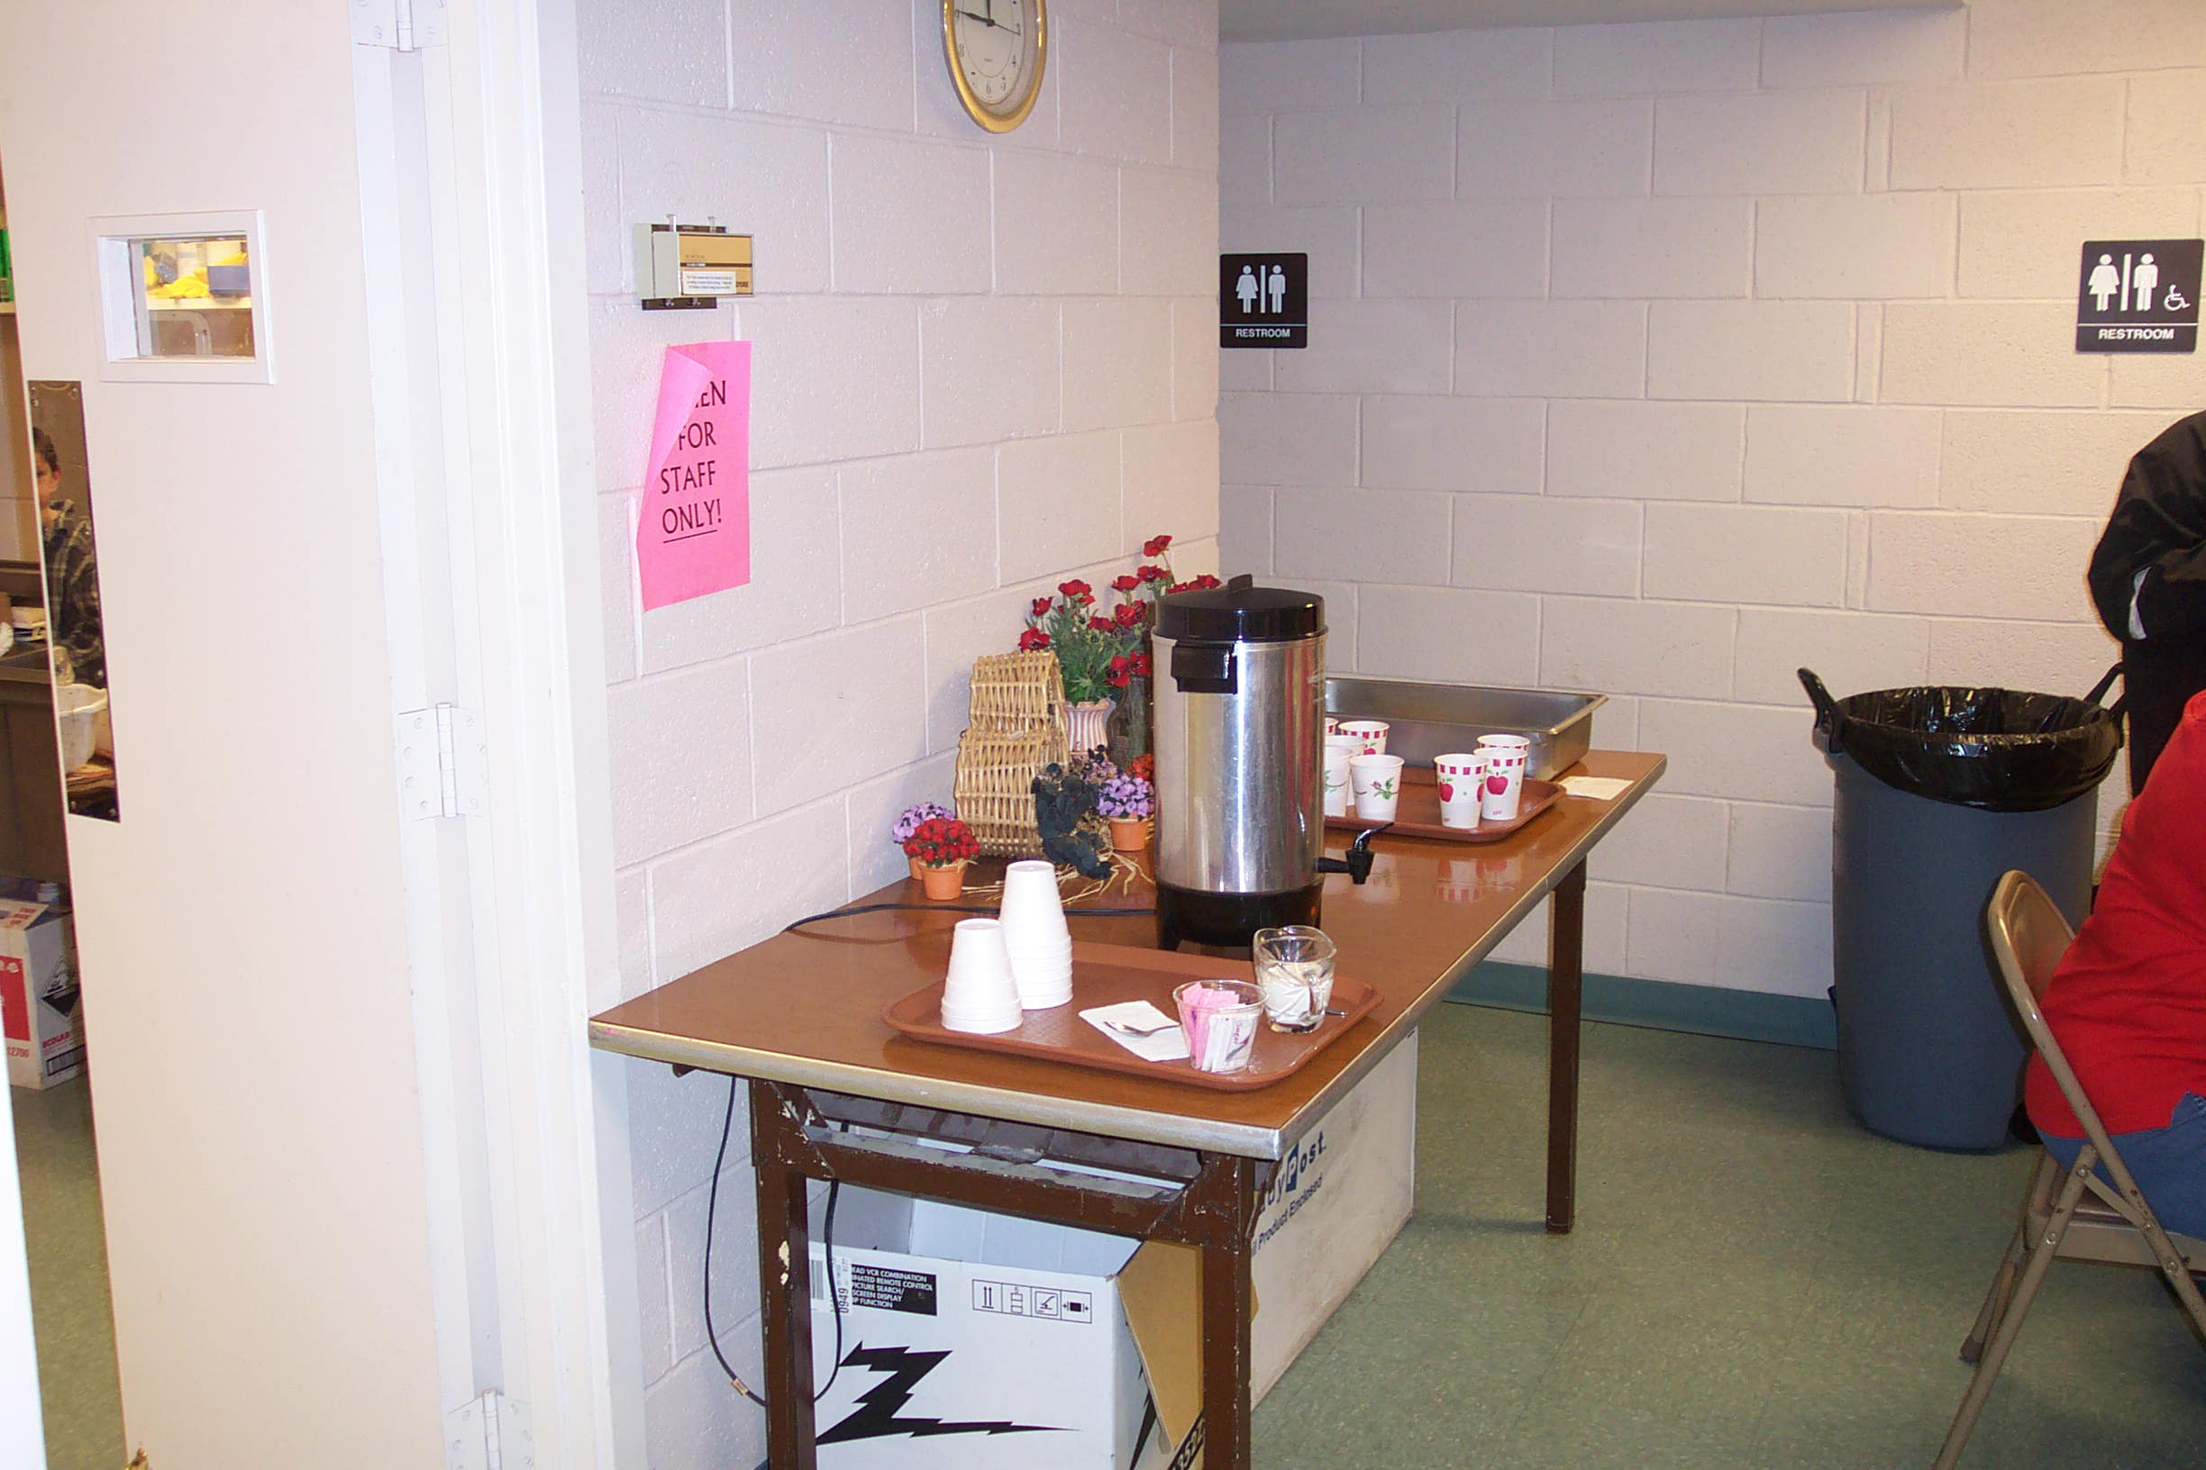
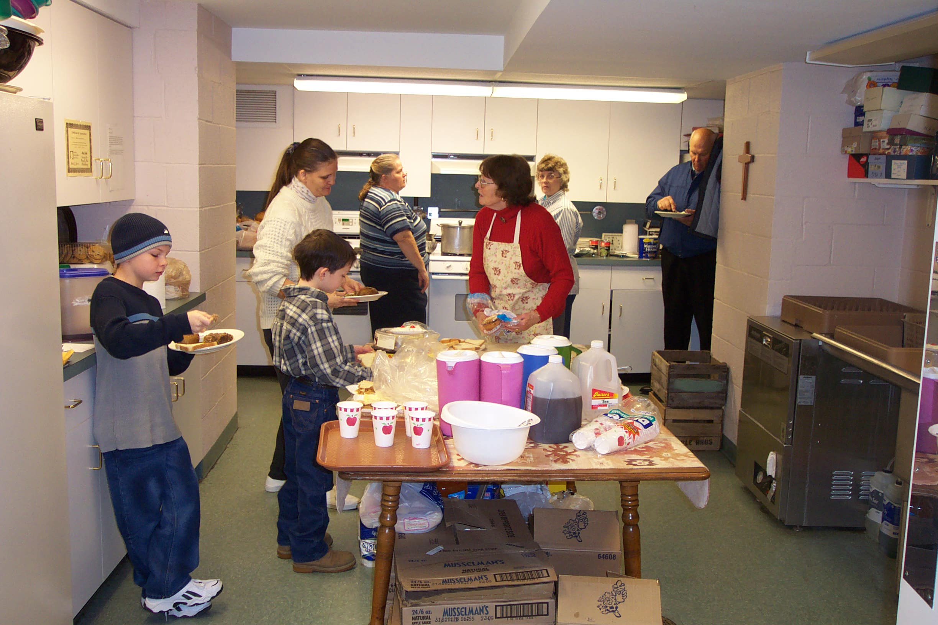
A Nurturing and Supportive Agency

Prince of Peace Episcopal Church
20 W. High Street
Box 3005
Gettysburg, PA 17325
(717) 334-6463

Program Director: Nancy Forgang

Location: Basement of the Prince of Peace Episcopal Church
Lunch Served: Monday- Saturday 11:30am- 12:30 pm, Open Year Round

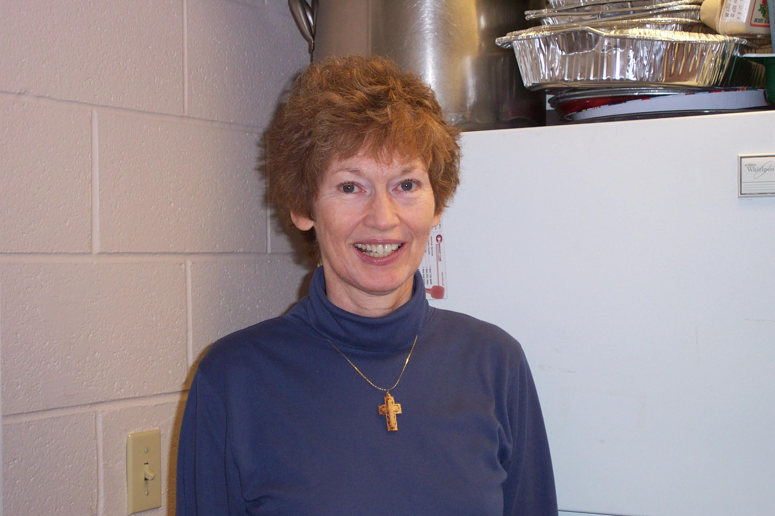
History
Volunteer Information
Client Information
Community Service Papers
Outside links

Program Director Nancy Forgang is always there to meet the clients’ needs

History
In 1991 Prince of Peace began a soup kitchen. In 1995 this ministry became officially incorporated as The Gettysburg Community Soup Kitchen, which now serves 10,000 meals Monday-Saturday at Prince of Peace. In 2000 the Church completed a renovation and expansion of its facilities. As part of that project, the soup kitchen was enlarged to accommodate the growing numbers of guests who come to be fed.
Information provided by Gettysburg’s Prince of Peace Episcopal Church website.



Volunteer Information
On Mondays, Tuesdays, Wednesdays, and Saturdays volunteers are from local churches and on Thursdays and Fridays, during the school year, the kitchen is a training site for L.I.U students who serve the volunteers. For anyone for would like to volunteer, the kitchen is always open to volunteers. Volunteers will assist in meal preparation, serving and interacting with the guests, and clean up. Please contact Nancy Forgang if interested.



Client Information
The Gettysburg Community Soup Kitchen’s lunches are free of charge and the kitchen welcomes all who are in need. The kitchen is open year round and features special meals for Thanksgiving, Christmas, Easter, Birthday Celebrations, and other holidays. The clients will find the environment to be very welcoming and warm and the volunteers are always there to brighten your day.

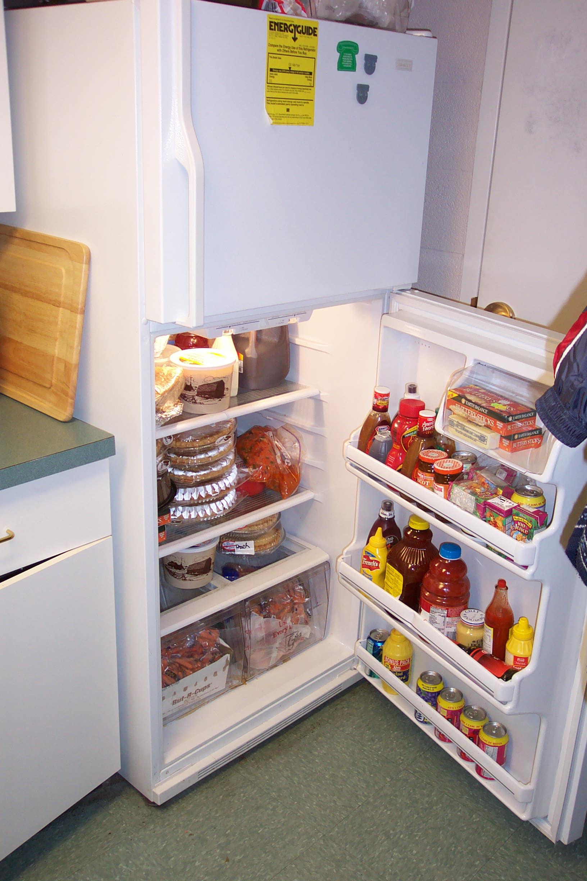


Gettysburg College Community Service Papers
- Emily
- Elizabeth
- Liz
- Peggy
- Tyler

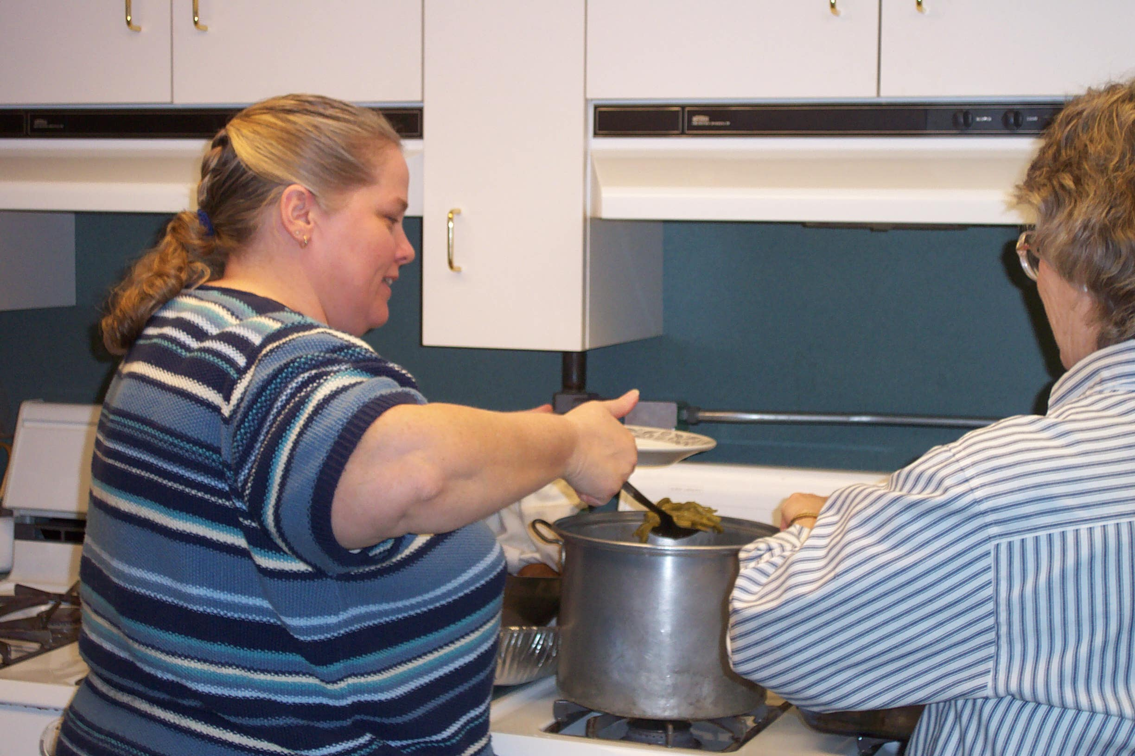

The Refrigerator is always stocked, ready to feed the hungry guests.

Outside Links
- About Our Course
- Service Journals at BlogDrive.com
- Gettysburg Prince of Peace Episcopal Church
- Gettysburg College
- Gettysburg College Center for Public Service
- Adams County American Red Cross
- Habitat for Humanity
- National Coalition for the Homeless
Many hands make light work in the kitchen. Here a volunteer helps put food on a plate.
- Amnesty International

Back to top

Created by First Year Students at Gettysburg College enrolled in Literature and Legacy of Homelessness in America.
December 2003



