On Friday night Liz, Mike, BK, Rob, and I were in charge of running Bingo for the women’s shelter that is on the floor above where we are staying. Before heading upstairs I think we were all pretty nervous, not really knowing what the ladies were going to be like and how they were going to act around us. One of the things I was really scared about was whether or not these women actually wanted to participate in Bingo. I didn’t know whether or not we were going to have to be really energetic and encourage them if they really didn’t want to be there. But this was immediately erased from my mind when a woman came up to us when we first arrived to tell us how excited she was that we were there.

Earlier this week Courtney took a couple of us to pick out fun things from the dollar store the winners of Bingo. When all the ladies saw what we brought with us they were that much more excited to play. This one woman came up to us and was so excited about all the pink, she told us everything she was going to win, it was hilarious. We placed all the prizes out on the table so that they could all get all excited about winning, and they definitely were.

At first it was a little awkward because it was pretty much completely silent except for BK shouting out the numbers. But once some of the ladies started getting close to winning they all started to bicker about who was going to get BINGO first. It was so funny, some of them started building barriers around their boards so that the others couldn’t see how close they were, and others were like shaking with the possibility of winning. The first prizes to go were the mini radios and the perfume; which we were told were already in use the next morning.

We only stopped when all the prizes were gone because they all just wanted to keep going. It was good to know that they had a good time, and of course we had a great time as well.

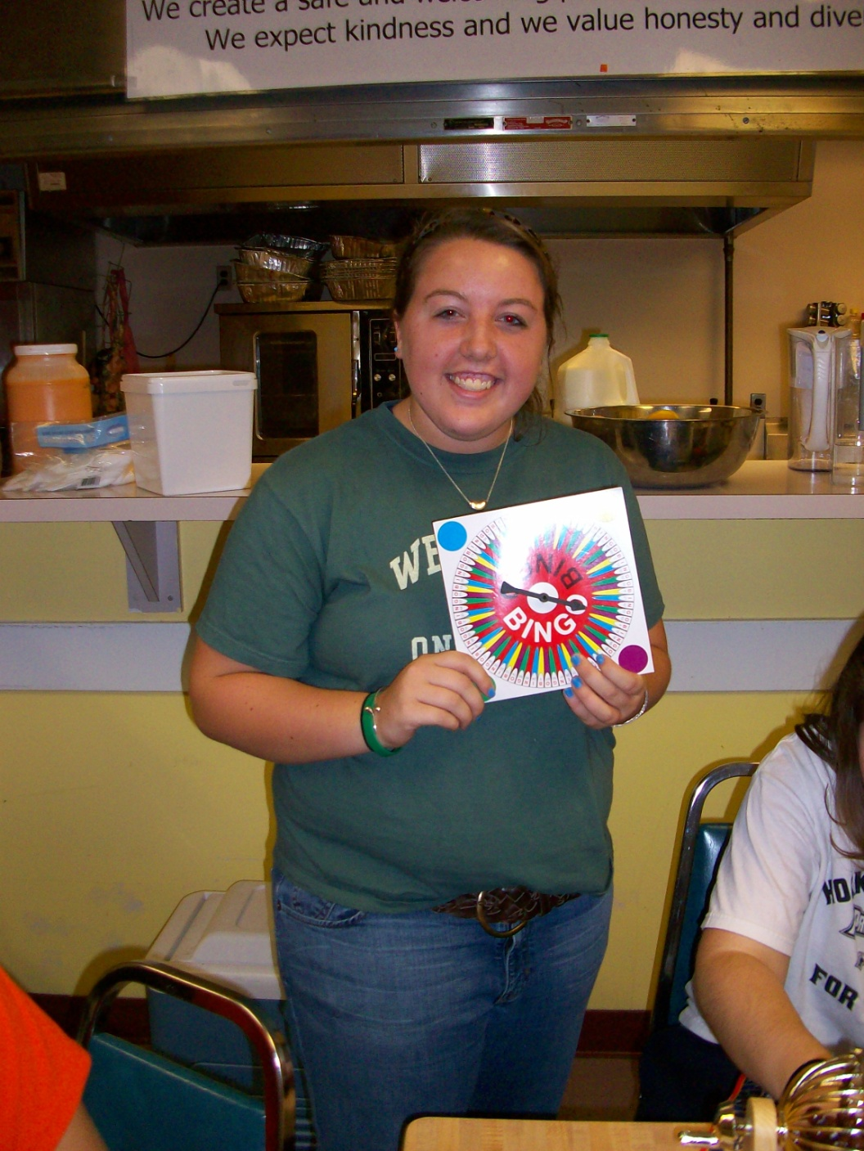

Martha Barber

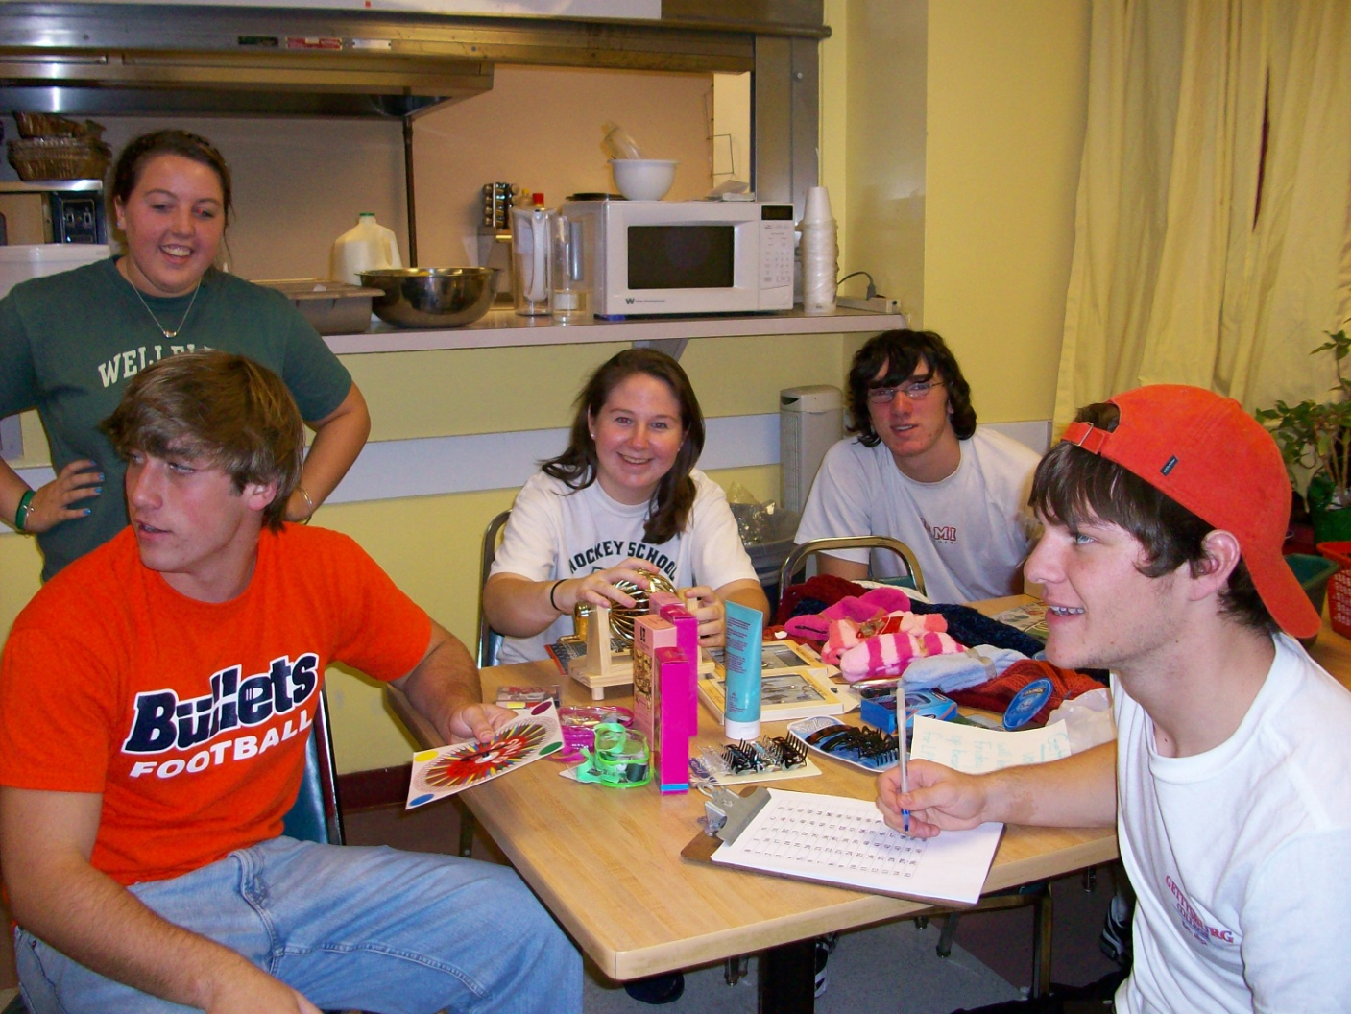

(from right: Martha Barber, Brian Keenan, Liz DeMetro, Rob Lagno, Mike Byrne)

