Judge Nelson Rupp

Christina Malles

We met with Nelson Rupp after a long day at DCCK. He is a drug court judge for Montgomery County. He is also the father of Eddie Rupp, a student who took the course last year. To start off our discussion he asked us if we knew what drug court was. None of us had a solid idea about it except for a few scattered concepts. He began to tell us that addicts are in a vicious cycle that is hard to get out of. Throwing them in prison will in no way help them escape from the cycle. This is where drug court steps in to provide special services for their needs.

First the substance abusers go to court to get sentenced. During their sentence they are not allowed to leave the secured facility except for appointments or meetings. Some meetings they are required to go to are AA meeting 3-4 times a week and group therapy 2-3 times a week. They also must to back to drug court multiple times a week. At the end of their sentence they graduate and move on to a halfway house called Oxford homes. These homes are a safe environment for the substance abusers to continue their recovery. They can live is the homes as long as they want, as long as they pay the rent and stay clean.

After Judge Rupp’s description of drug court, he told us about a huge success story of one of the substance abusers. This man was on the way to drug court when he passed by a burning house. He looked through the window and saw an older women trapped in her home. He acted quickly and broke the window to get inside to safe her. He managed to get her out safely and became a national hero. He would have never been passing by this women’s house if he wasn’t on his way to drug court. The old substance abuser made a full recovery and is doing fine now.

To conclude our discussion, Judge Rupp asked us how drug court relates to our course about homelessness. I must admit, at first I had no idea why we were listening to a man speak about drug court, but by the end it all made sense. A lot of homeless people are drug addicts and throwing them in jail will not solve any of their problems. Drug court gives people a second chance to get their lives back on track. Not only does it give them the tools for recovery, it also gives them a safe place to live after they graduate from the program. Judge Rupp is an amazing man who does great work.

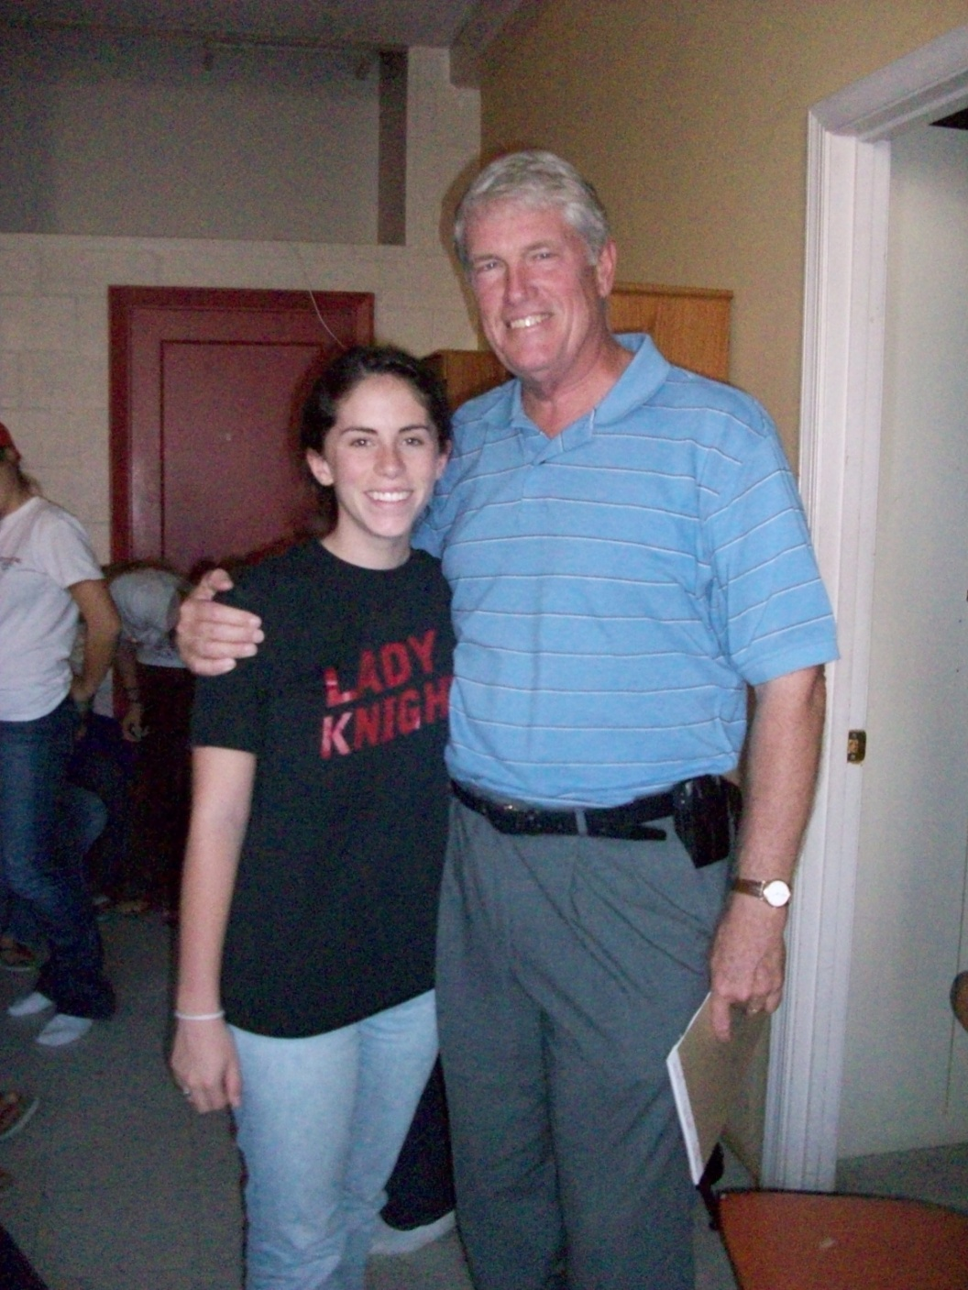

Christina Malles

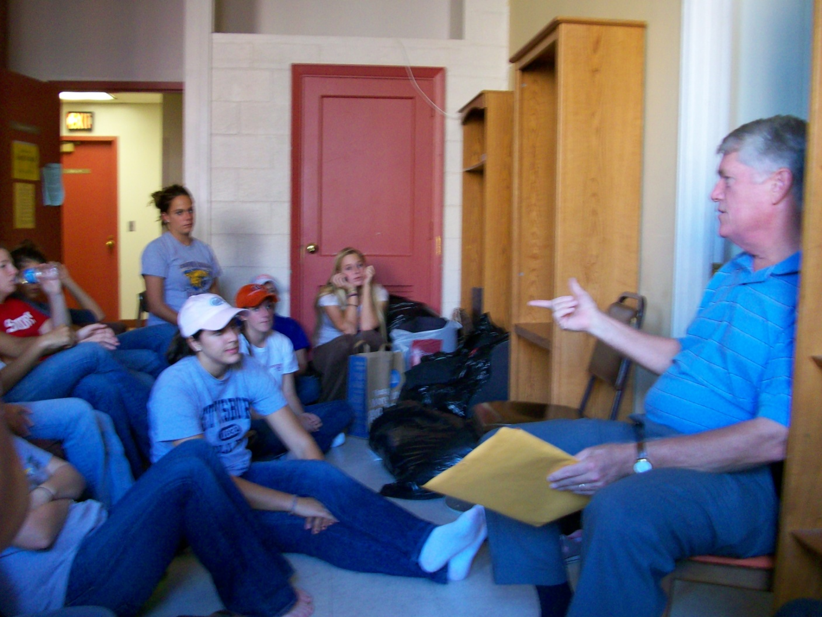

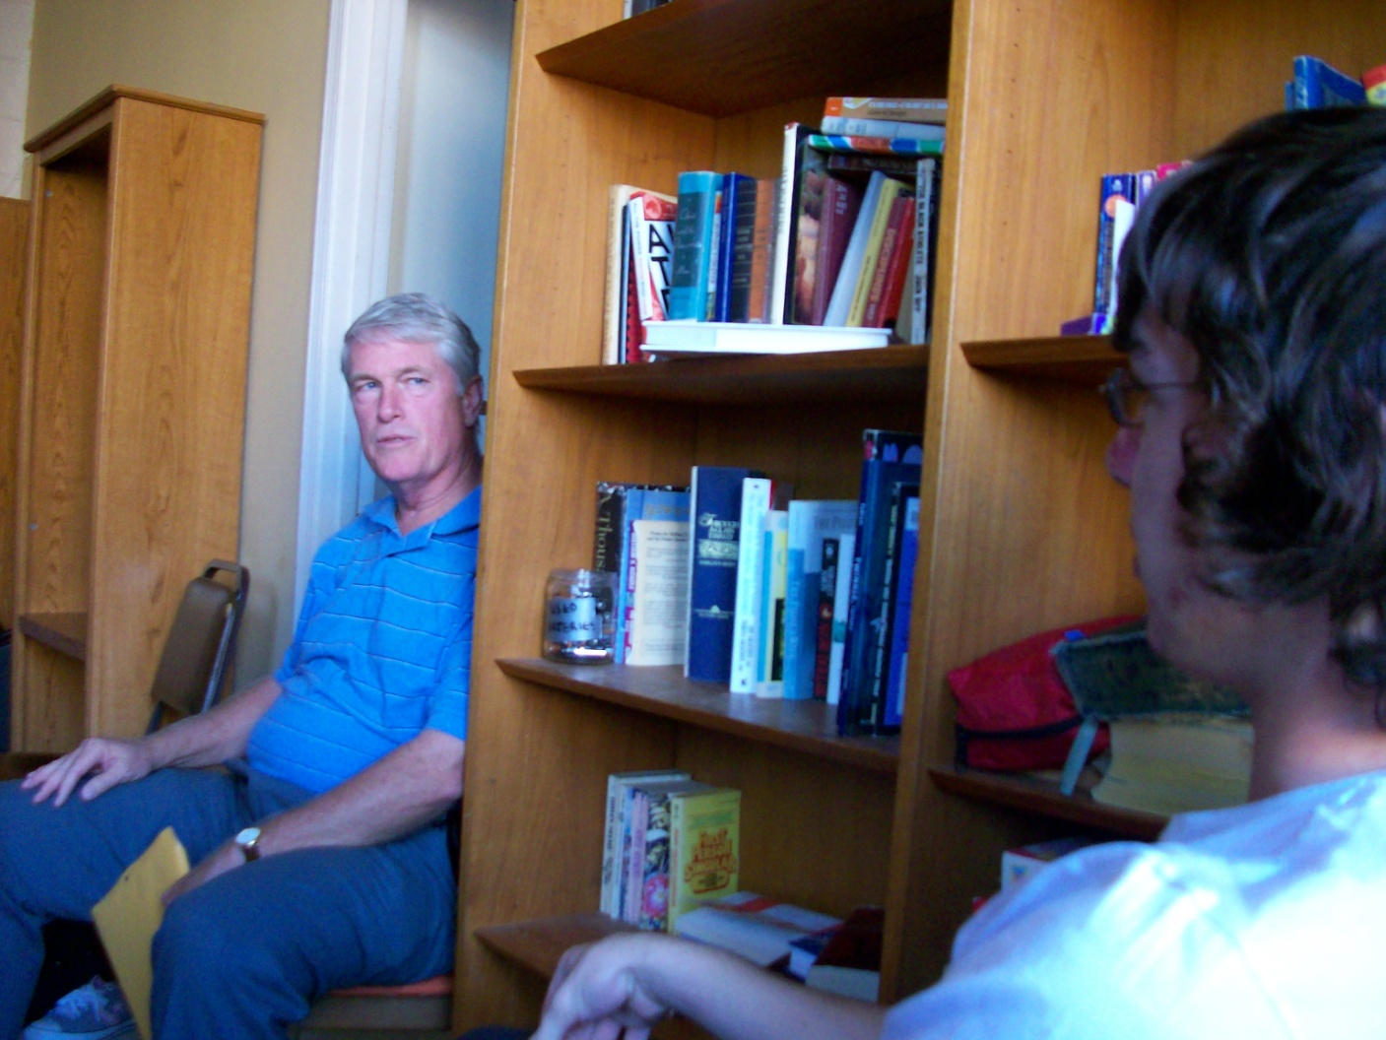

Judge Rupp and Rob Lagno