National Coalition for the Homeless

Today we had a meeting at the National Coalition for the Homeless. The organization, founded in 1982, is committed to fighting and eventually ending homelessness. We heard from three formerly homeless people, all of whom had very interesting and moving stories. Jesse Smith spoke first. Jesse became homeless after his wife filed for divorce. Jesse left everything to his wife, and he moved to Washington, D.C. to move in with his mother. Jesse became severely depressed. He quit his job and left the comfort of his mother’s home. Jesse was homeless for over six years before he finally returned to his mother’s home and became involved with the National Coalition for the Homeless. Brenda spoke next. She is fifty three years old and she became homeless due to family issues. She was homeless for four years and eight months before she was able to get off the streets. Brenda was very passionate about the issue of homelessness and her talk was very moving. Brian was the last to speak, and although his talk was a little long, he was also very interesting. He also became homeless due to family issues. Brian has been homeless for three years, and he recently moved into an apartment.

All three speakers spoke about their time in shelters and their experiences were very surprising. The speakers talked about how horrible most of the shelters are. They talked about the abuse, both physical and verbal, that the staff had inflicted upon them. Brian said that he was thrown through a wall and Brenda talked about how she was harassed and verbally assaulted every morning at the shelter. It was shocking to hear this, considering that we had been hearing all about how great the shelters in the city are. The speakers were so interesting because this was the first time that we got to hear what it is like to be homeless from people who had actually been homeless. By Liz DeMetro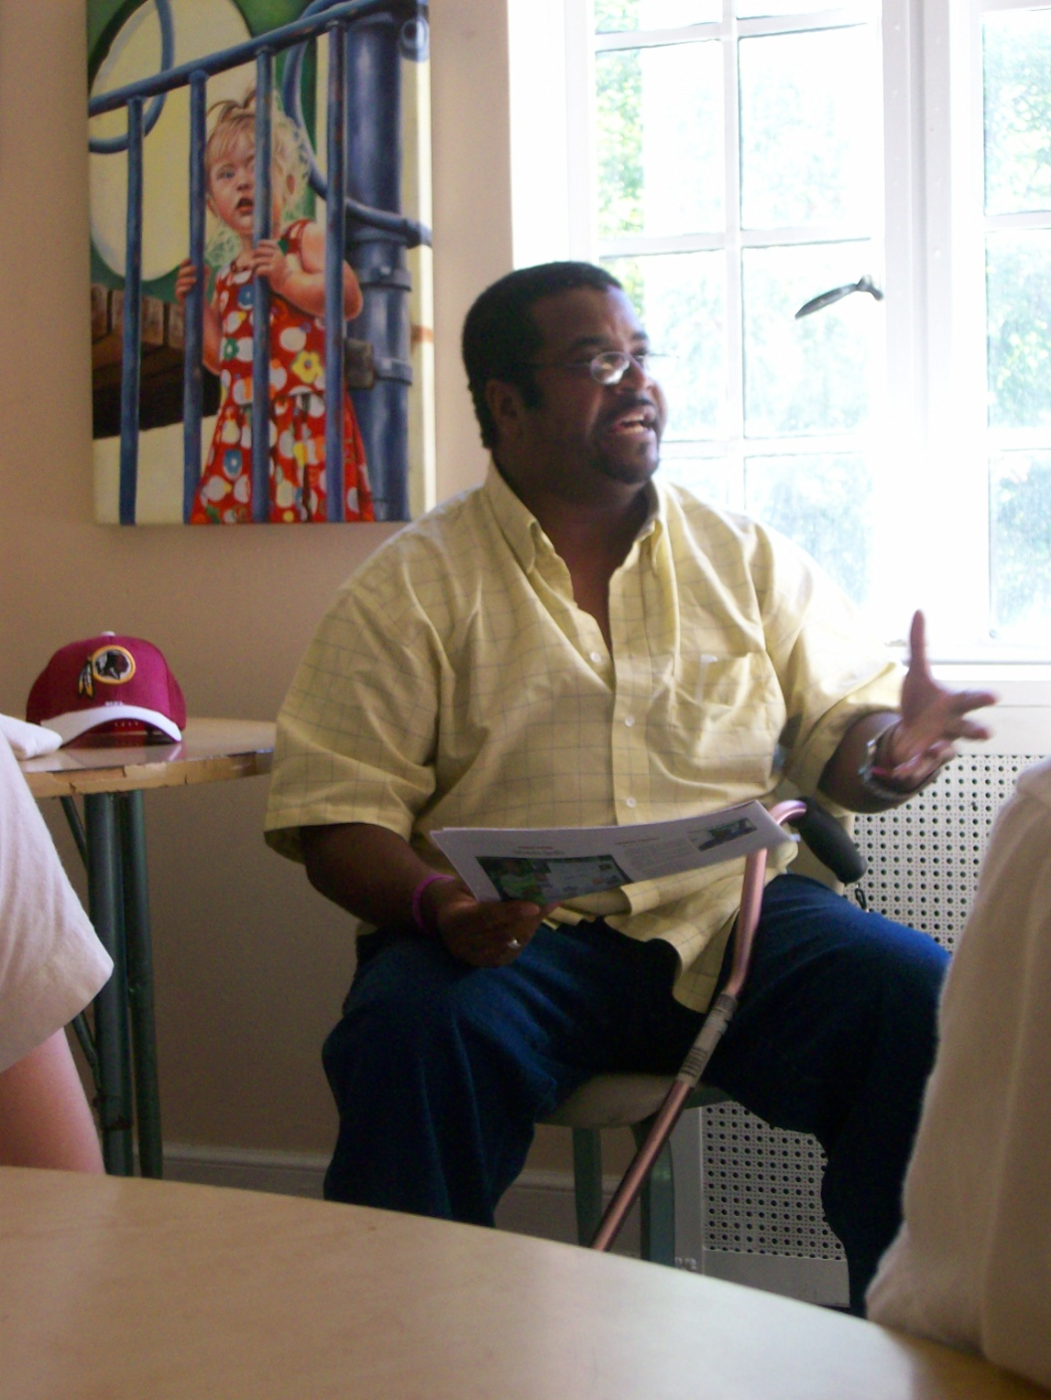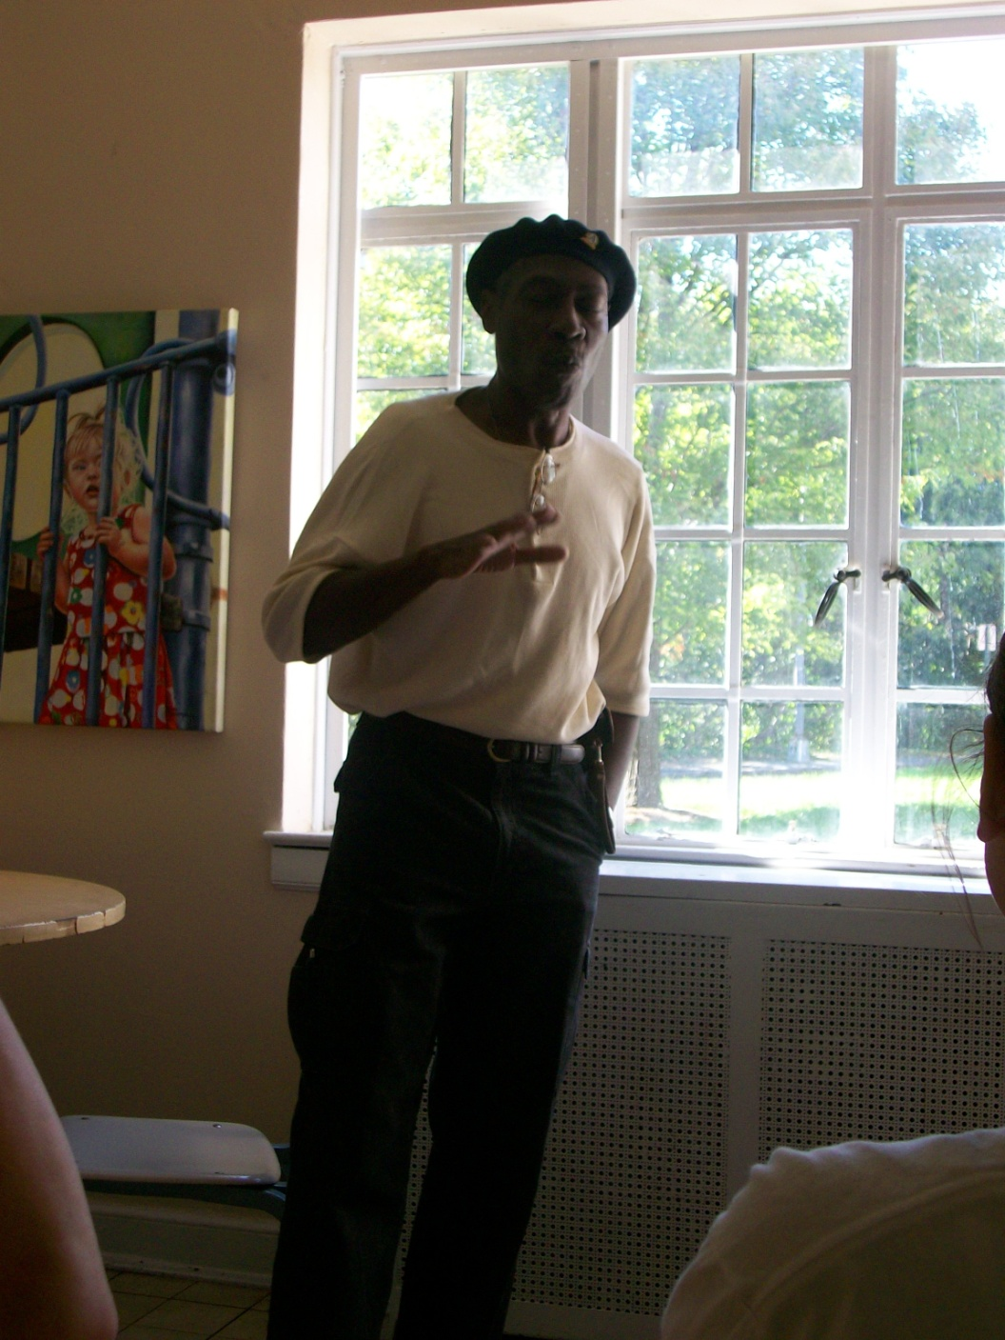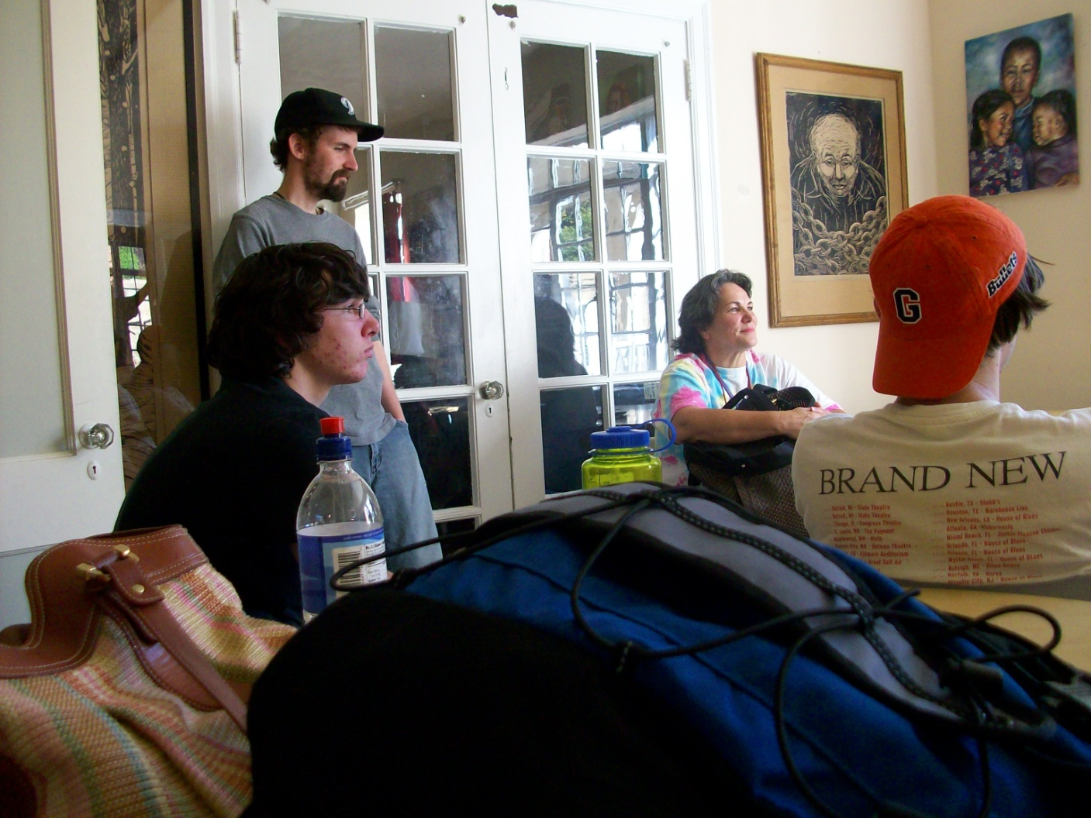

Rob Lagno and Mike Byrne

