Saturday – CCNV

Chrissie Walker

After lunch today, we visited the Community for Creative Non-Violence (CCNV). CCNV is a large building which houses many other operations in addition to its own organization. In the basement is DC Central Kitchen which we spent time at this morning. There are also a couple facilities for those with addition problems. In the building, there are two 12 hour shelters meaning clients only spend the night there, but leave during the day. At these shelters the clients’ spots are not saved so the clients change from night to night. This is extremely different from CCNV. CCNV is a shelter for steady clients to come for a longer stay. While at CCNV we heard from Donald Page. He informed us of both the history of CCNV and current facts.

CCNV was started by a group of recent college graduates. They saw a need for a facility that would not only serve meals and house clients for the night, but take more of an interest in their well-being. They founded CCNV to fill this void. The CCNV building was originally built for the Navy while the Pentagon was being built. Once the Navy moved the building was empty. CCNV got permission from the government to use the building for a winter, but convinced the government to let them stay after that.

The large building is extremely beneficial to the many clients CCNV houses. CCNV is one of the largest shelters in the country. It has the ability to house about 1300 people at one time. When we visited the estimate was between 800 and 900 clients. The male to female ratio is about 3:1. Only the first floor houses women. All the other floors are for men. The men are divided for floors by age. CCNV has many programs for their clients to help them find jobs. They also have many programs to help them enjoy their stay such as computer and art classes. CCNV relies heavily on donations of both money and objects. Many people donate furniture, clothes, and other belongings. Mr. Page told us that most of the money donations are for less than $100, commonly $10 and $20. This really gave the impression that every little bit helps. All of these donations add up over time. CCNV runs on about 600-800 thousand dollars a year. In addition to donation, CCNV receives some money from the government and other organizations.

It was nice to hear about how many clients have great success because of CCNV. Mr. Page explained to us that the highest success rate is with the young people. The young males at CCNV are generally able to turn their life around with the help provided are CCNV. Unfortunately, we didn’t get a tour of CCNV because they were spraying for bugs. Even with the tour though, it was easy to see how important CCNV is to the community.

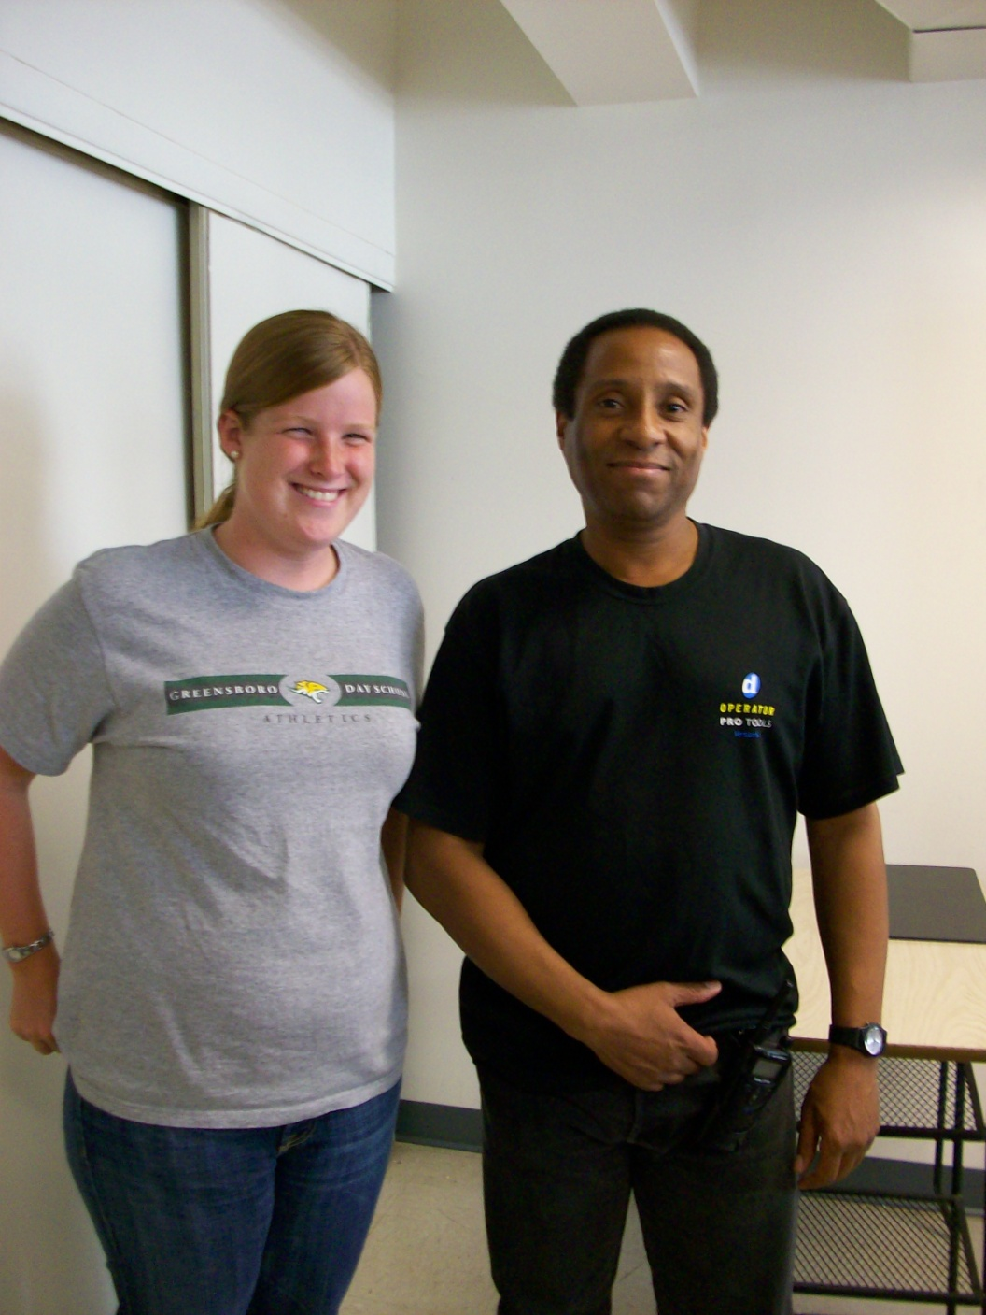  
Chrissie Walker and Donald Page

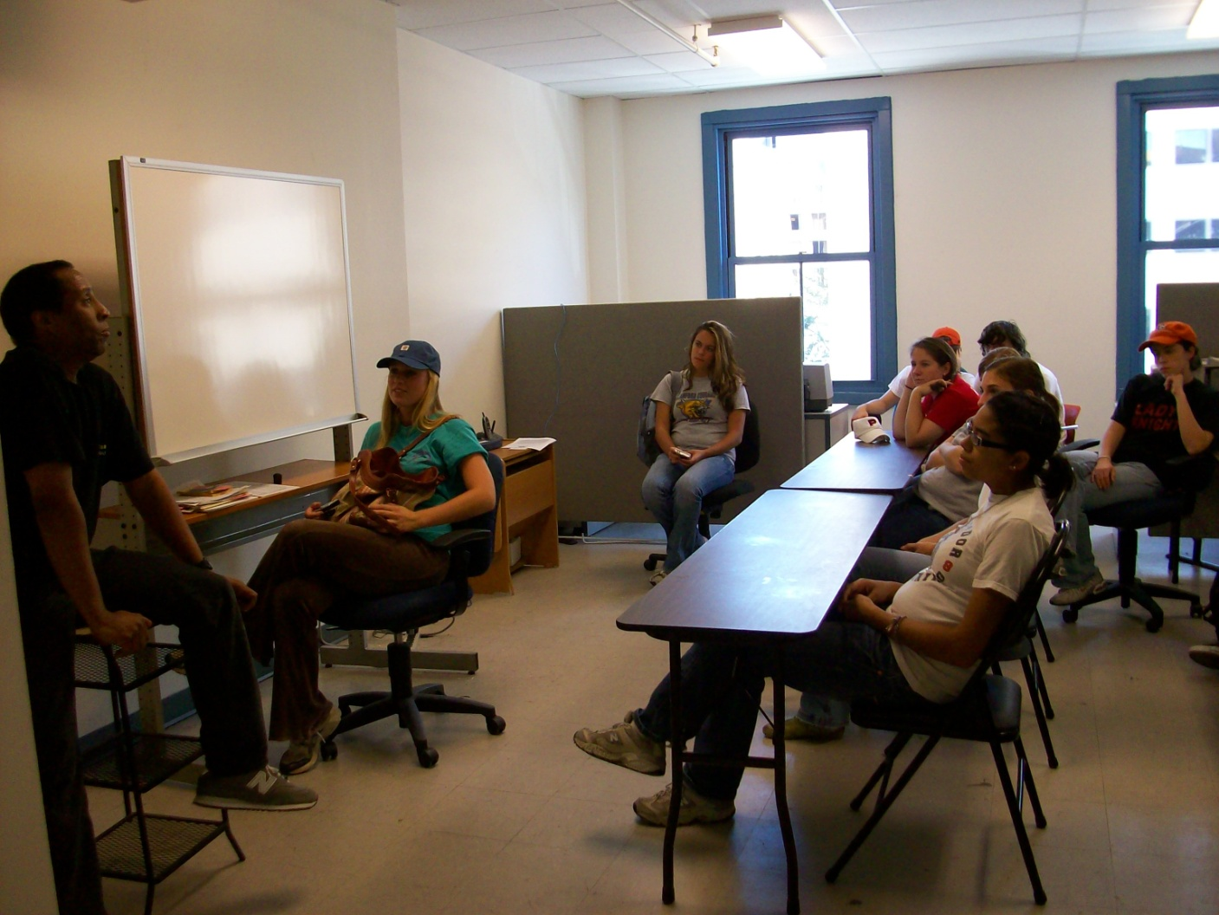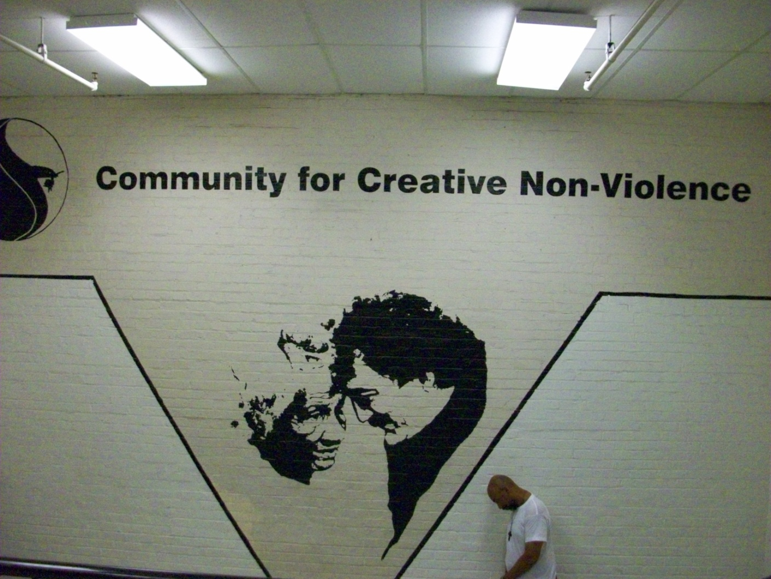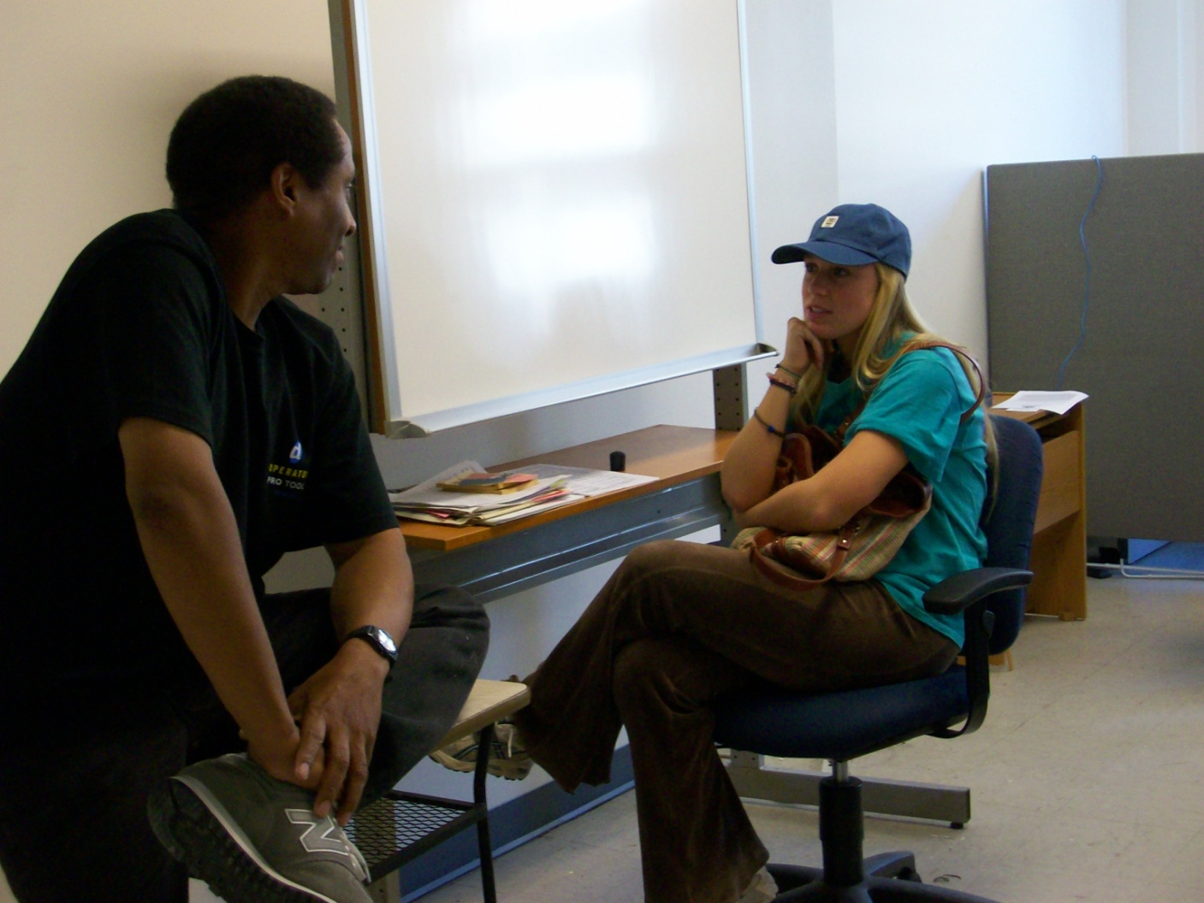

Donald Page and Harriet Manice

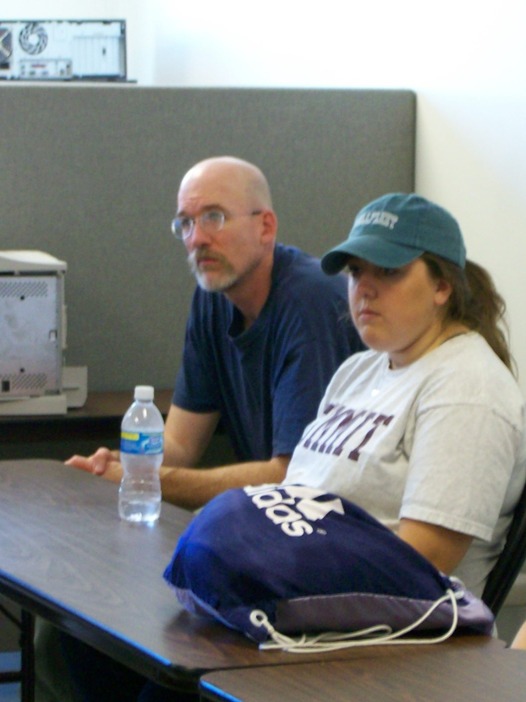

Chris Fee and Martha Barber