Day one:

(overview: Nstreet, Kyle Anderson, Bingo, night supervision)

Nstreet: (picures of Nstreet are after write up)

Nstreet

After unloading our luggage and the garbage bags that were filled with the clothes for the DC outfitters, we crossed the street to N Street Village. The N Street Village encourages low income and homeless women to have an opportunity at a better life. It was founded in 1973 by a Luther Place Memorial Church. Due to the increase in the homeless and the de-institutionalization of mentally ill patients, the N Street Village was created. The idea of hospitality and welcoming in strangers is the founding principle of the N Street Village. It started out welcoming men and women by providing sleeping mats on the floor for them, but after a few years it only focused on women. Men had many more opportunities than women in DC. It is now a womens shelter, but also has low income housing for families. By the mid 1970s, the church and other religious organizations turned over an enitre blocks worth of housing to the organization. The housing provided services such as medical clinics and food and clothing distribution centers. By the 1980s, it became apparent that more housing was needed for the women. The church stepped in and lead a community based effort to build affordable housing.

This organization has been a community based and will continue to be. It has thousands of volunteers a year aiding the two dozen staff members. The staff take pride in supporting their clients’ dignity, responsibility and ability. The clients are offered passionate relationships with their staff in order to promote good habits needed to get themselves back on their feet.

We were given a tour of the place by Kyle Anderson, a political science major in the Gettysburg College class of 2006. He wasn’t sure what to do right out of college, so he got a volunteer job at the N Street Village. After a year of volunteering, he thought he was ready to find a job elsewhere. He tried out a job at another place, but was unhappy. He decided to come back to N Street Vilage as a full time staff memb er, and loves every minute of his work. When he gave us the tour, he told us about all the services that N Street offers to the women in its program. Everything from free massages given by volunteer masseuses to free chiropracting services for women with aches and pains are given at the shelter’s health center. Kyle also told us about the day shelter for women, and took us down to the common area of this shelter. He explained that through this program, the women, provided they adhered to the rules, were given a place to stay during the day and a good nutritious lunch as well. The N Street Vilage is one of the most unique shelters and successful non profits in the DC area, and it was a great experience to see its inner workings thanks to Kyle.

Brian Keenan

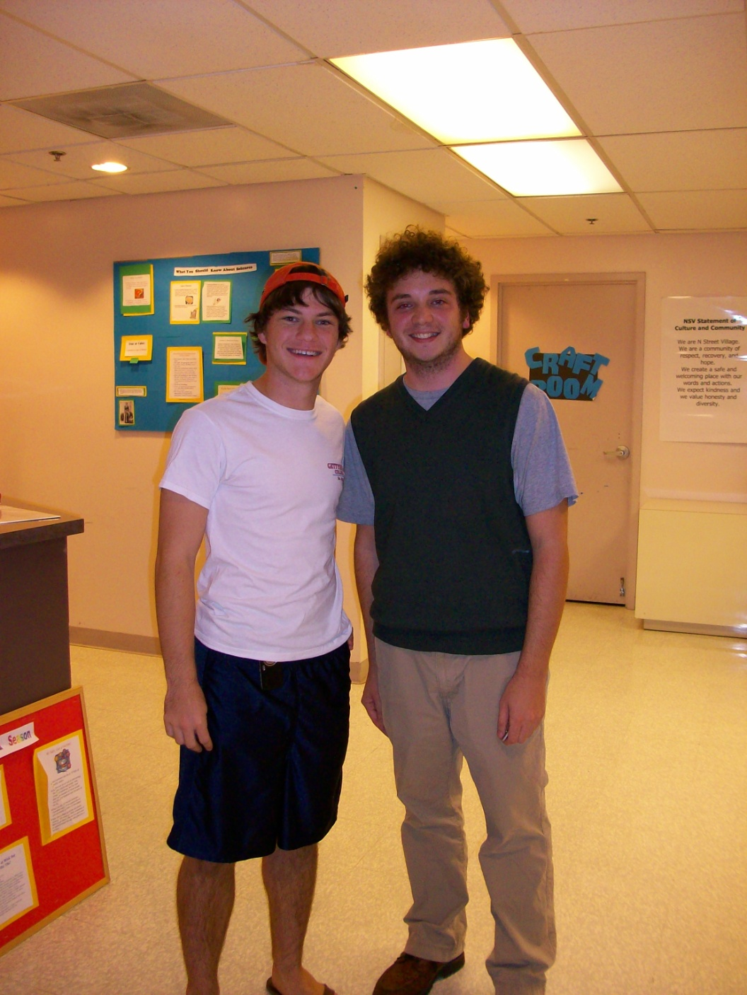

Michael Byrne and Kyle Anderson

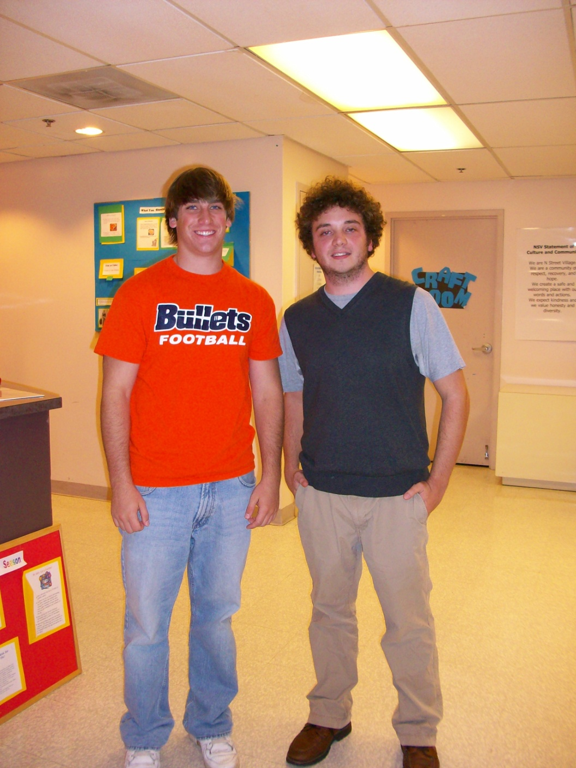

Brian Keenan and Kyle Anderson

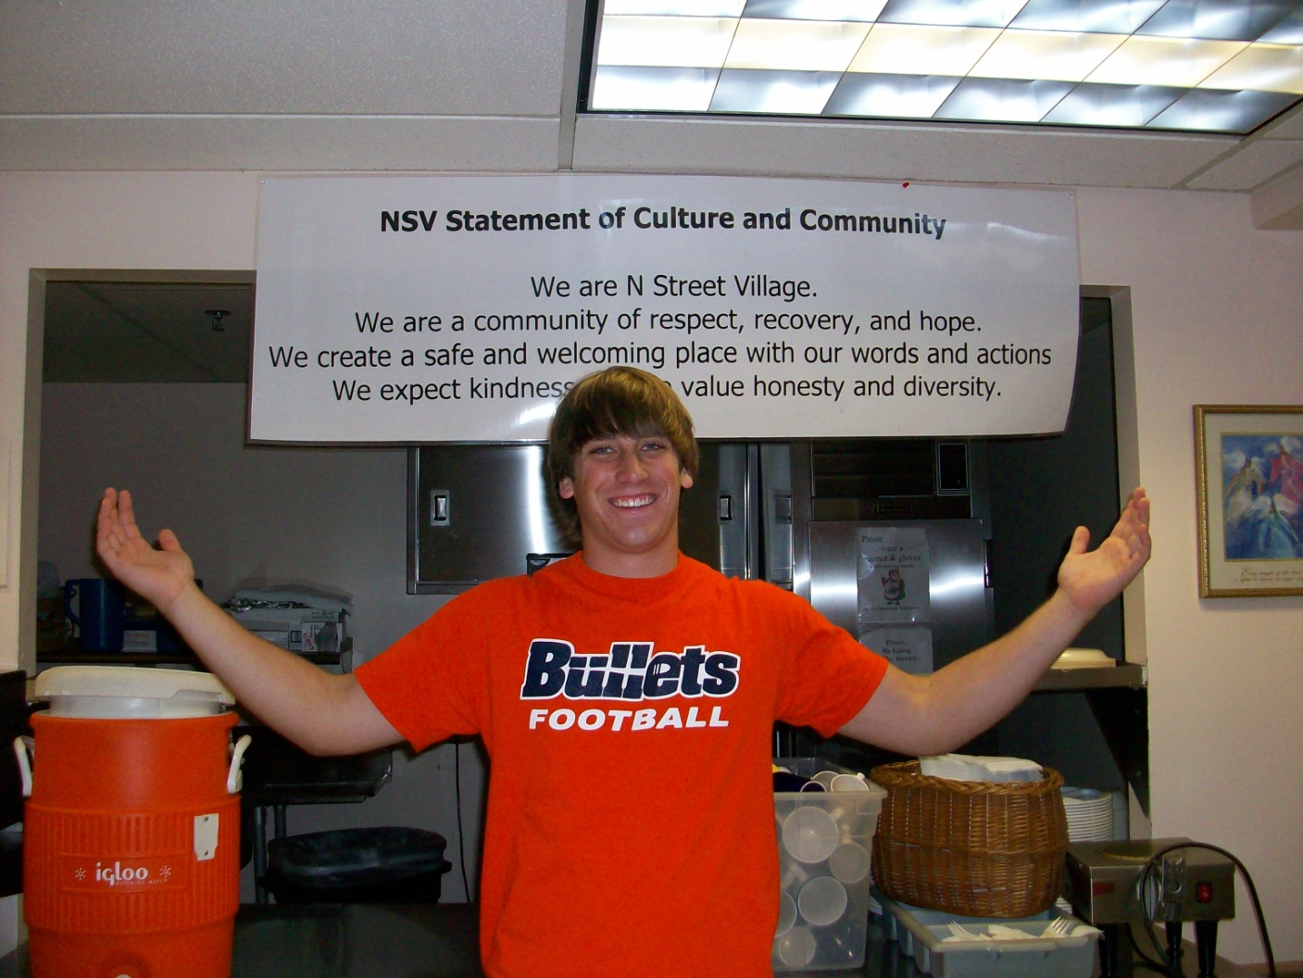

Brian Keenan

