D.C. Central Kitchen Day 4

By: Clair Pomponi

Today at D.C. Central Kitchen, as well as having us for volunteers, they also had another group our size (about 15 or so), helping as well. Of course, we are the elite crew and we dominated in the kitchen per usual. Lindsay and I got the job of husking corn, while Sara, Harriet and Kirsty made turkey and cheese sandwiches, and everyone else was in the other room chopping vegetables. Later, Kirsty, Lindsay, Harriet and I chopped tofu while Sara opened cans and managed to spill some of the canned vegetable juice all over her pants. Harriet also managed to splash us with tofu juice, which was so lovely. Although it was great that there were so many volunteers, it made the kitchen super crowded and we didn’t get to do as much. The experience was still just as rewarding and although we had a new group of chefs, they were still so nice and made the experience so fun. One great thing about DCCK is that all of the employees are so supportive and make you feel so comfortable in the kitchen. Courtney missed Bo from the weekend chef group but found a new friend in Freddy who she could be seen hugging and taking pictures with all day.

After we had finished cooking for the day DCCK served us lunch that consisted of corn on the cob, baked chicken, ribs, tossed salad, cupcakes, and coconut macaroons. Besides being able to get our food before the other group, we also had the pleasure of eating lunch with Robert Egger, the founder of DCCK, the author of Begging For Change, and as Fee likes to say, “a rock star.” Because Robert was at the kitchen today, there was also a camera-woman from Voice of America, an international TV and radio show, who was filming everyone in the kitchen, including us! The food was really good, and it was cool to know that we had made some of it over the weekend, and just like we were eating what we made, we were also feeding 4,500 people on the streets every day with it as well.

DCCK day four

By: Courtney Raneri

We had another adventurous day at DC Central Kitchen. We had a guest appearance by the “Man” himself, Robert Egger, amongst us in the kitchen. The morning was filled with chopping onions, sweet potatoes and salad making. As many people may come to conclude that Robert Egger is, in fact, a rock star, today definitely spoke the truth to that statement. Not only did this man create the concept of DC central kitchen but his office is located in the kitchen itself. Today, while I was chopping up the green peppers, I could feel his presence; literally he was everywhere. He was asking people about their morning, see what was being made today, as well as the plans for tomorrow. Robert truly showed his involvement even when a camera was following him around the entire time. It’s amazing to see that this man can still be a part of the everyday basics of the organization he created despite the fact that he flies all over the country and world to speak to others about this organization. He really is a rock star.

On the other hand, we were blessed with Miss Dot’s presence today, an infamous woman notorious for her reprimanding hand of “how to use a knife correctly”. She was in a jolly mood and even though I was under her wing last year, I immediately thought upon seeing her that she would clearly remember me. Miss Dot sees hundreds of volunteers every week and even though she did not, per say, remember me, she welcomed me with a hug, that took away my doubting thoughts. Even though I did not personally work with Miss Dot this year I know my peers thoroughly enjoyed her company.

So apparently, I’m name dropping, but to continue to do so a little further, Louisa Polos, a Gettysburg alum of ’08 paid us a short little visit. Louisa was a student of this class her first year at Gettysburg and continued to be a part of the class the remaining three years by being Professor Fee’s peer learning assistant; the position that I received when Louisa graduated. Not to mention that she also brought Campus Kitchens to Gettysburg’s campus. This organization is a smaller scale of DDCK which takes un-used food from our very own campus’s dining facility and products from our local farmer’s market, etc. and re creates meals for local organizations such as Circles of Support. She stopped by to sit with us for a few and it was nice to see the familiar face that had such an impact on this seminar and the campus for the past four years.

So as I previously stated, this camera lady was walking around the kitchen the entire morning, zooming in on a few of us dicing and cutting, and tossing and churning; a somewhat awkward scenario. But it was not until she pulled me aside to ask me a few questions in front of the camera did I realize how much this whole ideology not only impacted me as an individual but at the community at large. I can’t help but relate to our current economic situation, that many companies are cutting back at the moment and letting go many employees. It is now more important than ever that the community band together, something that the DC Central Kitchen has been doing for the past nineteen years. To many people DCCK is just a kitchen but after spending reading days last year as well as this year, it is much more than that. One thing that really sticks out in my mind is that Heart is being put into the creation of these 4,500 meals that are made each day. This kitchen is a family. They support each other and give each other the encouragement that one should need. Whether this is a little notion as saying thank you for bringing the dirty cutting boards to the wash area or creating an assembly line, that with the help of five people, can make 10 pans of salad that will potentially feed 250 people. To take it even further , I know that myself along with the staff and other volunteers are helping the less fortunate get through the day. Try sleeping on that thought every night! It’s an amazing concept and a success! After just spending a few days here everyone is giving each other hugs and smiling from ear to ear. DCCK has a positive atmosphere and to come work here and being able to love what you do every day is, is an aspect of a job description anyone would die to have.

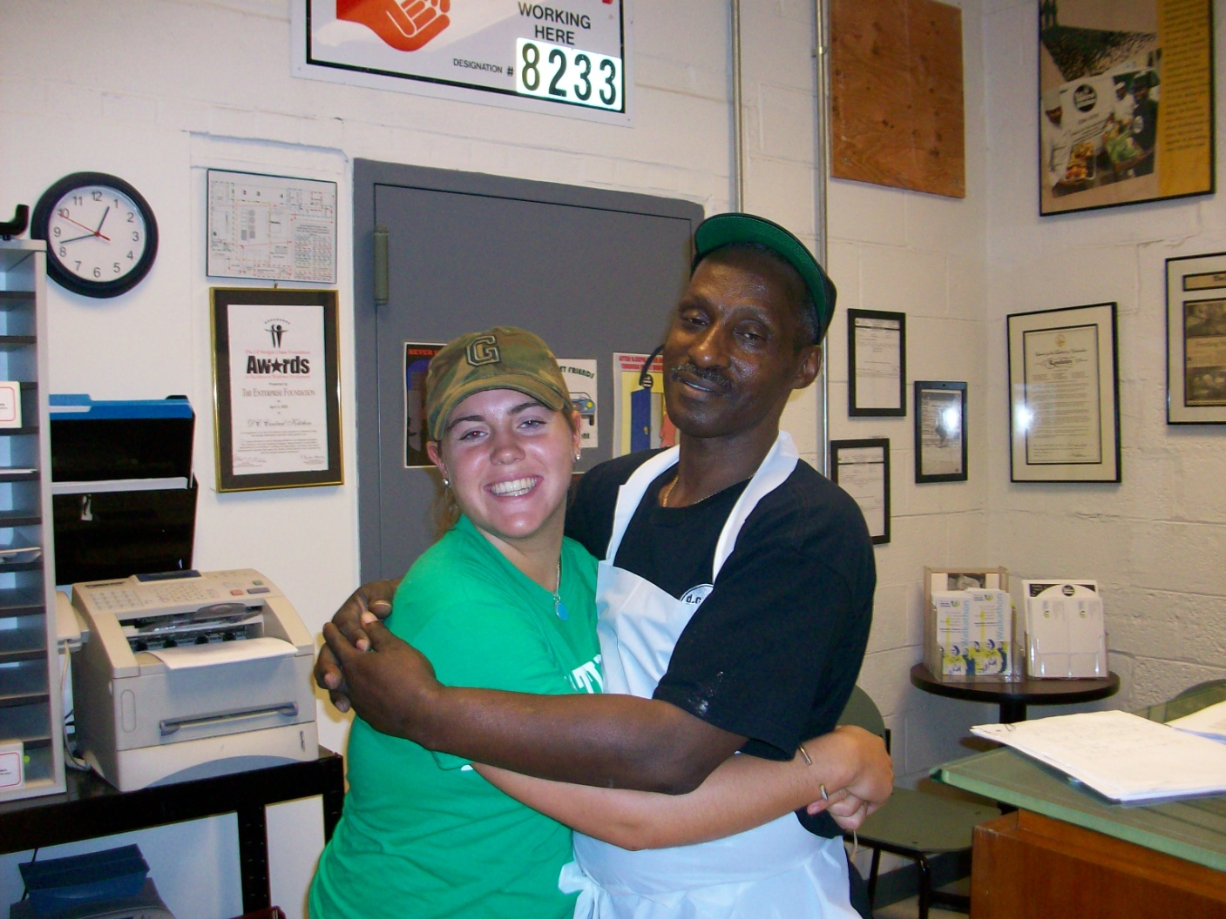

Courtney Raneri and Freddie

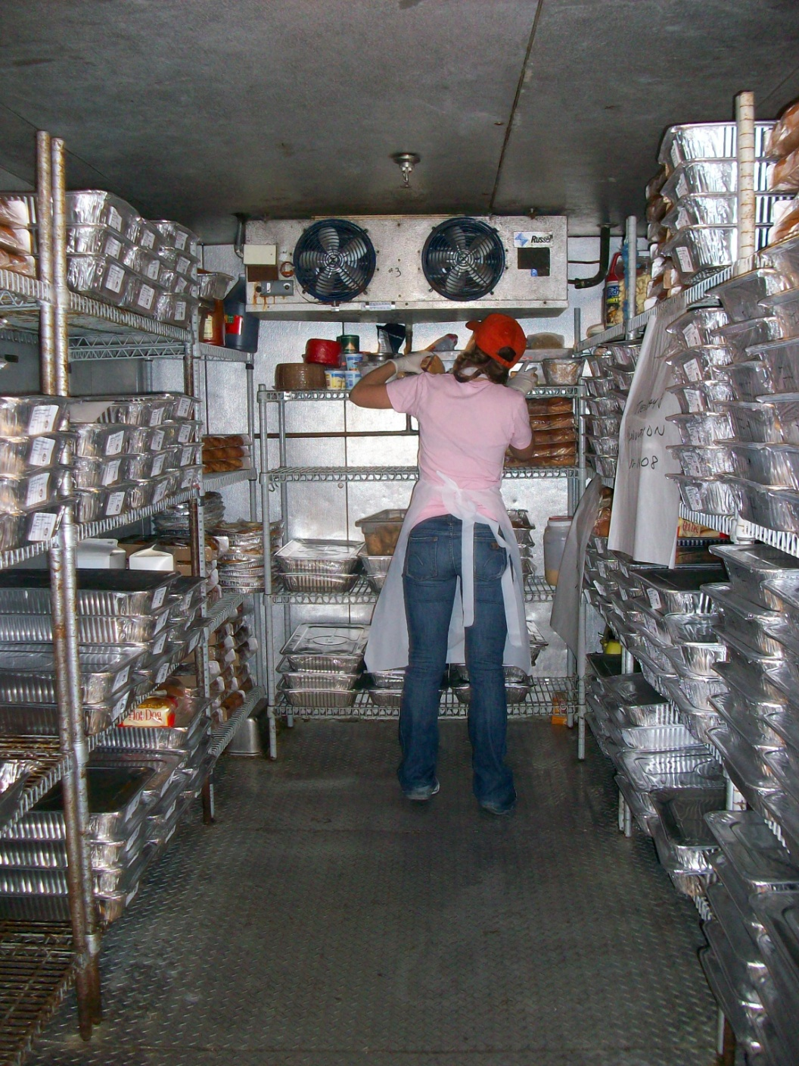

Clair Pomponi

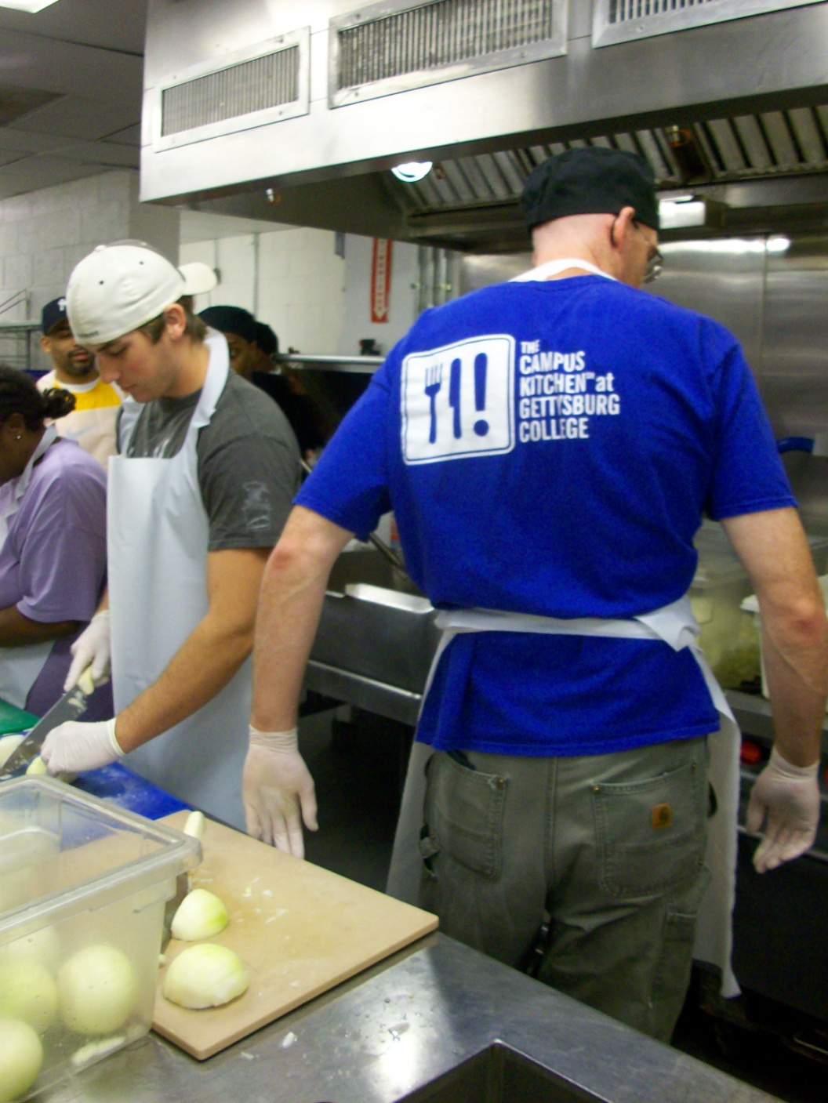

Brian Keenan and Chris Fee

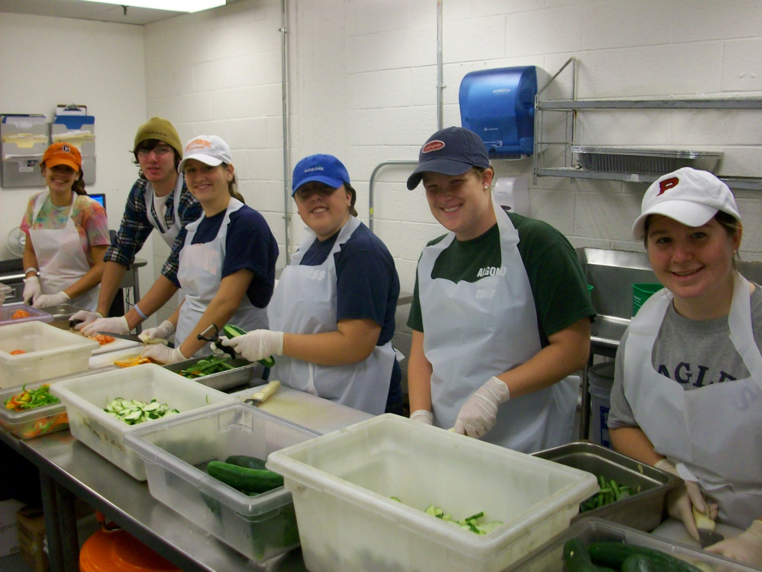

Shelby Lutz, Rob Lagno, Christine Chace, Martha Barber, Chrissie Walker, Liz DeMetro

Ro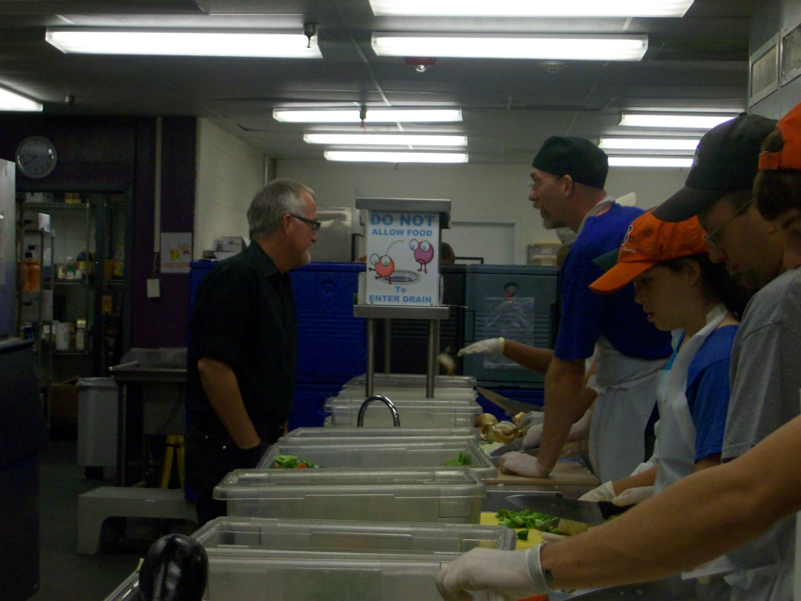

The “Rock Star” Robert Egger and Chris Fee

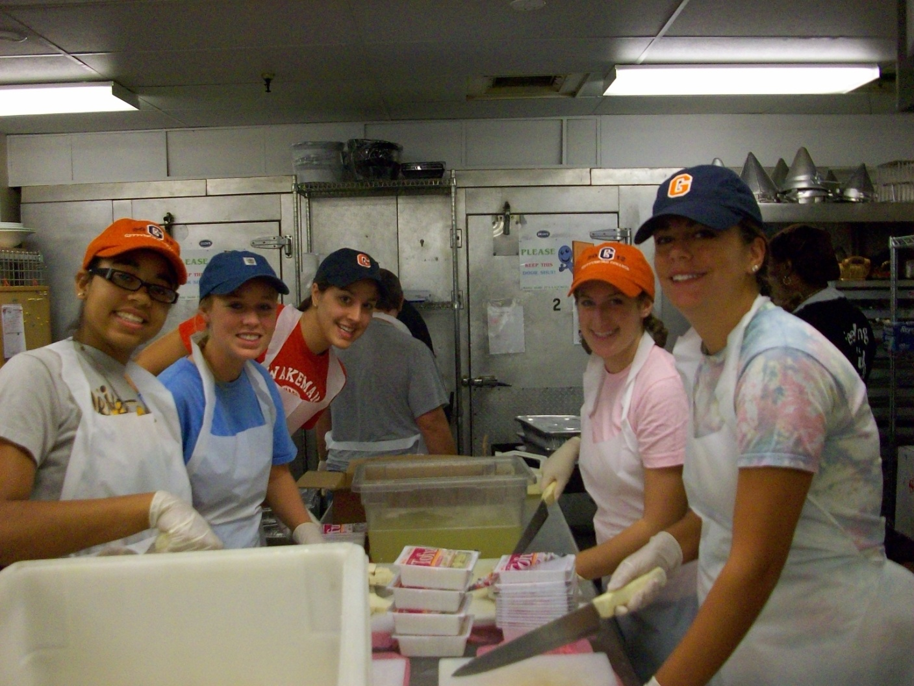irsty Bryant-Hassler, Harriet Manice, Sara Kinsley, Clair Pomponi, Lindsay Preucil

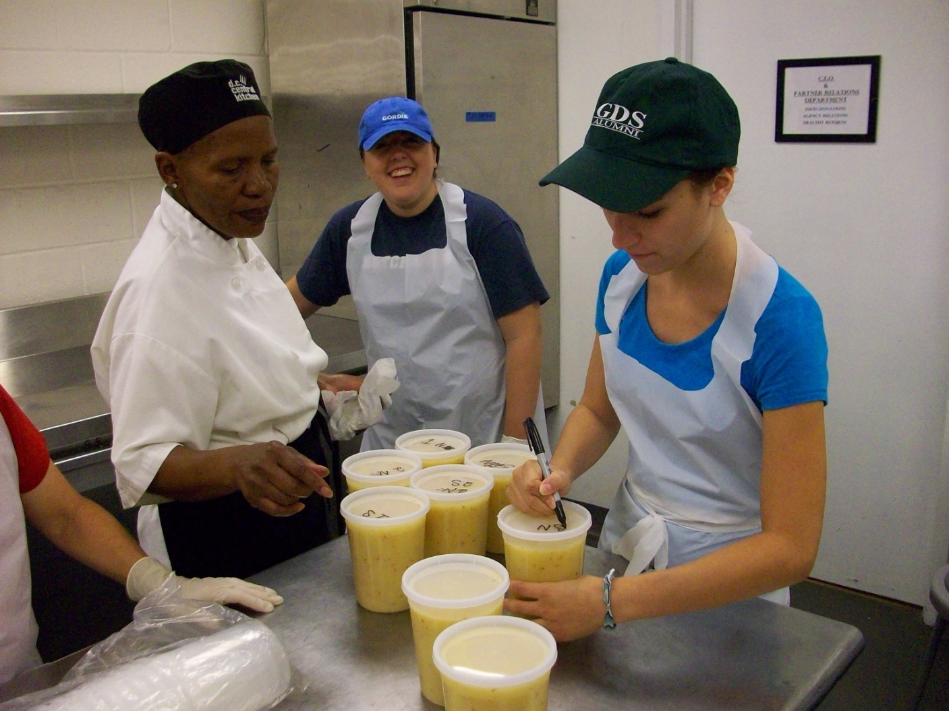

Miss Dot, Martha Barber and Gia Galatro

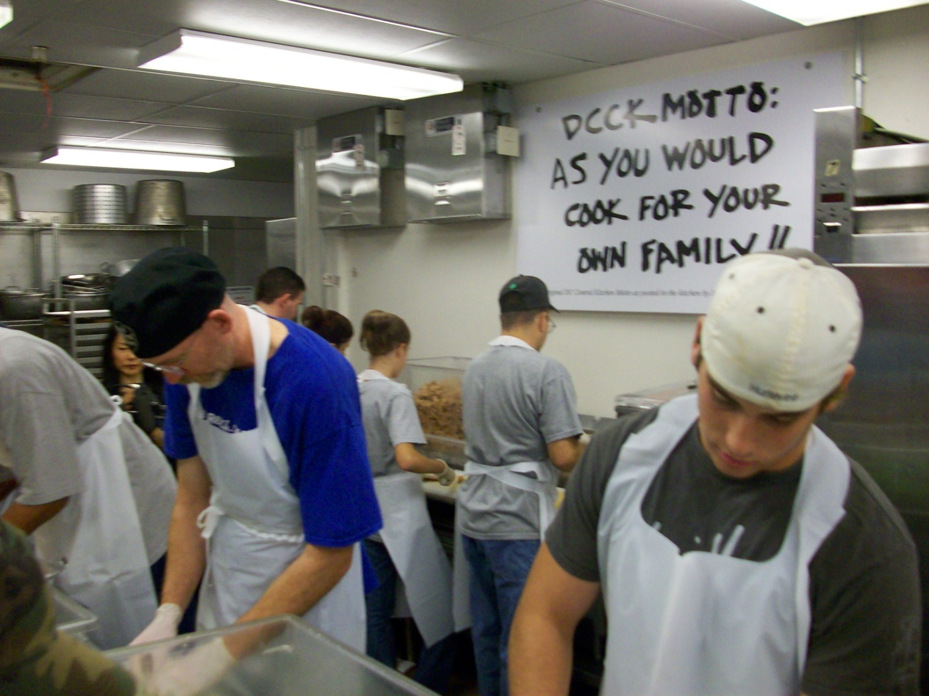

Chris Fee and Brian Keenan, displaying the DCCK motto: “As you would cook for your own family!!”