Day Four: Robert Egger

“It’s so simple but sometimes there’s nothing better than a croissant with cheese,” said Robert Egger as he stopped at our station and started small conversation. After he moved on to the next group, the five of us making croissant sandwiches paused and gave puzzled glances to each other until one of us realized, “That’s him! That’s Robert Egger!”

In his book, *Begging for Change*, Egger gave off a confident air that demanded a change in the way nonprofit organizations are run. He assured his readers that his way was the right way and the way of the future. This was someone described to me before we met him as the “Man” and a “rock star.” There was no way this small, friendly man walking around the kitchen interacting with staff and volunteers was not the large, booming man I pictured.

During his talk to the group of us, however, his sweet demeanor packed a powerful message. Robert Egger grew up with the dream of running a famous nightclub. He was moving up in the business when an experience with the homeless along with his knowledge of restaurant waste inspired an idea. He realized that all the food thrown away by restaurants at the end of the night could be utilized to make meals for those who can’t afford it. Also, he could create a job training program that would teach the homeless basic food handling skills. He abandoned his night club dream to fight the cycle of poverty with his revolutionary idea.

D.C. Central Kitchens was born and has grown to the great organization it is today. It makes 4,500 meals daily and has empowered many formerly homeless to become successful in the working world.

When he stood at the head of our table as we all ate lunch, he challenged us to use what we know and learn to make a better system out of something that already exists. He said we should use our skills and experience volunteering to create new ways to solve society’s problems. Even though obstacles and resistance may stand in the way, a new and good idea is something worth fighting for. Robert Egger’s ability to remain humble and kind yet enforce his ideas with vigor and passion proved that he lived up to his description as “the Man.”

Lindsay Preucil

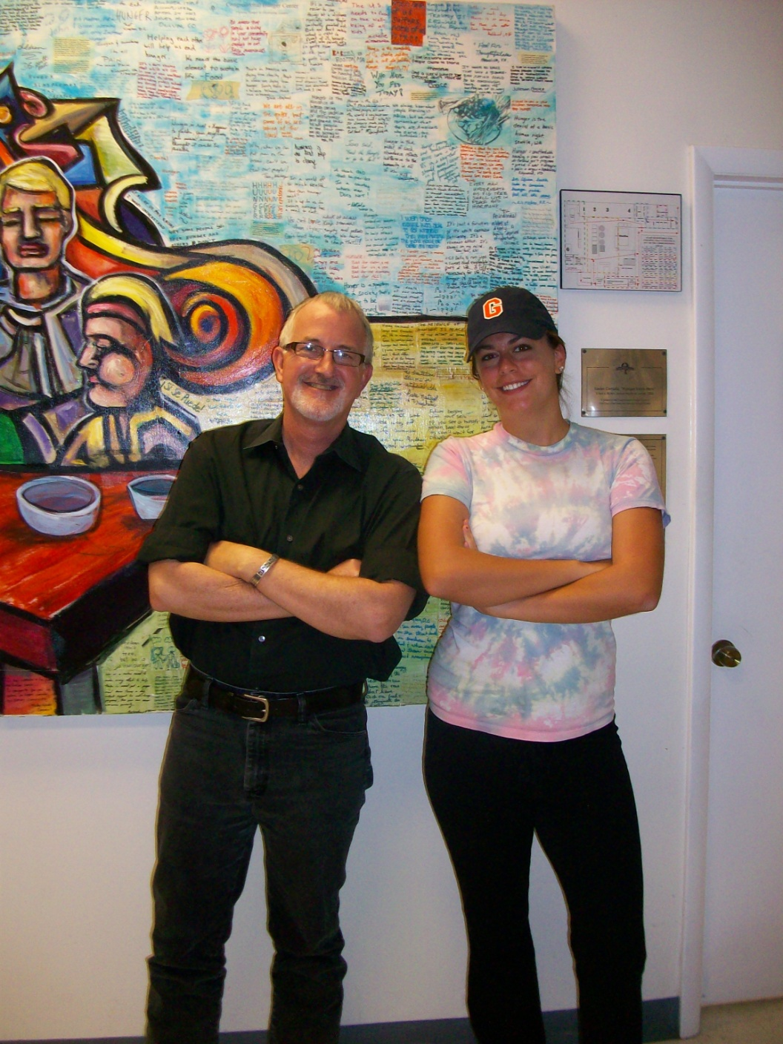

Robert Egger and Lindsay Preucil