05/16/06

Images of Gold Using LabVIEW

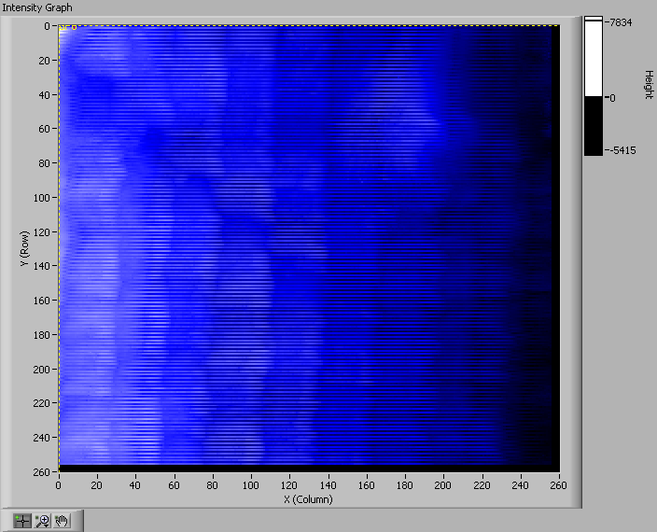
Figure 1: Intensity graph using 256x256 points.

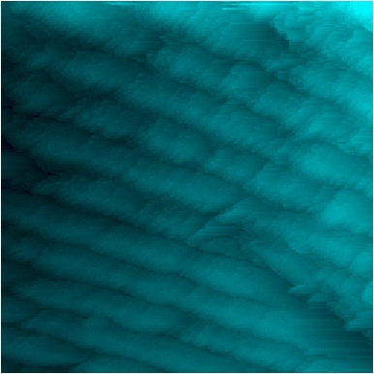
Figure 2: Data taken using the old system (this is different data).

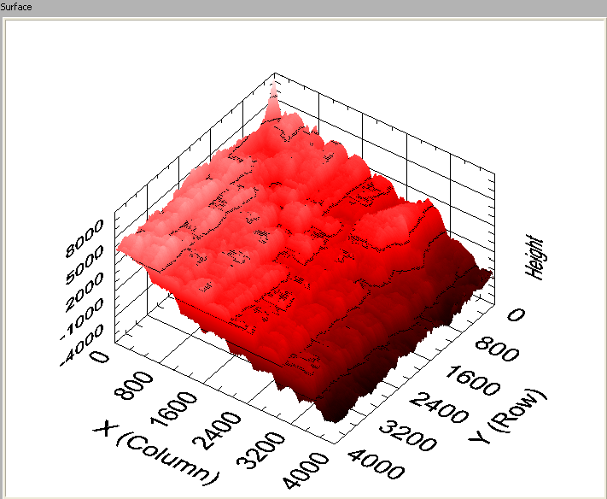
Figure 3: 3D plot using 256x256 points.
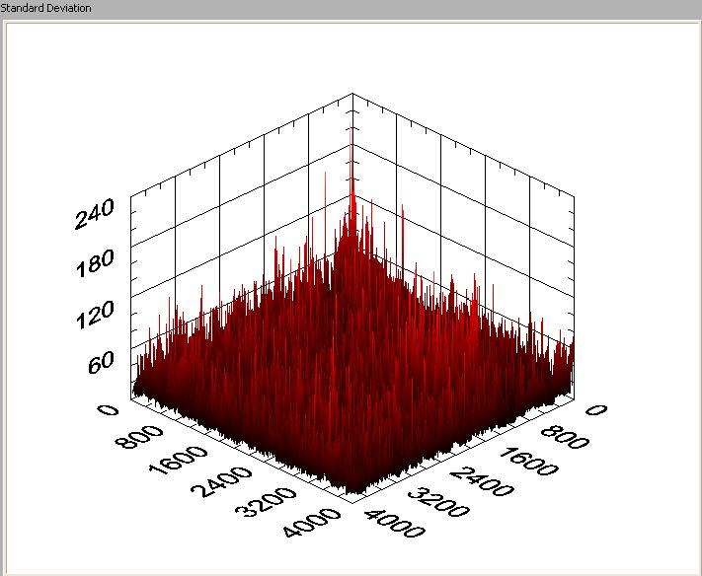
Figure 4: Standard deviation of data using 256x256 points.

