05/02/2006

First Images of Gold

I was able to successfully image a new gold sample. To do this I had to drip solder from the gold to the sample holder for good conduction and use a piece of platinum iridium wire. To compare our new DAQ system to the old one, I took images using the old system and, without changing any of the microscope settings, took an image using the new system.

Figure 1 shows an image of the surface of a gold plated grating using the old system. The corresponding image taken using the new system is shown in Figure 2. These images were taken with a zoom factor of 10x. I also took images at 2x zoom, see Figure 3 and Figure 4.

Notice that the raised area in the middle of Figure 1 can be seen in Figure 2. It also appears that images using the new system are not as clear. It’s possible that the old system does some sort of smoothing.

Figure 4 shows that the current system is definitely not a final product. It’s not possible to make out the period of the grating using the new system.

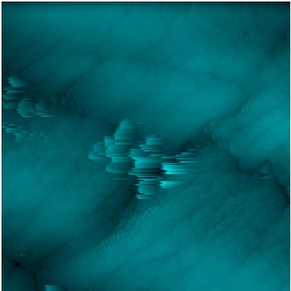
Figure 1: Image taken using the old system at 10x zoom.

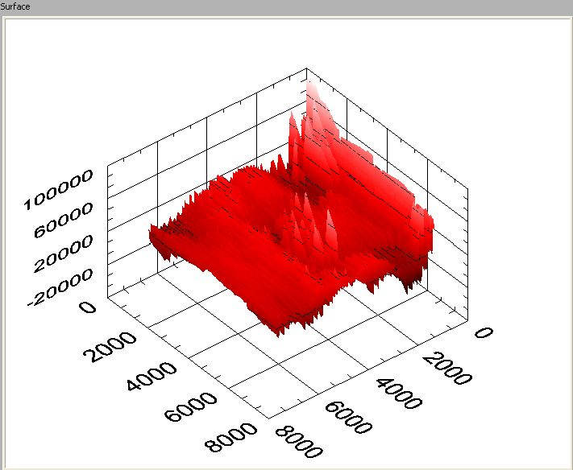
Figure 2: Image taken using the new system at 10x zoom.
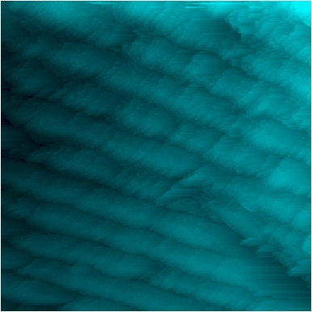
Figure 3: Image taken using the old system at 2x zoom.

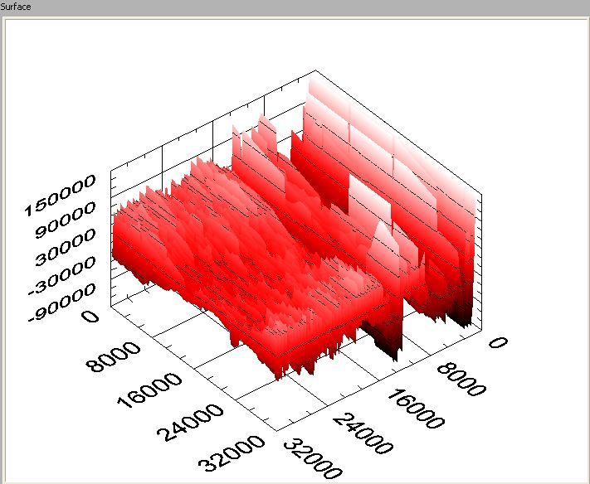
Figure 4: Image taken using the new system at 2x zoom.

