# JUPITER’S MOONS AND THE SPEED OF LIGHT

Student Manual

A Manual to Accompany Software for

the Introductory Astronomy Lab Exercise

Edited by Brad Knockel, CNM Community College, 2015

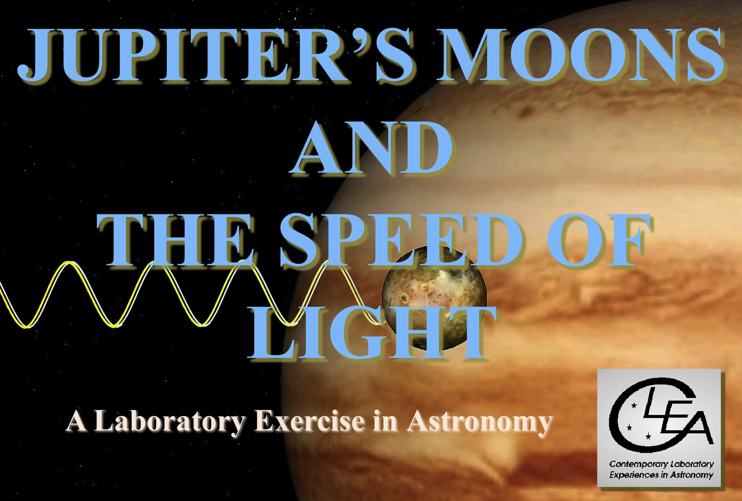

|  |  |
| --- | --- |
| Department of Physics  Gettysburg College  Gettysburg, PA 17325  Telephone: (717) 337-6028  email: [clea@gettysburg.edu](mailto:clea@gettysburg.edu)  ***Database, Software, and Manuals prepared by:***  Jan Paul Dabrowski, Marylhurst University, Glenn Snyder and Laurence Marschall (*Project CLEA*, Gettysburg College) | Contemporary Laboratory Experiences in Astronomy |

Contents

**Learning Goals 3**

Procedural Objectives 3

Useful Terms 3

Introduction: Historical Background of the Roemer Experiment 4

Starting the Program 9

Accessing Help Files 9

Summary of the Lab Activity 9

Overview of the Observing Procedure 10

Before you Begin 11

Observing Procedure---A Worked Example 14

Your Observations and Calculations 19

Questions and Discussion 20

**Goals**

You should be able to use the observations of eclipses of Jupiter’s moon Io by Jupiter’s shadow, taken at different points in Jupiter’s orbit, to determine the speed of light. You should be able to understand how Ole Roemer, in the 17th Century, was able to notice that light did not travel through space instantaneously, but had a finite speed.

**Objectives**

**If you learn to …….**

Observe Jupiter’s Moons as they orbit the planet.

Recognize eclipses and record precise times for them.

Predict the timing of future eclipses of Io by Jupiter using the known period of Io around Jupiter and observations of the time of one eclipse.

Observe eclipses of Jupiter’s moon Io, once when it is close to Earth, and once when it is much further from Earth (when Jupiter is on the opposite side of the Sun.

**You should be able to …….**

Compute the time difference between an expected eclipse and your observations.

Determine the speed of light due to the difference between the observed and expected time of eclipse.

**USEFUL TERMS YOU SHOULD REVIEW IN YOUR TEXTBOOK AND IN THIS MANUAL**

|  |  |  |  |  |  |
| --- | --- | --- | --- | --- | --- |
| *Astronomical Unit* | *Conjunction* | *Eclipse* | *Ephemeris* | *Galilean Satellites* | *Julian Day* |
| *Jupiter* | *Latitude* | *Longitude* | *Opposition* | *Orbit* | *Percent Difference* |
| *Period of an Orbit* | *Satellites* | *Shadow* | *Speed of light* | *Universal Time* |  |

**INTRODUCTION**

**Ole Roemer and the First Measurement of the Speed of Light**

The CLEA Moons of Jupiter simulation can be used to duplicate an experiment performed three centuries ago to determine the speed of light. In this activity you will be able to recreate that feat and find the speed of light.

## Introduction

The first accurate determination of the speed of light ( c ) was made in 1676 by Danish astronomer Ole Roemer. He did this using timings obtained by Giovanni Cassini of the eclipses of Jupiter’s moons.

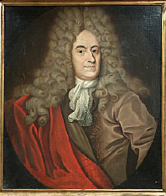

Figure 1: Ole Roemer

Roemer obtained a value of:

***c = 2.14 x 108 meters per second***

This is 70% of today’s value:

***c = 3.00 x 108 meters per second***

The significance of Roemer’s determination was finding that light had a finite speed and was not instantaneous, as many people had thought before him. In other words, light took time to cover a distance. He also showed that light was amazingly fast.

Keep in mind that Roemer did this more than 300 years in the past without the benefit of technology other than good clocks and a telescope only 60 years more advanced than what Galileo had used to discover Jupiter’s moons.

Roemer was not initially trying to find the speed of light. Like many scientific investigations today, his research took a left turn. His original goal was to see if the orbiting moons of Jupiter could be used to find the longitude of places on earth, something that was of paramount importance to ships’ navigators.

## Jupiter the Clock

Galileo discovered that Jupiter had four moons in 1610, which went around the planet with remarkable regularity. It didn’t take long before astronomers had highly accurate measurements of the orbital period of these satellites. Io orbited in about 1.8 days. Europa took 3.5 days. Ganymede’s orbital period was just over 7 days. And Callisto, the most distant of the Galilean moons, went around Jupiter in 16.7 days.

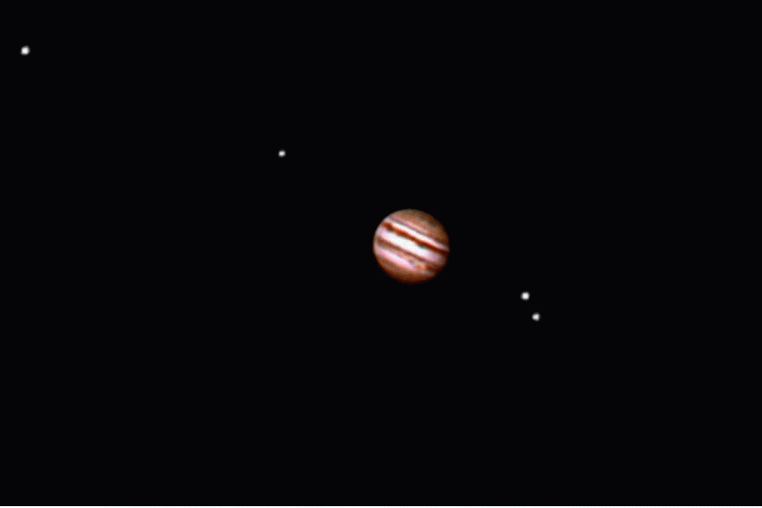

Figure 2: Jupiter and the four Galilean moons.

Credit: Michael Stegina/Adam Block/NOAO/AURA/NSF

If the periods were indeed regular, and could be determined with high precision, the positions of the moons around Jupiter could be predicted for any given time in the future. A table of predictions of the positions of celestial objects at given times is called an *ephemeris*.

The disappearance or reappearance of the moons at certain points in their orbit was the easiest position of the moons to time exactly. Astronomers, of course, noted that the moons disappeared when they went behind Jupiter. But it was even more common to see the moons disappearing *before* they actually passed behind the planet or reappear slightly *after* they came out from behind it. That is because the moons only shine because they reflect light. When the moons pass into Jupiter’s shadow, they go dark. Jupiter’s shadow is a cone of darkness that extends out from Jupiter into space in the direction opposite to the sun. So the position of Jupiter’s shadow depends on where Jupiter is in its orbit. Astronomers had to take this into account, as well as the orbital period of the moons, when they calculated an ephemeris for eclipses of the moons. But once they had done these calculations, the ephemeris could be used to forecast the times of future eclipses. In a sense, the moons were like the hands of a very precise celestial clock.

For example, imagine that you have an ephemeris of eclipses and know that Io will be eclipsed tonight at 22:31 your time. Later tonight when you observe Io disappear into Jupiter’s shadow, you could be sure that the time was 22:31, even if you didn’t have a wristwatch.

In the 17th Century, though, people didn’t have accurate wristwatches, or precision timepieces of any sort, for that matter. So eclipses of Jupiter’s moons actually were considered as an important way to tell time precisely, especially for navigation at sea, where a few miles could make the difference between safe passage and shipwreck.

## Finding Latitude and Longitude: The need for accurate timekeeping

The main purpose of navigation is to determine a ship’s position on the surface of the earth so that the ship can get safely to its destination. The system of latitude and longitude is used for this.

Latitude, the angular distance north or south of the equator, is easy to determine. The angular altitude of the North Celestial Pole (NCP) is equal to a person’s latitude. Polaris is close to the NCP so for accuracy to a degree, Polaris’ altitude gives the latitude. Devices like sextants and octants are used to determine the altitude of Polaris. For instance, at the North Pole, the latitude is 90°N, and Polaris is at the zenith, an altitude of 90°. In Salem, Oregon, Polaris is 45° above the northern horizon, so Portland’s latitude is 45°N.

Longitude is the angular distance east or west of some arbitrary zero longitude meridian, known as the prime meridian. Because of all its preeminence as a sea power in the late 1700’s and early 1800’s, the meridian passing through Great Britain’s Royal Observatory at Greenwich, England has been considered the world’s prime meridian, by international agreement, since 1884. Longitude begins at 0° at the Greenwich prime meridian and goes 180° East and 180° West.

But unlike latitude, Longitude is difficult to determine. Because the earth is spinning, things in the heavens appear to continually move from east to west , and there is no way to tell where you are east or west on the globe by observing the altitude of a star---unless you also know the time. And you need to know the time to very high accuracy---an error of a few minutes can put you miles away from where you really are. A reliable clock that would work on a rocking, heaving ship at sea was not invented until 1764 by John Harrison. So for centuries, the longitude problem—the difficulty of determining longitude in the absence of a reliable sea-going clock—was one of the most important challenges facing maritime societies like England, Spain, and France.

How does timekeeping help determine longitude? Simply put, you can determine your longitude if you know the difference between the time on a local sundial, and the time at the prime meridian. Since it takes the earth 24 hours to turn 360°, it follows that to turn through 15° takes one hour. And to turn 1° takes 4 minutes. Knowing this is the basis for finding longitude. For example, imagine that it is March 22 and you are sailing from London, down the Thames going east to the sea. When you enter the English Channel you steer to the west-southwest and sail into the North Atlantic. After several weeks nothing is visible on any horizon. It is an hour before dawn and you want to know your position.

A sextant sighting of Polaris shows that it is 47° above the horizon, so your latitude is 47°N. As the sun peeks above the horizon, you note the time on your watch: 8:00 am. When you left London you set your watch to the clock at the Greenwich Observatory and you haven’t reset it. The watch shows the time in London.

Remember that this is the Vernal Equinox (March 22), which means the sun should have risen very close to 6:00 am. But your watch shows 8:00 am. The two hour difference between the time the sun tells (local time = 6 am) and what your watch shows (Greenwich Mean Time = 8 am) represents your longitude. A one hour difference would indicate that you were 15° West of the prime meridian. Two hours means you are 30° West, and that is your longitude.

Your position is 47°N latitude and 30°W longitude.

If your watch kept time to within one second and you marked the sun’s rising to within one second, you would be within one mile of your true location in longitude. With a good sextant that is skillfully used and knowing how much Polaris is shifted from the NCP, your latitude position would similarly be about 1 mile in error.

## Looking to the heavens for clocks---and discovering the speed of light!

Galileo discovered Jupiter’s moons a century and a half before Harrison’s invention of a precise sea-going mechanical clock. The idea that Jupiter and its moons could be used as a clock for marine navigation, therefore, seemed most attractive, and Galileo not only suggested this, but even designed a special telescope that made it easier to sight the moons at sea. But astronomers did not yet have good enough ephemerides of Jupiter’s moons to really make the method work.

The French astronomer, Giovanni Cassini, was one of the people who took up the challenge of longitude by careful timing of Jupiter’s rotation. He also made many other important discoveries, such as the cloud bands on Jupiter. Roemer, a Danish astronomer, had also made extensive observations of Jupiter and its moons, and in 1672, he went to Paris to observe with Cassini.

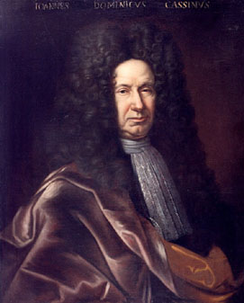

Figure 3: Cassini

Cassini had been timing the period of Io around Jupiter marking each orbit by when the moon left Jupiter’s shadow. His data showed that when Jupiter and earth were close, the observed times of Io’s eclipse agreed with those predicted by the ephemeris. But when Jupiter and earth were far apart, the observed eclipse times occurred 10 to 12 minutes later than predicted.

He originally deduced that this was a result of light taking a finite time to travel from Jupiter to earth. However he changed his mind, believing that light could not have a finite speed, and thought that something else was responsible for the errant timings.

Roemer, however, agreed with Cassini’s first interpretation of the data and used Cassini’s work to determine the speed of light arriving at a value that was about 70% of the value of c that we accept today. For this reason, he is credited as the person to make the first modern measure of speed of light.

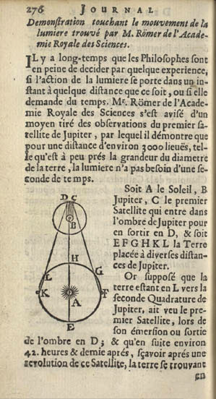

Figure 4: Roemer’s report on the Io Eclipses and the speed of light.

Jupiter’s Moon Io and the Speed of Light

**The Lab Activity**

**Starting the Program**

The *Jupiter’s Moons and the Speed of Light* program is a standard program under MS-Windows. To run it, click on the CLEA icon labeled *Jupiter Moons & Speed of Light* on you desktop. Select ***File🡪Login*** from the menu bar, and type in your name when asked. If you then click “OK”, you will see the title screen for the *Jupiter’s Moons and the Speed of Light exercise*, and will be able activate the program from the menu bar using the ***File🡪Run*** menu option.

**Accessing Help Files**

By selecting the ***Help*** option from the menu bar, you can find general instructions on using the Jupiter’s Moons program and its features. The help files are arranged by topic, and can be accessed just by clicking on the desired topic. The Help menu item also provides access to the CLEA website and other websites of interest to users of the program.

Summary of the Lab Activity

The speed of light will be determined using a method developed in the 17th Century by Ole Roemer using data obtained by Giovanni Cassini.

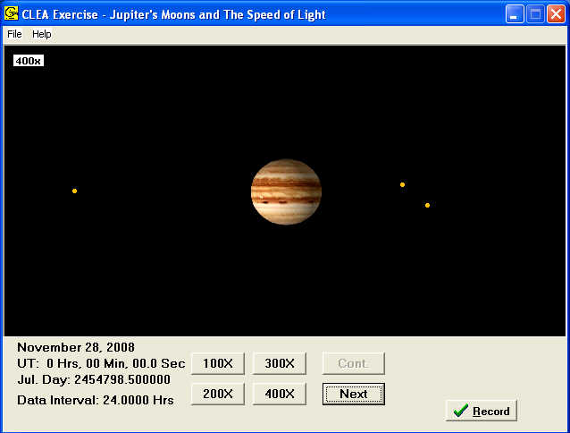

In this activity, you will observe Jupiter using the CLEA simulation “Jupiter’s Moons and the Speed of Light”. (See Figure 5 at the right).

The activity consists of observing the times of Io’s eclipses when Jupiter is far from and near the earth. You will find two dates when the distances between Jupiter and earth are larger and smaller

Figure 5: The Jupiter’s Moons observation screen

respectively. The greatest distance between the two occurs when Jupiter is at conjunction. Closest approach occurs at opposition.

Times for conjunction and opposition can be obtained in the CLEA exercise under:

***File🡪 Observation Date🡪 Jupiter Phenomena***

Distances between Jupiter and the earth are found by clicking “Record” on the bottom right of the main window.

Alternatively, conjunction and opposition dates, as well as distances can be determined from planetary data found at the U.S. Naval Observatory (USNO) ***Topocentric Configuration of Major Solar System Bodies*:**

<http://aa.usno.navy.mil/data/docs/ssconf.php>

In practice, dates about two months after conjunction and a month prior to opposition provide observing situations that allow Io’s eclipses to be seen more easily.

Giovanni Cassini observed the time when Io emerged from Jupiter’s shadow. In this activity you will instead observe when Io enters the shadow.

Overview of the Observing Procedure

On the far date, observe and time an eclipse of Io. Then use the synodic period of Io to predict an eclipse several months later. Observe and time the predicted eclipse and compare the predicted time to the observed time.

Since the light from Io takes more time to travel the distance between Jupiter and earth when they are far, and less when they are near, the difference in time (ΔT) between predicted and observed time corresponds to the time light had to travel the difference in distance (ΔD).

Knowing the difference in distances between Jupiter and earth on the two dates and the difference in time permits a straightforward calculation of the speed of light:

Speed of Light = c = ΔD **/** ΔT

Before You Begin

* Become familiar with the CLEA simulation.

You should be able to:

* **Set dates and times:** Select the ***File🡪 Observation Date🡪Set Date/Time…*** option from the menu bar.

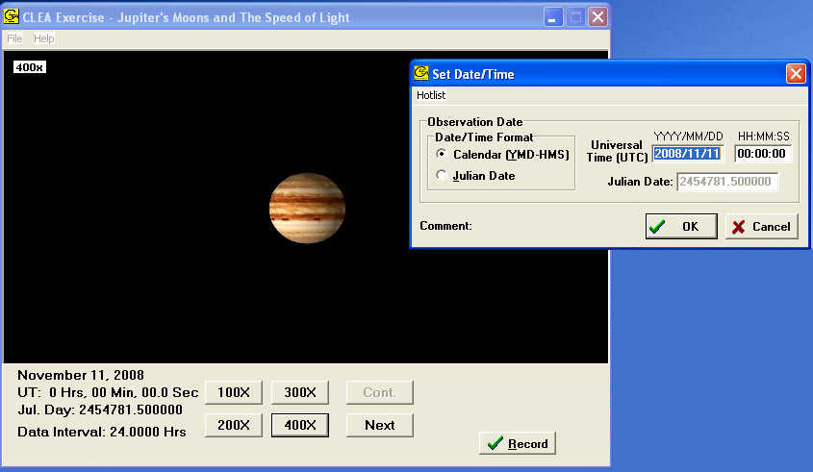

Figure 6: Setting Date and Time

* **Change the view magnification:** Click the buttons at the bottom of the view screen to choose 100, 200, 300 or 400 times magnification. For most observations of Io, you will want to use the largest magnification possible in which the moon is visible.
* **Set the Observation Interval to various values (from several hours to 0.005 hours):** This sets how much time elapses between each observation each time you press the ***Next***  button.Select the ***File🡪 Timing*** option from the menu bar, and enter the desired interval in the blank marked ***Observation Step***.
* **Advance the view in time:** Click the ***Next*** button. The moons will move slightly, or a lot (depending on the time interval. Eclipses of Io occur frequently, almost every day. To get the exact time of an eclipse, you’ll want to start with hour-long time intervals to get the moon close to eclipse (very close to Jupiter’s shadow, as described below) and then set the time intervals shorter and shorter so that and you step forward you can see the exact moment when the moon passes into Jupiter’s shadow and disappears.
* **Set the ID Colors for the satellites and identify Io:** Select ***File🡪 Features*** from the menu bar and check the box marked ***Use ID Colors***. The different moons will appear different colors. Which one is Io? You can find out by using the mouse to point the cursor at the moon and left clicking on it. The name of the moon will appear at the lower right of the view window, along with the x and y position of the moon with respect to Jupiter. If you don’t immediately see the name of the moon, try moving the cursor---you need to be pointing right at it.
* **View the satellites from the overhead perspective**: Select ***File🡪 Features*** and check the box labeled ***Show Top View.*** See Figure 7 below. This view makes it easy to sort out the moons Io, Europa, Ganymede, and Callisto on the telescopic view. The shadow of Jupiter is marked, too, by two green lines, so that you can see when a moon is about to enter Jupiter’s shadow.

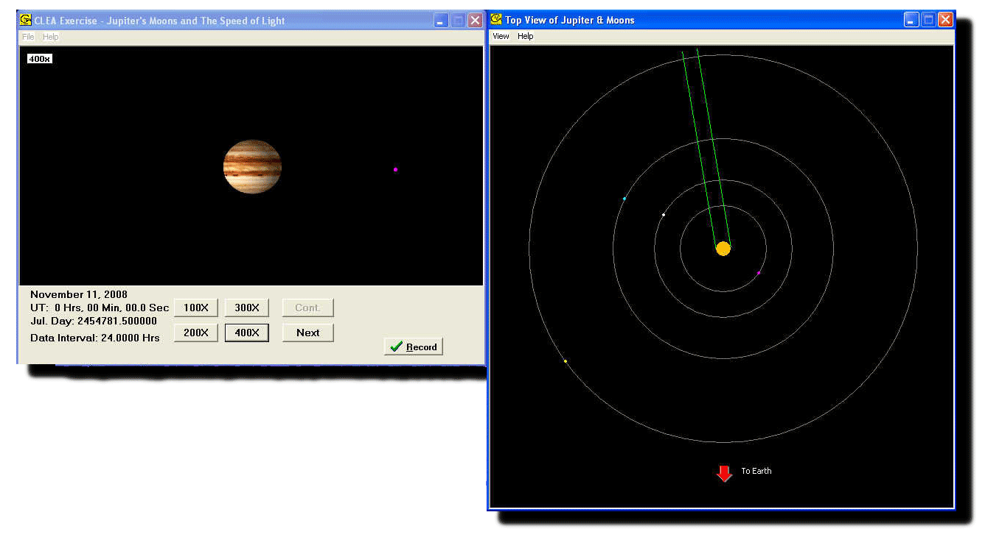

Figure 7: The Telescope View and the Top View of the Galilean Satellites

* **Determine when conjunction and opposition occur:** Select ***File🡪 Observation Date🡪 Jupiter Phenomena*** from the Menu Bar. You will see a window as in Figure 8 below, that shows in the top two lines the exact date and time of the next oppositions and conjunctions.

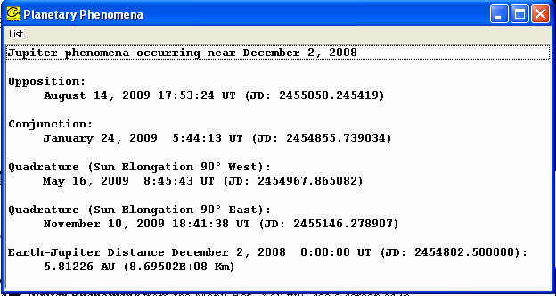

Figure 8: The window showing positions of conjunction and opposition.

* **Find the distance between Jupiter and earth on any date.** One way is to select ***File🡪 Observation Date🡪 Jupiter Phenomena*** at any time---you see the screen shown in Figure 8 above. The last line shown above is the Earth-Jupiter distance at the time you are observing (the time shown in the view of Jupiter’s moons.). Another way is to click the ***Record*** button on the telescope view window. A popup will open that will show you the Earth-Jupiter distance, and will also allow you to record the time of the eclipse in a data file for later manipulation. See figure 9 on the next page.

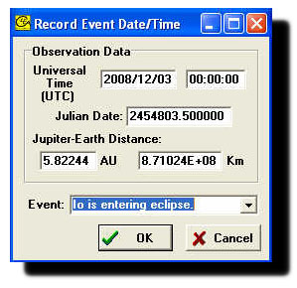

Figure 9: The data Recording Screen showing timing and distance information.

* **View and print saved data**: By selecting ***File🡪Observation Date🡪 View/Print Saved Events*** you can see a record of timings and distances for eclipses, and print the records out. This is the data you will use in your determination of the speed of light. Figure 10 below shows a sample of this data screen.

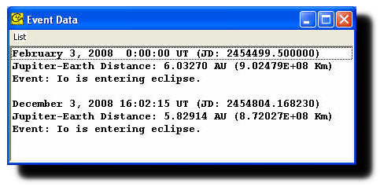

Figure 10: The stored data records for two eclipses, one in February and one in December.

* **Try the sample observation** in the ***Worked Example*** on the next page.
* A Note about Julian Day (JD) and Universal Time (UT)

**Observing Tip:**

* Time in the simulation is shown in two ways: standard format (Month-Day-Year, and UT as Hours-Minutes-Seconds) and Julian Day (JD). Universal Time is essentially the time at the Greenwich Meridian (5 hours ahead of Eastern Standard Time). Julian Day is just a running date that starts at noon Universal time and advances one unit every day. The fifth decimal place, 0.00001 JD, is about 0.8 seconds, or roughly 1 second.

Review JD’s at the American Association of Variable Star Observer’s web site:

<http://www.aavso.org/jd-calculator>

Review Universal Time at these NASA and U.S. Naval Observatory (USNO) sites:

<http://eclipse.gsfc.nasa.gov/SEhelp/TimeZone.html>

<http://aa.usno.navy.mil/faq/docs/UT>

Part 1 – Observing Procedure – A Worked Example

The following is an example that determines the speed of light from Jupiter’s satellite Io. Work this example through using the program before trying your own determination on another set of dates.

**Important Note:**

You may obtain data from the simulation that are close to but not exactly the same as what appears in the example. Differences of a few seconds to a minute are to be expected. This is due to the simulation and not necessarily a reflection of your observing technique.

**Overview of the Technique**

**(referring to steps that follow)**

**Step 1: Find two dates for Jupiter and Earth, one when the planets are far from each other, and the other when they are next near---the far date will be near conjunction, and the near date about a month before the *next opposition*.**

**Step 2: Observe and time an eclipse of Io close to the *far* date. Since eclipses occur every couple of days (roughly), you just watch (advancing the time slowly), until Io disappears. Record the time.**

**Steps 3-5: Predict the precise time an eclipse of Io close to the near date based on the period of Io.**

**Step 6: Observe and time the eclipse of Io. It’s important to start observing a few hours before the predicted time, so as not to miss the exact time of the eclipse.**

**Steps 7-8: Calculate the difference between the predicted and observed time of the near eclipse, and the difference in distance between Earth and Jupiter at the times of the two eclipses.**

**Steps 9-10: Calculate the speed of light (the time difference divided by the difference in distance) and compare this with the accepted value of the speed of light.**

Find two dates when Jupiter and earth are far and near, preferably about two to three months after Jupiter is in conjunction and a about month before Jupiter is at opposition These conditions ensure that Jupiter’s shadow is to the east of the planet so that eclipses are easily seen.

The Far Date and Near Date for this example are:

Far Date = March 1, 2008 (three months after conjunction )

Near Date = May 31, 2008 (about a month before opposition)

On these dates the orbital geometry allows Jupiter to be easily observed from earth. In March, the local time for observing Jupiter would be a few hours before dawn. In May observing would be around midnight.

In addition, these dates put Jupiter’s shadow on the east side of the planet so that it is possible to observe moons moving into the shadow.

The relative positions of Jupiter, earth and the Sun for these two dates are shown in the diagram in Figure 11 along with the distances between Jupiter and earth.



Figure 11: Relative positions of Earth and Jupiter at far (March) and near (May) dates.

1. **Observe and time an eclipse of Io on the Far Date**

(the eclipse happens at the moment Io moves into Jupiter’s shadow). If there is no eclipse on your Far Date, there will be one the next day – observe that one.

Observing Tips:

* Set the magnification view to 400x and use the ID Colors to identify Io.
* Turn on the “Top View” to see where Io is with respect to the position of Jupiter’s shadow.
* When Io is **more** than one Jupiter disk away from the planet’s edge, set the Observing Interval to 0.5 hour.
* Use the Next button to advance the observations.
* When Io is one Jupiter disk away from the planet’s edge, set the Observing Interval to 0.01 hour. Advance a few steps…
* When Io is about one quarter of a Jupiter disk away from the planet’s edge, set the observing interval to 0.005 hours.
* Gradually advance time, step by step, until the moon just disappears---this is the start of the eclipse.

Time of the Far Date Eclipse

Standard Format: March 1, 2008 18h 07m 18 sec

Julian Day: 2454527.255069

Estimate how many orbits Io will make from the Far Date to the Near Date

Number of Orbits = (Far Date – Near Date) / Synodic Period of Io

Synodic Period of Io = 1.769861 days

Number of Orbits = (May 31, 2008 – March 1, 2008) / 1.769861 days per orbit

Number of Orbits = 91 days / 1.769861days per orbit

= 51.42 orbits

Note: This is the number of orbits Io will make to go from the first eclipse on the Far Date to the predicted eclipse at the Near Date

Round the value ***down*** to a whole number of orbits:

Number of Orbits = 51

Calculate the time interval from the first eclipse to the predicted eclipse

Time to Predicted Eclipse = Number of Orbits **x** Synodic Period of Io (***don’t round off the period—keep as many decimal places as you can***)

Time to Predicted Eclipse = 51 orbits **x** 1.769861 days per orbit

= 90.262904 days

1. **Calculate the JD of the predicted eclipse at the Near Date:**

Predicted Eclipse Time = Far Eclipse Time (JD) **+** Time to Predicted Eclipse

Predicted Eclipse Time = 2454527.255069 **+** 90.262904

= 2454617.517973

Observe the predicted eclipse

Advance the simulation to ***a few hours before*** the Near Date eclipse. ***Starting your observations before the predicted eclipse is a key part of getting good data.*** The reason for this is that you expect the near eclipse to occur several minutes before the predicted time, and you don’t want to miss it. If you miss it, and observe the next eclipse, several days later, you won’t get the right speed of light***. So, just to be on the safe side, let’s start our observations 0.1 JD, or 2.4 hours, before the predicted eclipse time. In other words, since the predicted eclipse time is Julian Day 2454617.517973, we start our observations on Julian Day2454617.417973.*** Then slowly advance the time to catch the predicted eclipse a few minutes before your predicted time.

Observe and time the eclipse of Io that happens on this Near Date

Observed Eclipse Time (JD) = 2454617.508208

Find the time difference between the predicted eclipse and the observed eclipse

Time Difference = Observed Eclipse Time (JD) **–** Predicted Eclipse Time (JD)

Time Difference = 2454617.508208 **–** 2454617.517973

= **–** 0.009765 days

Note: The negative value indicates that the eclipse occurred before the predicted time

Time Difference (ΔT) = **–** 14.1 minutes

Find the change in distance between Jupiter and earth from the Far Date to the Near Date

Distance (au) of Jupiter from Sun (March 1) = 5.71785 au

Distance (au) of Jupiter from Sun (May 31) = 4.39149 au

Change in distance = March 1 distance **–** May 31 distance

Change in Distance (ΔD) = 5.71785 au **–** 4.39149 au

= 1.32636 au

Calculate the Speed of Light

Speed of Light = ΔD / ΔT

Speed of Light = 1.32636 au **/** 14.1 minutes

= 0.094327 au **/** minute

Convert this value in au **/** minute to the more familiar meters **/** second

Speed of Light = 2.34 x 108 m**/**s

Compare your value to c

Find the Percent Difference between your calculated value of the Speed of Light and the accepted value, c = 3.00 x 108 m**/**s

Percent Difference = [ (Speed of Light – c) **/** c ] x 100%

Percent Difference = [ (2.34 x 108 m**/**s – 3.00 x 108 m**/**s) / 3.00 x 108 m**/**s ] x 100%

= [ **–** 0.64 x 108 m**/**s / 3.00 x 108 m**/**s ] x 100%

= **–** 21%

Part 2 – Your Observations and Calculations

For each value you find or calculate make sure you show the units!

1. Find two dates when Jupiter and earth are far and near, preferably about a month before Jupiter is at opposition and about two to three months after Jupiter is in conjunction These conditions ensure that Jupiter’s shadow is to the east of the planet so that eclipses are easily seen.

Far Date = ________________

Near Date = ________________

1. Observe and time an eclipse of Io on the Far Date (the eclipse happens at the moment Io moves into Jupiter’s shadow). If there is no eclipse on your Far Date, there will be one the next day – observe that one.

Time of the Far Date Eclipse

Standard Format = ________________

Julian Day = ________________

1. Estimate how many orbits Io will make from the Far Date to the Near Date

Number of Orbits = ________________

1. Calculate the time interval from the first eclipse to the predicted eclipse

Time to Predicted Eclipse = ________________

1. Calculate the JD of the predicted eclipse at the Near Date:

Predicted Eclipse Time = ________________

1. Observe the predicted eclipse

Observed Eclipse Time (JD) = ________________

1. Find the difference between the times of the predicted eclipse and the observed eclipse

Time Difference (**ΔT**) = ________________

1. Find the change in distance between Jupiter and earth from the Far Date to the Near Date

Change in Distance (**ΔD**) = ________________

1. Calculate the Speed of Light

Speed of Light = ________________

Convert this value in au **/** minute to the more familiar meters **/** second

Speed of Light = ________________

1. Compare your value to c

Percent Difference = ________________

Questions and Discussion

In this activity you set the Observation Interval to 0.005 hours (18 seconds). This represents how accurate your “clock” was – it kept time to about 20 seconds over three or four months.

***How would your prediction and eventual determination of the speed of light have changed if your clock was accurate to several minutes instead of 20 seconds?***

Similarly the values of the distances between Jupiter and earth were given by the simulation to five decimals places of one astronomical unit. In other words, the distances were known to within 930 miles or 1500 km.

***How would your determination of the speed of light have been affected if the distances were known to only a half astronomical unit?***